| **South Korea - Culture, Economic Measures of Development, and the World Economy (2 days)** |
| --- |

**Day 1**

[Hallyu Explained | The reason Korean culture is taking over the world | This Is Why](https://www.youtube.com/watch?v=CmkULRHGa40) - 5 Minutes

**Describe the significance of the Korean wave (Hallyu) beyond just K-pop music.**

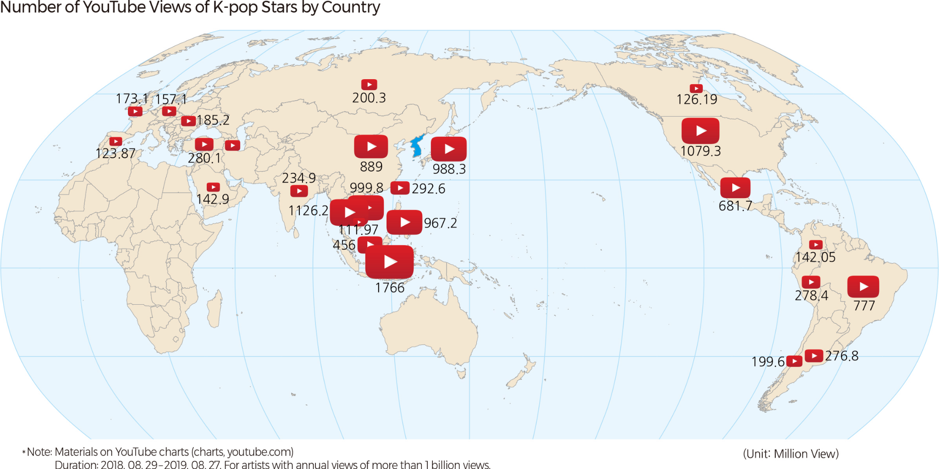

**Let’s Review:**

1. What type of thematic map is presented above?
2. What is the scale of the map? The scale of analysis?
3. Through what type of diffusion has Korean Culture spread throughout the world?
4. To what extent has technology played a role in the globalization of Korean culture worldwide?

| **GDP: Gross Domestic Product**  The dollar amount of all final goods and services produced within a country in one year. | **GNP: Gross National Product**  The dollar amount of all goods and services produced by a country’s citizens in one year regardless of the country they are presently residing in.  *\*Also referred to as GNI*  *(Gross National Income)\** |  |
| --- | --- | --- |
| 1. Using the definitions of GDP and GNP above, explain if the Korean Wave (Hallyu) contributes more to South Korea’s GDP or GNP. | | |

Analyze the images on the next page - **GDP by Sector (2022)** and **Korea - External Trade**

1. Identify the economic sector(s) that a majority of South Korea’s exports belong to?
2. Identify the countries South Korea mainly exports to.
3. Describe the spatial pattern of the countries Korea chooses to export to.
4. Using the information provided and your knowledge of South Korea, explain how South Korea might be classified according to Wallerstein’s World Systems Theory.

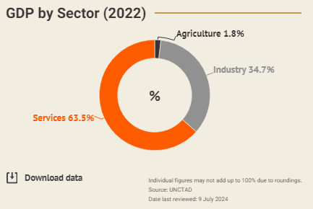

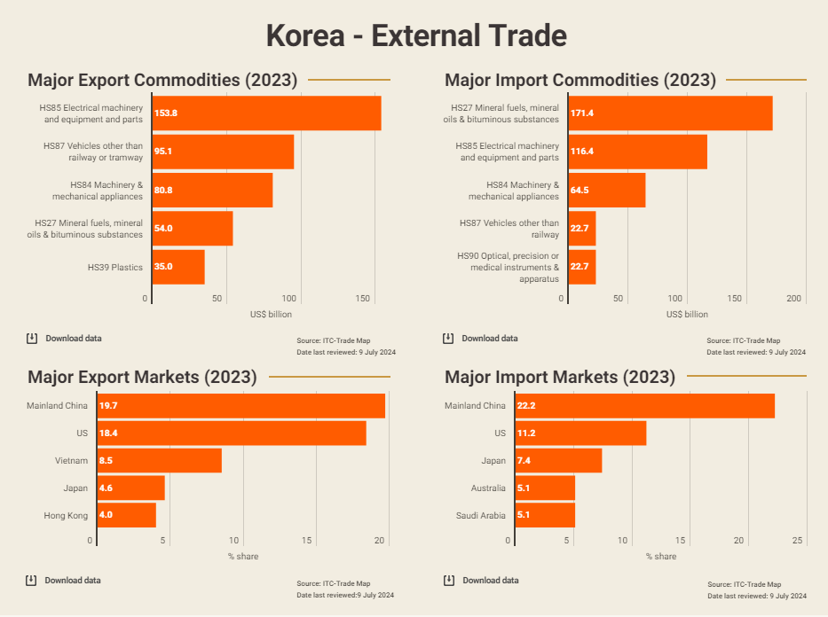

**Day 2**

[‘Memory Semiconductor’ Explained | 'All About Semiconductor' by Samsung Semiconductor](https://youtu.be/R5iHUyNPMtU?si=pXxUIsBj3Qv2_bZK) - 4 minutes

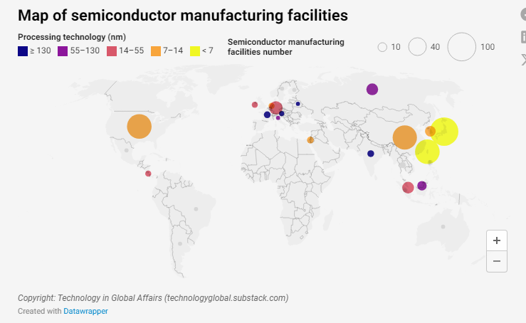

**Let’s Review**

1. What type of thematic map is represented above?
2. What is the scale of analysis of the map?

***The export of memory semiconductors from South Korea reached US $8.8 billion in June 2024, accounting for 65.8% of total semiconductor exports worldwide.***

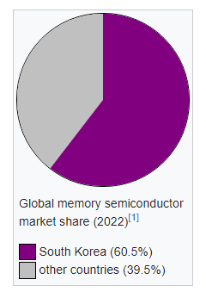

| **Comparative Advantage**  An economy's ability to produce a particular good or service at a lower opportunity cost than its trading partners.  *\*The country with the comparative advantage is more efficient at*  *producing the product.\** |
| --- |
| [How South Korea Became a Semiconductor Powerhouse](https://www.youtube.com/watch?v=ZqqdsC7YFVA&t=504s) - 15 minutes  [S. Korea to build world-leading semiconductor supply chain by 2030](https://www.youtube.com/watch?v=MzFEM_XUIZA) - 2:29  [S. Korea records all-time high for semiconductor exports in Sept.](https://www.youtube.com/watch?v=XL_D_2cERfs) - 2:08 |
| 1. Explain the degree to which South Korea has a comparative advantage in the sale of memory semiconductors. |

| 1. How might semiconductor manufacturing facilities in South Korea, such as those operated by Samsung demonstrate economies of scale? Consider factors such as production volume and government support. | 1. Describe how the last video represents the break of bulk point and containerization. |
| --- | --- |

**Supplemental Articles on Korean Pop Culture**

* <https://asiafundmanagers.com/us/kpop-and-economic-impact-on-south-korea/>
* <https://www.wionews.com/world-business-watch/flashback-friday-k-pop-a-cultural-juggernaut-powering-the-korean-economy-760495>

**Sources of Images:**

* [Chart: Where Can the Most Chips Be Manufactured? | Statista](https://www.statista.com/chart/31371/distribution-of-global-semiconductor-fabricating-capacity/)
* [Semiconductor Manufacturing Facilities Map](https://technologyglobal.substack.com/p/semiconductor-manufacturing-facilities)
* [Korea: Market Profile | HKTDC Research](https://research.hktdc.com/en/article/MzU3OTc3NTU0)

**Supplemental - Explain how the video represents the idea of agglomeration.**

[How Arizona is building the workforce to manufacture semiconductors in the U.S.](https://www.youtube.com/watch?v=uR6xaHmqsDM) - 8:05