AUTHOR INFORMATION

Author: Lisa Smith

GENERAL INFORMATION

Lesson Grade Span: 9-12
Targeted Grade Level: 9
Targeted Course: AP Human Geography
Estimated Time to Complete Lesson: One 90 minute class block
Brief explanation of content connection and/or inspiration of lesson from Discover Korea Research Fellowship: Population decline is evident in Korea and the government is addressing it by creating a ministry to tackle the low birth rate. Steps taken so far to address the issue include parking spaces and reserved seats for pregnant women, vouchers for parents, and social campaigns urging men to contribute to the household. While talking to women in Korea it’s clear that many do not want children due to high housing costs, increased work demands, and stress of taking care of the house. When children are seen with parents it’s usually one child only and very few have a sibling. As the population continues to decline Korea will face a crisis as the population ages and retires and will need support from the working population. Mass immigration continues to be slow.

FOCUS QUESTION

What factors have accounted for historical and contemporary trends in population in South Korea?

NATIONAL STANDARDS, STATE STANDARDS, AND/OR AP CED EKS

Advanced Placement Human Geography
CED Topic 2.4: Population Dynamics
Enduring Understanding: Changes in population are due to mortality, fertility, and migration, which are influenced by the interplay of environmental, economic, cultural, and political factors.
Essential Knowledge:
2.A.1: Demographic factors that determine a population’s growth and decline are fertility, mortality, and migration.
2.A.2: Geographers use the rate of natural increase and population-doubling time to explain population growth and decline.
2.A.3: Social, cultural, political, and economic factors influence fertility, mortality, and migration rates.
LEARNING TARGETS/OBJECTIVES

- Explain factors that account for contemporary and historical trends in population growth and decline.

LESSON SUMMARY (brief paragraph)

A country needs a fertility rate of 2.1 to sustain the population. South Korea’s population has been steadily declining for decades, after years of rapid industrialization and this is leading to a crisis as the working population and thus, social services that are paid for by the working population, declines. South Korea’s fertility rate is just 0.72 births per woman as of 2023. This gives South Korea the lowest fertility rate of any country in the world. Students will look at the historical trend in population in South Korea since the Korean War and will explain the reasons the population has been declining recently as well as the steps the government is taking to increase the fertility rate. Furthermore, students will predict what the population trend will be in future decades in South Korea, with or without government assistance.

LESSON PROCEDURES (step by step teacher instructions)

- Students will go to populationpyramid.net and work in small groups to analyze South Korea’s most recent population pyramid. Discuss the trends seen among the different age groups and causes for population numbers in these groups.
- Small groups will receive a set of 8 population pyramids from Korea (one from each decade beginning with 1950 through 2020) without the years given. Students will put the population pyramids in order. Check as a class for the correct order with a slideshow.
- Using peardeck.com students will write the trends they see in the population over the 8 decades and what they think the causes are for the trends. Discuss in small groups and as a class. Students should note the increase in population during Korea’s rapid industrialization followed by a population decline in more recent decades.
- Introduce AP Human Geography concepts such as: dependency ratio, crude birth rate, crude death rate, doubling time, life expectancy, natural increase rate, pronatalist policies, total fertility rate, zero population growth, democratic momentum, infant mortality rate.
- Students watch a video about Korea’s declining population. One example is: https://youtu.be/Y5WWvZ9EJDs?si=ojPjTTYykjIrrfrn or read an article. One example is:
https://time.com/6835865/south-korea-fertility-rate-2023-record-low/
- Students fill out Frayer Model: 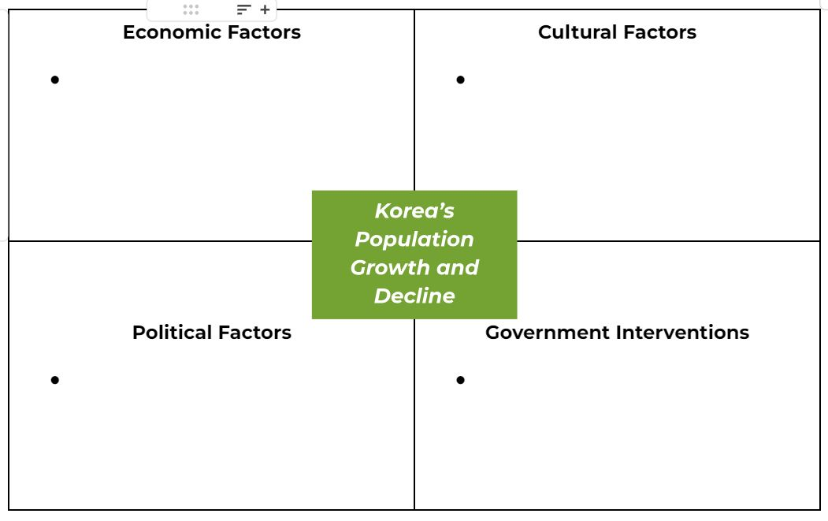
- Students will create an ad, commercial, brochure, etc. over pronatalist policies in South Korea (current policies the government has created AND student’s own ideas about Korea’s pronatalist policies). They will identify the fertility rate, the economic, cultural, and political factors that have led to population decline over the decades and the problems South Korea faces as a result of the low fertility rate.

SUPPORTING MATERIALS (links, resources, handouts, etc.)
https://www.populationpyramid.net/
https://www.peardeck.com/
Slideshow of population pyramids (teacher prints in color and distributes to students): https://docs.google.com/presentation/d/1QytULJNUanlJKnkMb9Jmp7vOGoliWnupSdM28cMd2cs/edit?usp=sharing
Video:
https://youtu.be/Y5WWvZ9EJDs?si=ojPjTTYykjIrrfrn
Article:
https://time.com/6835865/south-korea-fertility-rate-2023-record-low/

