AUTHOR INFORMATION

Author: Elizabeth Jorgensen
GENERAL INFORMATION

Lesson Grade Span: 5-12

Targeted Grade Level: 9-12

Targeted Course: Social Studies or ELA

Estimated Time to Complete Lesson: This lesson could be completed in a day or fleshed out over the course of several classes.

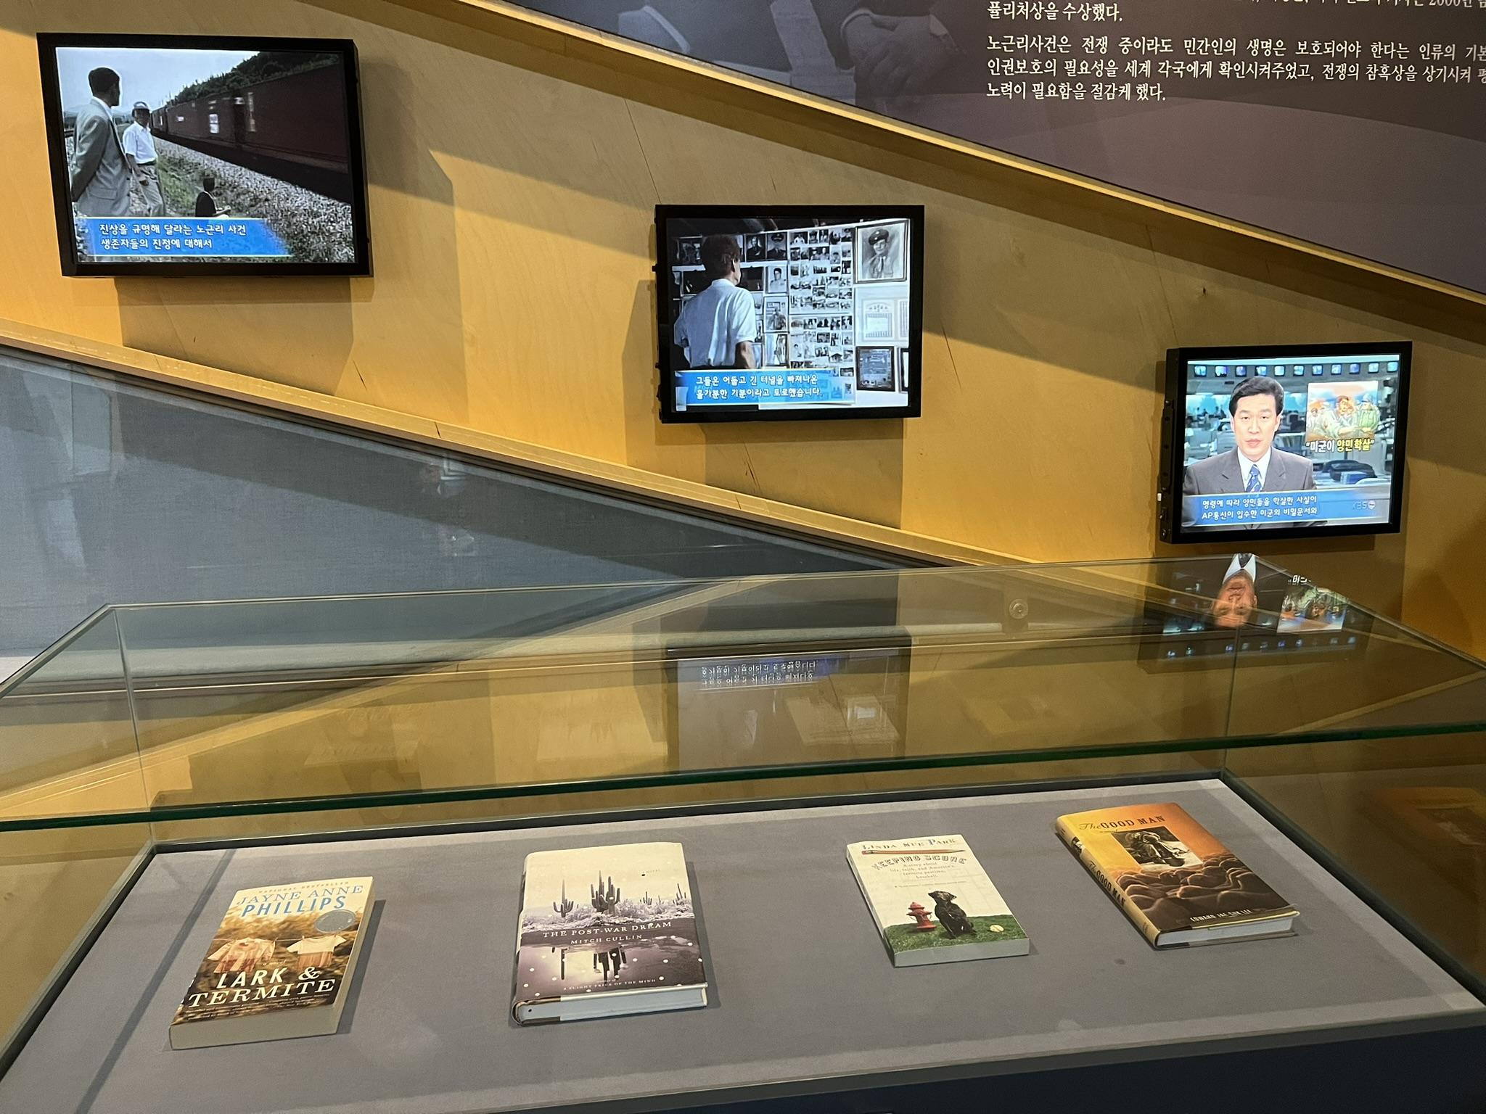
Brief explanation of content connection and/or inspiration of lesson from Discover Korea Research Fellowship: In the No Gun Ri Memorial Peace Park, there was a display featuring many books. One of those was Linda Sue Park’s Keeping Score.

According to the Goodreads description, “Both Maggie Fortini and her brother, Joey-Mick, were named for baseball great Joe DiMaggio. Unlike Joey-Mick, Maggie doesn't play baseball—but at almost ten years old, she is a dyed-in-the-wool fan of the Brooklyn Dodgers. Maggie can recite all the players' statistics and understands the subtleties of the game. Unfortunately, Jim Maine is a Giants fan, but it's Jim who teaches Maggie the fine art of scoring a baseball game. Not only can she revisit every play of every inning, but by keeping score she feels she's more than just a fan: she's helping her team. Jim is drafted into the army and sent to Korea, and although Maggie writes to him often, his silence is just one of a string of disappointments—being a Brooklyn Dodgers fan in the early 1950s meant season after season of near misses and year after year of dashed hopes. But Maggie goes on trying to help the Dodgers, and when she finds out that Jim needs help, too, she's determined to provide it. Against a background of major league baseball and the Korean War on the home front, Maggie looks for, and finds, a way to make a difference. Even those readers who think they don't care about baseball will be drawn into the world of the true and ardent fan. Linda Sue Park's captivating story will, of course, delight those who are already keeping score.”

I read this book after seeing it in the No Gun Ri Peace Park Museum and it inspired me to connect students to Korean War veterans through letter writing.

FOCUS QUESTION

How can writing a letter to a Korean War veteran enhance students’ understanding of the war and foster gratitude and appreciation for those who have served?
NATIONAL STANDARDS, STATE STANDARDS, AND/OR AP CED EKS

Common Core State Standards (CCSS):
- Produce clear and coherent writing in which the development, organization, and style are appropriate to task, purpose, and audience.
Wisconsin Academic Standards for English Language Arts:
- Produce clear and coherent writing in which the development, organization, and style are appropriate to task, purpose, and audience.
- Develop and strengthen writing as needed by planning, revising, editing, rewriting, or trying a new approach.
- Use technology, including the Internet, to produce and publish writing and to interact and collaborate with others.
LEARNING TARGETS/OBJECTIVES

- Develop letter writing skills by focusing on a specific purpose and audience.
- Reflect on freedom, patriotism, and American opportunities and cultivate a sense of gratitude and appreciation by reflecting on who and what they should be thankful for.
- Analyze previous student letters for quality and content to understand effective communication.
- Watch videos of veterans and engage in discussions to learn how to communicate effectively with veterans.
- Decorate letters to add a personal touch and show appreciation.
- Send letters to veterans and experience the impact of expressing gratitude firsthand, including potential responses and interactions.
LESSON SUMMARY (brief paragraph)

In “Encouraging a Sense of Gratitude in Students”, Marissa King suggested students write letters. She says, “Letter writing is an academic skill—requiring students to focus on a specific purpose and an authentic audience—but it’s also a perfect opportunity to get students thinking about who and what they should be thankful for.” King’s recommendation aligns with this lesson: writing a letter to a Korean War veteran. If possible, I recommend you connect with the National Honor Flight Network, to make sure veterans receive the students’ letters. In Wisconsin, I’ve worked with the Stars and Stripes Honor Flight. You might also contact the Korean War Veterans Association.

After I completed this lesson, I asked my students what they thought. Here’s what they said:
- “I have never thanked a veteran before, but I’ve always wanted to. I liked how personal this project gets. It was nice to be able to thank a veteran because it truly means something to them and if I could make a part of their day just a little bit better even, it’s all worth it.”
- “I enjoyed this project because I think we often take what the veterans have gone through and done for us for granted. So I liked that we took time out of our day and had everyone thank them for their service.”
- “I liked the planning portion of the project so we got some ideas on what to include in our letter. I appreciate writing a letter to a veteran because I admire their bravery and sacrifices. It means a lot to them to get letters, even from people they don’t know.”
- “I like that this project is something where we are recognizing and giving back to something outside of our sheltered worlds. I think this project is very meaningful and important. It gave me a chance to tell a veteran something other than ‘thank you for your service.’ It gave me a chance to direct my gratitude toward someone that truly deserves it.”
- “I appreciated the opportunity to make an impact in a veteran’s life. Personally, I don’t write letters of thankfulness often, and even less often to strangers, but I’m happy that I was able to write something for an important event like the Honor Flight.”
- “I love that we are impacting other people’s lives. This project is so much more than just another writing piece, and I think this is a great project because veterans should know how much we appreciate their time served.”
- “It was cool to get to watch the Honor Flight movie and to hear all these different stories and watch these videos on other people. It makes writing the letter that much more personal and it is fun to write the letters because I feel special making someone else feel special.”
- “At first, I was honestly less than enthralled by the idea of writing letters since I’m not a huge fan of writing essays, structured articles, or letters. However, the more we proceeded with this project, and the more we were shown the impact of the letters, the happier I became with the idea of writing a letter to a veteran. Overall, I’m happy with how my own letter came out, and I’m even happier to know it’s going to make an impact on someone else.”
- “I still talk to one of my old middle school teachers. He was my social studies teacher, so I figured it would be a good idea to let him know about this opportunity. He said he’s going to work with one of our middle school English teachers on having the kids write letters and submit to the program! He was very thankful I let him know about this and he can’t wait to have the kids start writing!”

LESSON PROCEDURES (step by step teacher instructions)

To introduce students to the unit, show the Stars and Stripes Honor Flight movie.

Have students read previous student letters and analyze them for quality and content. My students read Maddie’s letter, Josh’s letter, and Alyssa’s letter.
One of my colleagues asked a family member and veteran to create a video message. Students watched his short video and then a Ted Talk about how to talk to veterans. After each, students and I discussed what we noticed and learned. In our discussions, students referenced a social studies teacher who collects donations for the Stars and Stripes Honor Flight, our school’s Rho Kappa Club that hosts a Veteran’s breakfast and the Arrowhead SAVE Team (Survivor and Veteran Experience) that “conducts and records interviews with WWII and Holocaust survivors and saves their stories for posterity.”
To understand a bit more about the Korean War, students watched Beyond The Bridge of No Return: Legacy of a Korean War Veteran.
And then, students wrote their letters. Varying in length from 300 to 500 words, students reflected on freedom, patriotism, gratitude and American opportunities. I provided these suggestions:
Open in a creative way. Then, introduce yourself and why you’re writing:
- Watched the Honor Flight special about the 50th flight on WISN 12; watched Beyond The Bridge
- Your age and what your future plans are
- Your connections to the military/our vets

Then, perhaps you’ll answer some of these questions:
- Why/when are you thankful for veterans?
- Have you been to War Memorials? What did you think/feel?
- Why are you thankful/grateful for our veterans’ service/sacrifice?
- What is the legacy of our veterans?
- What did you learn/notice from the videos we watched in class?
- What did you learn about the work students are doing to help vets?
- What connections do you have to veterans?
- What do you know about the Honor Flight?
- Why do you call veterans heroes?
- What do you think about patriotism?
- Many of the vets were drafted at age 18. What connections/feelings do you have?
- Are there veterans in your family? What connections can you make?
- Have you seen pictures (or are there pics in your family) of war veterans? What did you think/feel?

At the end of your letter, if you want a response, let them know that and include your contact information. You can use our school’s address. Example:
School Name
℅ Your Name
School Address
City, State Zip Code

Close (sincerely, thank you, etc.) and include your name/signature.
Students spent the remaining time decorating letters.
See examples of decorated letters here and here.
I sent the letters to our local Stars and Stripes Honor Flight. Veterans received the letters during their trip to Washington, D.C., and many wrote back to the students. Here is one example.
One veteran came to our school to present a challenge coin to the student who wrote to him. You can see the photo here and watch the series of videos here.
See the next section for an additional follow up.
SUPPORTING MATERIALS (links, resources, handouts, etc.)
BOOKS
- Keeping Score by Linda Sue Park
- We Were Innocents: An Infantryman in Korea by William Dannenmaier
- I Remember Korea: Veterans Tell Their Stories of the Korean War, 1950-53 by Linda Granfield
- The Bridge at No Gun Ri: A Hidden Nightmare from the Korean War by Charles J. Hanley, Sang-Hun Choe and Marth Mendoza

VIDEO CLIPS
- Beyond The Bridge of No Return: Legacy of a Korean War Veteran.
- Honor Flight 50: A Mission of Thanks
- Korean War Legacy Foundation offers “a free, searchable library of thousands of oral history video interviews from the Korean War.” These might also be helpful as you incorporate this lesson into your classroom.

A FOLLOW UP
- A veteran came to our school, saying he just needed to see and speak with the teacher and students featured in the Honor Flight 50: A Mission of Thanks special. I welcomed the veteran to my classroom. He walked in with a cane and bag and tears streaming down his face. He told my class how powerful their words, how impactful their gratitude, how impressed he was with their actions. Although this veteran was never on an Honor Flight and never received Mail Call, he was so moved by the special and what the students were doing, he wanted to personally meet and thank some of them. We learned he was John Poweleit, an Arrowhead Union High School graduate (class of '65) and Vietnam War Veteran. He sat down at the front of my class and began to answer students' questions and tell of his time in the service. It was the first time he had EVER–in 53 years–shared such details about his time in the service. He passed around newspaper clippings and showed photographs. The students and I, in addition to John, had tears in our eyes. When the bell rang, the students spontaneously formed a line and one-by-one shook his hand and thanked him for coming in, for his time in the service. I invited John to stay and speak with my third and fourth hour class, the class featured in Honor Flight 50: A Mission of Thanks special. Again, John shared about his time, about his experiences. He spoke of patriotism, about recognizing servicemen and women, about the power of the students' voices and their letters. He showed such grace and humility and encouraged the students to keep doing good in the world and to hear the stories of the servicemen and women in their families. After the period ended, I walked John to the commons to see the display case featuring Arrowhead graduates who served. I connected John with a social studies teacher at my school who added John's story and relics to the display. Students in that third and fourth hour class called John the best guest speaker they have ever heard. Before the semester is over, we plan to write to John to thank him. The courage John showed to come in and share his experiences for the first time in his life, moved the students and me beyond measure.

