INDUSTRIALIZATION AND ECONOMIC DEVELOPMENT MODULE OVERVIEW
SKILL FOCUS: SPATIAL RELATIONSHIPS, DATA ANALYSIS, SOURCE ANALYSIS | CONTENT: ENDURING UNDERSTANDING SPS-7
Spatial Relationships: Describe spatial patterns, networks and explain a likely outcome in a geographic scenario using geographic concepts, processes, models, or theories  Data Analysis: Explain patterns and trends in maps and in quantitative and geospatial data to draw conclusions.  Source Analysis: Analyze and interpret qualitative geographic information represented in maps, images (e.g., satellite, photographs, cartoons), and landscapes | Industrialization, past and present, has facilitated improvements in standards of living, but it has also contributed to geographically uneven development.  Topic 7.1 The Industrial Revolution  Topic 7.2 Economic Sectors and Patterns  Topic 7.3 Measures of Development

DAY 1 | What are economic sectors and the factors that affect their development?  CLASS ACTIVITY: Understanding and Identifying Economic Sectors  Students will work collaboratively to identify and learn the five different economic sectors. Students will then use their new understanding of the economic sectors and examine maps and data sets to predict the locations of different economic sectors within South Korea.  AP SKILL ALIGNMENT  Skill Category 2.B Explain spatial relationships in a specified context or region of the world, using  geographic concepts, processes, models, or theories.  Skill Category 2.C Explain a likely outcome in a geographic scenario using geographic concepts,  processes, models, or theories.  Skill Category 4.D Compare patterns and trends in sources to draw conclusions.

DAY 2 | What are the key measures of development in a country?
CLASS ACTIVITY: Understanding and Identifying Measures of Development
Students will work collaboratively to define and learn a variety of measures of development. Students will then analyze data sets to identify changes in several measures of development in South Korea over the past 70 years and speculate as to the reasons for those changes.
AP SKILL ALIGNMENT
Skill Category 3.F Explain possible limitations of the data provided.
Skill Category 4.D Compare patterns and trends in sources to draw conclusions.
Skill Category 4.E Explain how maps, images, and landscapes illustrate or relate to geographic
principles, processes, and outcomes.

DAY 3 | CLASS ACTIVITY: Concept Mapping and AP-Aligned Assessment  Students will connect vocabulary and concepts via a concept-mapping activity and then demonstrate understanding as they answer one Free Response Question (FRQ) with two stimuli and Multiple Choice Questions (5 MCQs total).  AP-ALIGNED ASSESSMENT: Free-Response Question (FRQ) and Multiple Choice Questions (MCQs)

INDUSTRIALIZATION AND ECONOMIC DEVELOPMENT SOURCES

DAY 1 | STIMULUS TYPE DESCRIPTION STIMULUS TYPE DESCRIPTION  - Map The Global Spread of 11. Image New York Stock Exchange  Industrialization  - Image Tractor on a Farm 12. Map Outline Map of South Korea  - Image Textile Manufacturing Equipment 13. Map Population of South Korea (Dot Map)  - Image Barbershop 14. Map Road and Highway Systems of South  Korea  - Image Researcher / Scientist 15. Map Food and Beverage Services of South  Korea (Dot Map)  - Image Business Leaders 16. Map Percentage of People per Subunit  Engaged in Market Gardening in South  Korea (Choropleth map)  - Image Open Mine Site 17. Map Percentage of people Engaged in  Manufacturing in South Korea  (Choropleth map).  - Image Manufacturing Plant 18. Map Distribution of Colleges and  Universities in South Korea  - Image New York Storefronts 19. Map Distribution and Number of Hospitals  Image University Research Facility in South Korea

DAY 2 | STIMULUS TYPE DESCRIPTION  - Data Chart Data Charts of GDP for South Korea from 1960 - 2018  - Article South Korea's GDP Surges 31,000-fold since 1953  - Data Chart South Korea’s GDP Growth (Annual Percentage) and  Annual Change from 1960 - 2018  - Data Chart South Korea’s Oil Consumption 1969 - 2018  - Article South Korea Relies on Imports to Meet about 98% of its  Fossil Fuel Consumption  - Data Chart South Korean Usage of Renewable Energies from 1990 –  2015  - Data Chart Trends in South Korea’s HDI Component Indices 1980 - 2014  - Data Chart South Korea’s HDI Trends  Map South Korean Regions by Human Development Index in 2017

DAY 3 | STIMULUS TYPE DESCRIPTION  - Data Chart South Korea’s Greenhouse Gas Emissions Rising Quickly  - Image Researcher / Scientist  - Image Worker in Rice Field  - Image Auto Factory
D A Y 3
Based on a 60-minute class

Lesson Focus: Reviewing Industrialization and Economic Development

AP curriculum Framework reference
Enduring Understanding SPS-7
Industrialization, past and present, has facilitated improvements in standards of living, but it has also contributed to geographically uneven development.
Topic 7.1 - The Industrial Revolution
Topic 7.2 - Economic Sectors and Pattern
Topic 7.3 - Measures of Development

Human Geography Skills:
Spatial Relationships: Describe spatial patterns, networks and explain a likely outcome in a geographic scenario using geographic concepts, processes, models, or theories.
Skill Category 2.B Explain spatial relationships in a specified context or region of the world, using geographic concepts,
processes, models, or theories.
Skill Category 2.C Explain a likely outcome in a geographic scenario using geographic concepts, processes, models, or
theories.
Data Analysis: Explain patterns and trends in maps and in quantitative and geospatial data to draw conclusions.
Skill Category 3.F Explain possible limitations of the data provided.

Source Analysis: Analyze and interpret qualitative geographic information represented in maps, images (e.g., satellite, photographs, cartoons), and landscapes.
Skill Category 4.D Compare patterns and trends in sources to draw conclusions.
Skill Category 4.E Explain how maps, images, and landscapes illustrate or relate to geographic principles, processes,
and Outcomes.

OVERVIEW
Students will work with the important terms and concepts from this module to review the essential content and skills. Working in groups, students will manipulate the important terms and concepts into a concept map that should begin with a central term or concept. Upon completing the task, groups rotate to other group concept maps to reflect on their synthesis, leading to interactive conversations and deeper review of the content as students make meaning individually and collaboratively. Then, students are given the opportunity to complete five AP-style multiple choice questions (MCQs) and one AP-style stimulus-based free response question (FRQ).

Materials needed For Day 3:
- Day 3 Handouts
  - Day 3 Student Handout (1 per student)
  - Day 3 Multiple Choice Question (MCQ) Assessment
  - Day 3 Free Response Question (FRQ) Assessment
- Day 3 Free Response Question (FRQ) Assessment Teacher Key

SEQUENCE OF INSTRUCTION

CLASS ACTIVITY 1 of 2: Concept Mapping

Class Activity (20-30 MINUTES): Concept Mapping

ACTIVITY 1: Students will consider the important terms and concepts for this module on Industrialization and Economic Development in order to find relationships and more deeply understand the content. The activity also integrates the geographic skills that run through the module by asking students to explain the connections between terms and concepts. Debriefing the activity and monitoring student progress are two essential elements to this collaborative work.

Activity Procedure:
- Have students sit in groups of four to five to facilitate group work throughout the course of the activity. Mixed-ability groups are recommended to achieve the best results.
- Explain what a concept map is by showing an example (see resource) and/or a brief video overview
  - https://tinyurl.com/geoconcept.
  - This video explains how concept maps are visual ways to express the connections between ideas and the steps to create an effective concept map (identifying main topic, organizing main points, creating map with major points and supporting details, reviewing map and looking for connections, including details, analyzing and improving the map).
- Students review the list of terms and concepts and begin to identify relationships as well as consider what the central term or concept might be.
  - Monitoring group conversations across the room and affirming good insights and/or prompting and redirecting groups that may need support is critical to ensure student understanding.
  - Students may need prompting to remain focused on connections and not definitions.
- Students display concept maps on desks or walls and groups rotate to see other concept maps.
  - Leading a discussion on similarities and differences among concept maps can reinforce conceptual knowledge
  - Groups may be given sticky notes to challenge connections between concepts with which they disagree. They can write how/why they disagree on the sticky note and place it on the concept map.
  - Taking pictures of concept maps and uploading all pictures for student access provides another opportunity for reflection and deeper learning
Teaching Tip

The list of terms and concepts for this activity is drawn from the two days of previous instruction in this module. Teachers might consider adding other terms and concepts to supplement this list depending on the scope of the unit and assessment.

Teaching Tip

If some groups work more efficiently and may seem to finish more quickly than others, having additional words or pictures or documents or even current event articles or excerpts can add a new dimension to the activity when the teacher gives those additional “cards” to groups. For example, handing out an excerpt from a recent news article on the industrial development of a country can force a group to wrestle with a current issue and make sense of it conceptually in light of their concept map.

CLASS ACTIVITY PART 2 of 2: Check for Understanding

CLASS ACTIVITY (30-40 MINUTES): AP ALIGNED ASSESSMENT

FORMATIVE ASSESSMENT: Students could complete the following assessments during class or as assigned homework or as part of another class to monitor student progress.

Activity Procedure:
- Hand out the Multiple Choice Question sets.
  - If this is truly formative assessment during class, consider going over the answers during class and have students who answered correctly explain their reasoning and process to the whole class.
  - Multiple Choice Answer Key: 1. B; 2. C; 3. C; 4. E; 5. A
- Distribute the FRQ and instruct students to complete all questions, monitoring the time and providing timing updates to simulate some of the time pressure students may feel on the day of the Exam.
  - Consider discussing answers either in small groups and/or as a class to check understanding or collect student work to provide specific, targeted feedback.
  - Consult the Teacher Key included in these resources as part of the feedback process.
Teaching Tip
If students are not already familiar with common FRQ command verbs, “discuss” and “explain” require development of an answer instead of a simple one- or two-word response.
- The following task verbs are commonly used in the free-response questions:
  - Compare: Provide a description or explanation of similarities and/or differences.
  - Define: Provide a specific meaning for a word or concept.
  - Describe: Provide the relevant characteristics of a specified topic.
  - Explain: Provide information about how or why a relationship, process, pattern, position, or outcome occurs, using evidence and/or reasoning.
  - Identify: Indicate or provide information about a specified topic, without elaboration or explanation.

Day 3 Student Handout

Name: ______________________________________________ Period: ________________

Concept Mapping

- Your group must create a central term for your list of words.
- Write this term/concept in the middle of your mind map. The concept/term should be something that demonstrates how the words are CONNECTED.
- Create a concept map that ​illustrates​​ how these terms are connected and why they are important. Keep all ​drawings/visuals​​ specific to understanding the terms. FEWER WORDS, MORE VISUALS!!!
- Make sure to use all of the terms below, but you will also need to add in additional words as transitions.

Terms/concepts:

- Measures of development
- Gross Domestic Product
- Gross National Income
- Formal Sectoral Structures of Economy
- Information sectoral structures of economy
- Income distribution
- Fertility rate
- Infant mortality rate
- Fossil fuels
- Renewable energy
- Literacy rate
- Gender Inequality Index
- Energy use
- Access to health care
- Industrial revolution
- Economic sectors
- Primary sector
- Secondary sector
- Tertiary sector
- Quaternary and Quinary sectors
- Market gardening
- Central Place Theory
- Von Thunen Model

Day 3 MCQ Assessment

Name: ______________________________________________ Period: ________________

1. Which of the following best explains why Korea’s greenhouse gas emissions increased so much (see chart above)?
- The population of South Korea has rapidly increased resulting in increased emissions.
- There are an increasing number of both factories and automobiles in Korea.
- There has been a large increase in the number of cities in the coastal areas of Korea.
- The increase of service sector jobs experienced in Korea is directly associated with higher emissions.
- The manufacturing of automobiles is the main economic activity in Korea today.

2. Which set of data best describes the overall structure of a highly developed country’s workforce? (% of workforce engaged in sector)
A) primary 75%, secondary 15%, tertiary 10%
B) primary 25%, secondary 50%, tertiary 25%
C) primary 10%, secondary 30%, tertiary 60%
D) primary 50%, secondary 25%, tertiary 25%
E) primary 20%, secondary 70%, tertiary 10%

3. Which of the following is most likely to decrease as a country experiences increased levels of economic development?
A) Life Expectancy
B) Literacy Rate
C) Infant Mortality Rate
D) Infrastructure Development
E) Gross Domestic Product per capita

4. Which of the following is most likely to increase as a country experiences increased levels of economic development?
A) Contagious disease rate
B) Percentage employed in agriculture
C) Total fertility rate
D) Maternal mortality rate
E) Female literacy rate

5. Businesses focused on the economic sector reflected in the image above are typically located in places that have which of the following?
- Universities that are known for highly educated and creative students
- Wages that are relatively low and result in a cost savings for the business
- Minimal environmental and labor regulations to allow businesses more freedom
- Major transportation networks that can be utilized to distribute finished goods
- Temperate climates with ideal soil environments and few physical barriers
Day 3 FRQ Assessment

Name: ______________________________________________ Period: ________________

ACTIVITY A ACTIVITY B
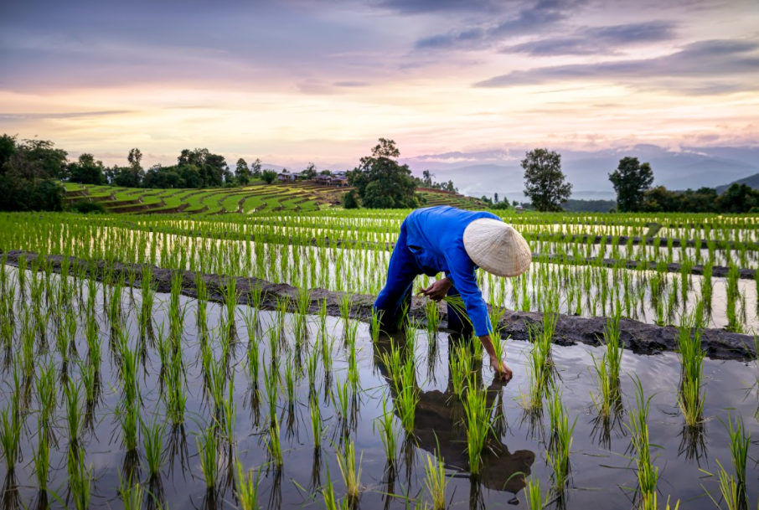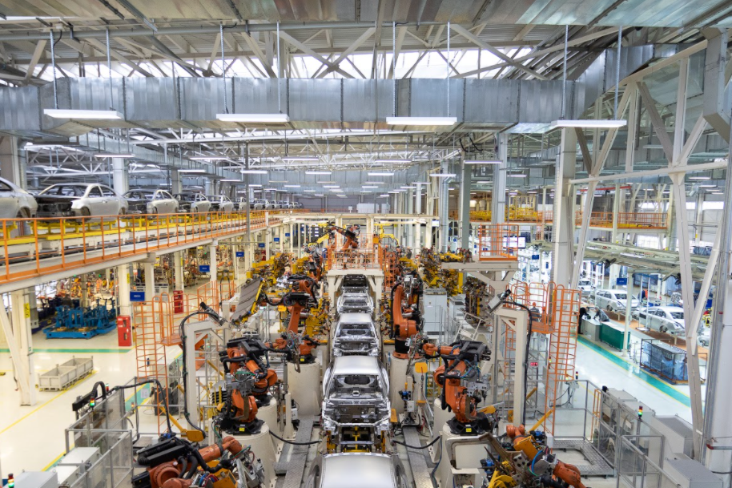

As industrialization has diffused across much of the world, the focus of the economies of countries has shifted.
- Identify the economic sector typified by each activity.
- Compare the role of cities in activity A and activity B.
- Describe ONE cause of industrialization in semi peripheral countries.
- Explain ONE positive impact of industrialization.
- Explain ONE negative impact of industrialization.
- Describe how the sectoral structure of an economy changes as it reaches a higher level of economic development.
- Explain the limitations of using Gross Domestic Product per capita as the measure of development.

Day 3 FRQ Assessment Teacher Key

*Teachers can use this Key to guide assessment and student peer assessment.

As industrialization has diffused across much of the world, the focus of the economies of countries has shifted.

A) Identify the economic sector typified by each activity.
Activity A- Primary
Activity B- Secondary
Students must correctly identify both sectors for 1 point

B) Compare the role of cities in activity A and activity B.
Cities are more associated with activity B because factories are typically located just outside cities (near cities) whereas activity A is likely to occur in rural areas (far away from cities).
Note: students must have a comparison so they must discuss the role of cities (or lack of) for both Activity A and Activity B.

C) Describe ONE cause of industrialization in semi peripheral countries.
Connections with transportation networks or proximity to markets- to allow the shipping out of goods for consumption in the core
Abundant labor supply and/or low cost labor or government policies (tax incentives, business-friendly regulations, etc)- to allow companies to have a higher profit margin or to sell

D) Explain ONE positive impact of industrialization.
Improvements in standards of living as reflected in increased
- Incomes
- GDP per capita
- GNI per capita
- education (literacy rates in general and/or female literacy rates)
- infrastructure development
- Income equality
- Access to healthcare (more physicians, lower Infant Mortality Rate, etc.)
- Life expectancies

E) Explain ONE negative impact of industrialization.
Uneven development
- Gaps between rural and urban areas
- Isolated industrial areas
- Focus on industrial areas
Pollution
- Factories using fossil fuels
- Increased use of automobiles

F) Describe how the sectoral structure of an economy changes as it reaches a higher level of economic development.
The economy shifts from primary to secondary as industrialization occurs.
The economy shifts from secondary to tertiary as deindustrialization occurs.
The economy shifts from tertiary to quaternary as services become more advanced.
Note: students must have what the economy shifts from and to since they are describing a change.

G) Explain the limitations of using Gross Domestic Product per capita as the measure of development.
- High GDP does not necessarily mean that other measures of development are high. (weakness of using one measure)
- Looking at GDP ignores social or quality of life measures such as health measures, treatment of women, happiness, etc.
- GDP per capita looks at total GDP divided by population and implies that is the typical experience when there may be high degrees of economic inequality
- GDP per capita includes everything produces in the country which could result in overstatement if there are many foreign companies operating within the country or understatement if the country has many companies producing goods outside the boundaries of the country

