South Korea: Then and Now
AUTHOR INFORMATION
Author: Rachel K. Turner
State: Texas
GENERAL INFORMATION
Lesson Grade Span: Elementary (3-5)
Targeted Grade Level/Course: Social Studies
Estimated Time to Complete Lesson: 1 day (approximately 50 minutes)
FOCUSED QUESTION(S)
- How has South Korea changed since the Korean War?
- How has South Korea stayed the same since the Korean War?
- What inferences can be made regarding life in South Korea before, during and after the Korean War?
STANDARDS (STATE/C3)
D2.His.2.3-5 - Compare life in specific historical time periods to life today.

D2.His.10.3-5. - Compare information provided by different historical sources about the past.
STUDENT & TARGET OUTCOMES
- The students will compare life in South Korean during and after the Korean War.
- The students will compare a variety of sources regarding life in South Korea during and after the Korean War.
- The students will generate inferences regarding what life in South Korea was like during the Korean War as well as life after the war.
LESSON OVERVIEW
In this lesson, students will be introduced to the country of South Korea and how it has changed over time. Students will be exposed to a variety of primary source photographs around 6 different themes (City of Seoul, Children & Schools, Businesses, Transportation, The Han River and Homes) that depict South Korea before the Korean War, during the war and modern day. Students will work in groups to compare and contrast what is happening in each of the sources.

ALL RIGHTS RESERVED WHDE

PROCEDURES
Materials Needed: Comparison charts (1 set for each group), station sources, introductory poster, pencils, projector, computer, exit ticket, document camera, timer

Prior Knowledge: Behaviors: Students should know how to work in a group cooperatively, students should understand how to analyze a photo, students should know how to ask and answer teacher facilitated questions.

Knowledge: Students should have an understanding that there are many countries that make up the world, students should know that war means to fight, students should understand the concept of past, present and future

Introduction: To engage the students in the lesson, show the introductory posters on the screen. Show page 1 and ask students what they have in common. Allow time for a variety of students to share their thinking. Ask how they are different and allow student response. Next show page 2 and ask students what they have in common and what is different about them? After allowing students to answer, tell students that another thing ALL these items have in common is that they are businesses that were created in South Korea. Explain that South Korea is a country far away that has had a unique history. Tell students that South Korea is our very good friend and we have tried to help them as much as they can. Tell students that in the past South Korea went through a very harsh war. Explain the objective of today’s lesson will be comparing and contrasting primary source photos that depict South Korea before their war, during their war, and today (over 60 years after their war).

Procedure: Split the students into 5 equal groups. Explain that each group will be starting at a different station number. Tell them at their station will be 3-4 photos. As a group, they will work together to analyze their photos and find things they have in common and things that are different about them. As a group, they will fill out a venn diagram from the comparison chart packet for EACH station. They will have about 8 minutes at each station to write down as much as they can. When it is time to switch, the timer will go off and they will move to their next station. Send students to their stations. Tell students that to get them started, you will be doing the first station together. Show the first station photos on the board. Have students share out some things they notice that are similar and different. As students mention different items, fill in a teacher version on the screen or on the board to model for students what to write on their chart. After finding a few similarities and differences, instruct students to begin their analysis of the station they are currently positioned at.

Evaluation and Closing: After the students have had time at each of the stations, come back together as a class for a discussion. Ask students to share 1 or 2 things they noticed from each of the different stations. After they have had a chance to share some of the things they found, tell students that as they get older they will be learning more about our good friends from South Korea. Remind students that when we want to know about a topic, it is always

ALL RIGHTS RESERVED WHDE

important to remember primary sources because they show what was happening during that particular moment in time. To get a better gage of what students learned, hand out the exit ticket. Give students 10 minutes to write down their answers in as much detail as possible.
FORMATIVE ASSESSMENT
Students will be assessed during the introduction by listening and responding to students answers. During the station activity, the teacher will monitor students and observe their behaviors and discussions as they analyze the station sources. Lastly, the exit ticket will allow the teacher to gain knowledge about what the students individually took away from the lesson. The exit ticket and checklist are attached.

RESOURCE LIST
https://soranews24.com/2014/03/05/35-fascinating-photos-of-korea-from-100-years-ago-before-k-dramas- took-over-asia/

http://www.hankk2kab.net/korea.html https://www.stripes.com/children-in-seoul-1953-1.416401 https://calisphere.org/item/e8ae59b8e06c9ae5e36e7f22eb404b44/ http://english.hani.co.kr/arti/english_edition/e_national/856757.html http://www.korea.net/NewsFocus/Society/view?articleId=100532
https://www.alamy.com/anniversary-of-the-2007-inter-korean-summit-oct-4-2018-south-korean-unification- minister-cho-myoung-gyon-l-ruling-democratic-party-leader-lee-hae-chan-front-r-late-south-korean- president-roh-moo-hyuns-son-roh-geon-ho-3rd-l-and-other-south-korean-officials-leave-for-north- korea-at-the-seoul-air-base-in-seongnam-south-of-seoul-south-korea-in-this-picture-taken-by-joint- press-corps-pyeongyang-and-handouted-by-the-south-korean-ministry-of-unification-a-group-of- south-korean-government-officials-politicians-and-civic-and-religious-leaders-arrived-in-pyongyang-on- thursday-to-partici-image221230966.html
https://www.alamy.com/seoul-south-korea-march-6-2018-seoul-city-and-yanghwa-bridge-at-han-river- image177719371.html
https://www.insidethegames.biz/articles/1056218/south-korea-hopes-pyeongchang-2018-will-lead-to-tourism- boom-following-china-boycott
https://depositphotos.com/201715106/stock-photo-seoul-south-korea-march-2018.html

ALL RIGHTS RESERVED WHDE

http://www.nysba.org/seoul2018/

https://www.japantimes.co.jp/news/2013/09/17/asia-pacific/social-issues-asia-pacific/after-decades-of- growth-south-korea-is-now-a-land-full-of-apartments/
http://www.koreatimes.co.kr/www/nation/2018/09/721_255548.html https://history.army.mil/photos/Korea/kwengin/bridges.htm http://www.koreaherald.com/view.php?ud=20180925000067 https://www.lg.com/us/mobile
https://www.samsung.com/my/smartphones/galaxy-a6-sm-a600/SM-A600GZKDXME/ https://www.kia.com/us/en/home
https://www.hyundaiusa.com/
MODIFICATIONS & EXTENSIONS (OPTIONAL)
Modifications: The groups can be split based on skill levels in case some groups needed more help than others. Students could orally respond to the exit ticket.

Extensions: One way to extend this lesson would be to have students read about modern day Korea and see if they can come up with their own station sources to help students understand what life is like in South Korea today.

ALL RIGHTS RESERVED WHDE

What do these items have in common?

What about these?

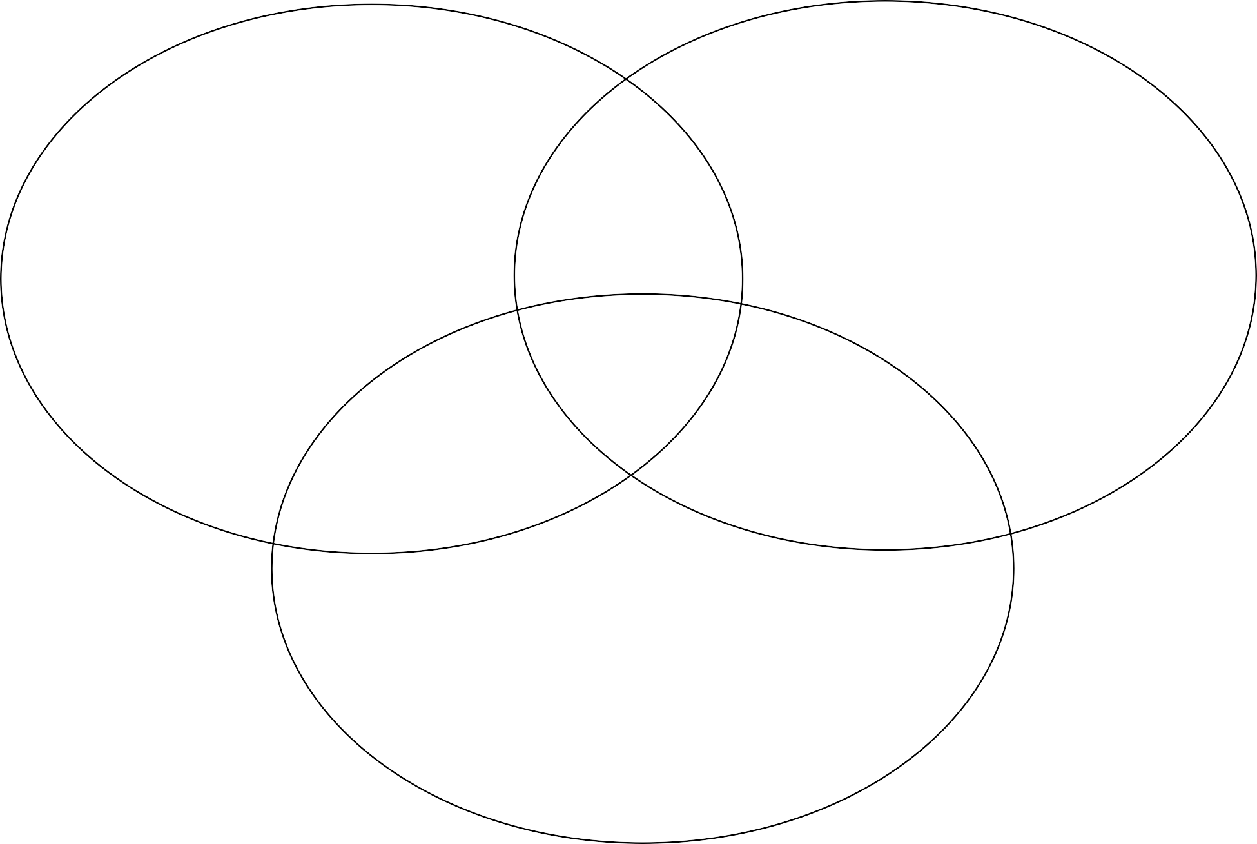Station #1: City of Seoul

Before the War During the War

Today

Station #2: Children & School

Before the War During the War

Today

Before the War During the War

Today

Before the War During the War

Today

Before the War During the War

Today

Station #6: Homes

Before the War During the War

Today

Before the War
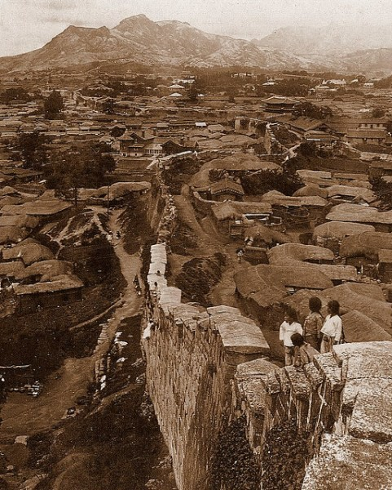

During the War

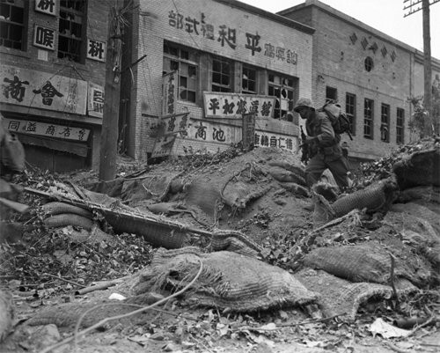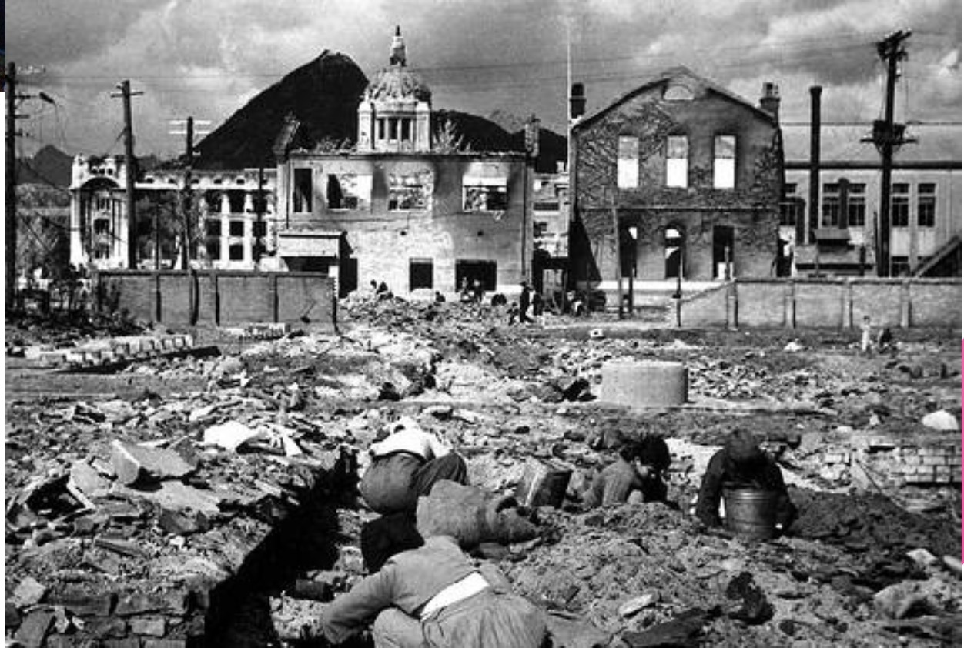

Today

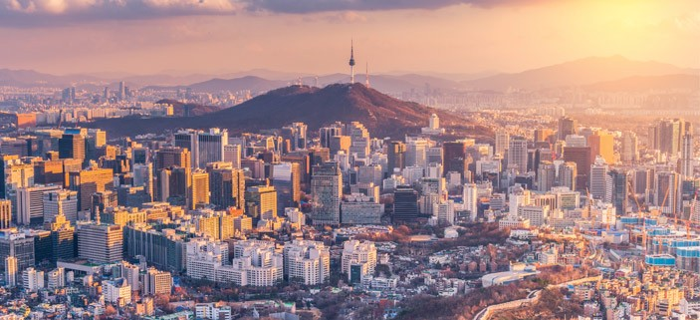

Before the War

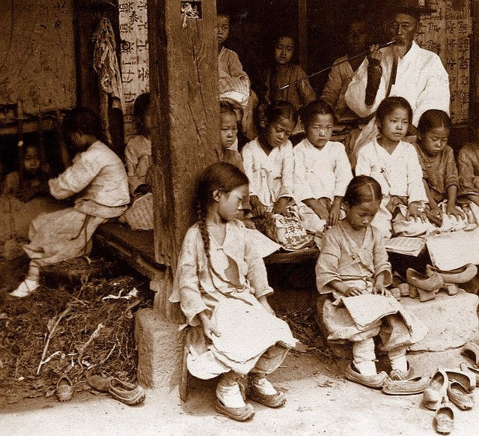

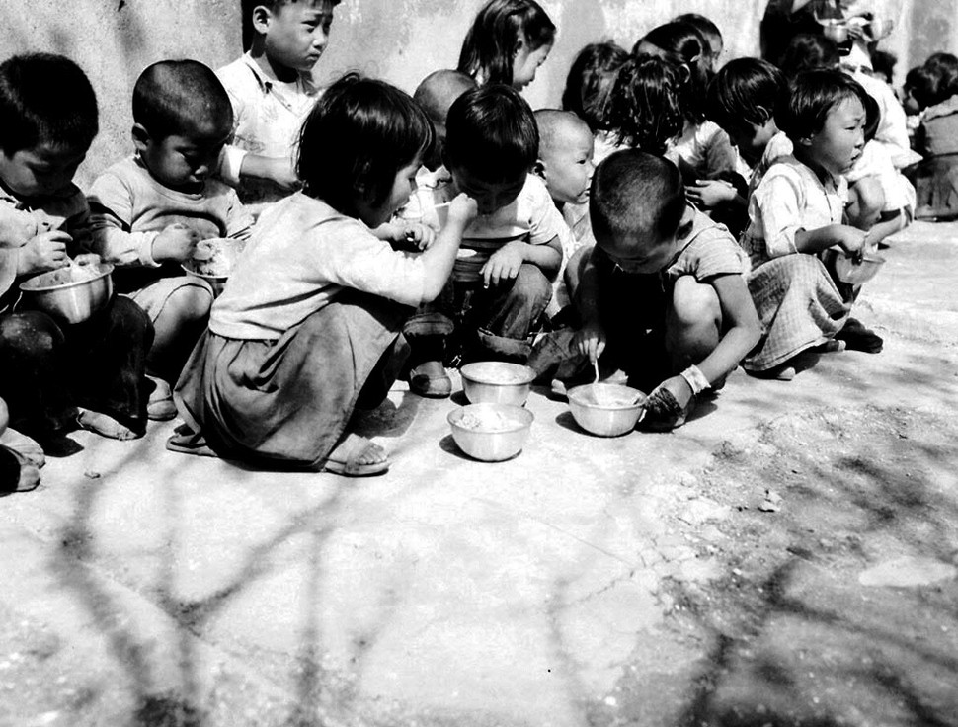
During the War

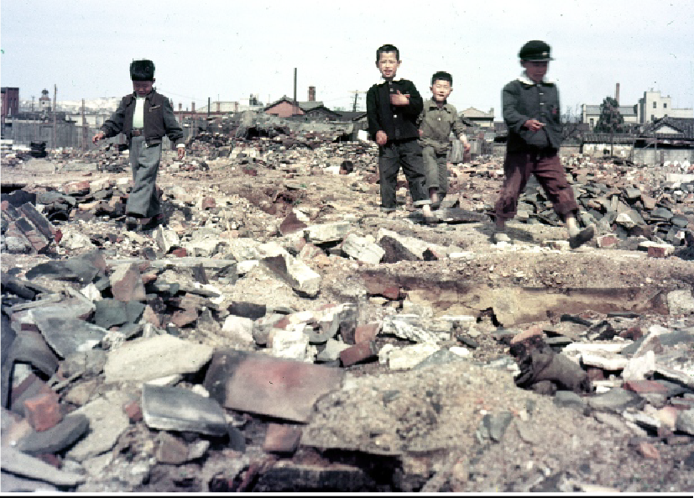

Today

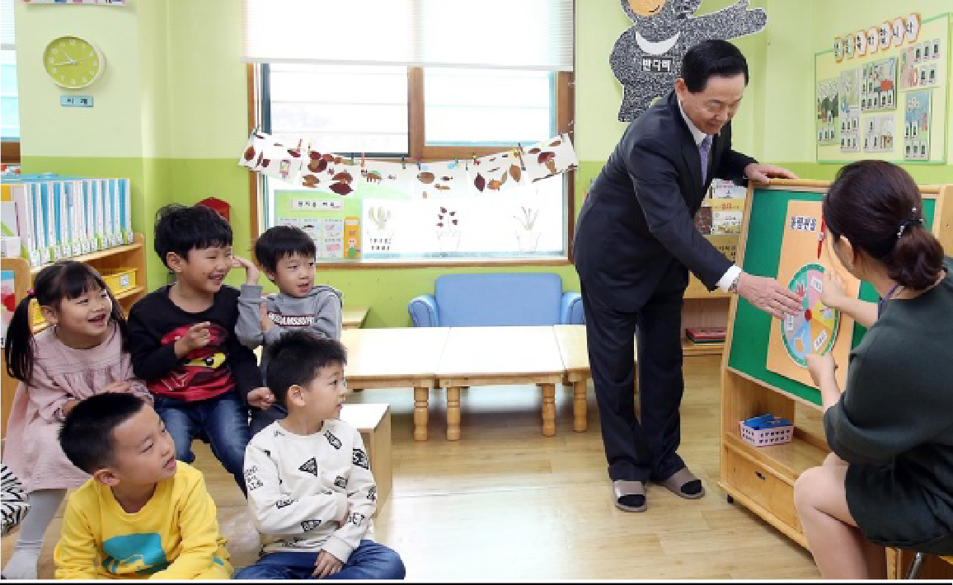

Before the War

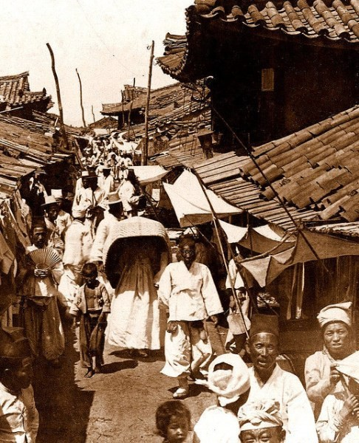

During the War

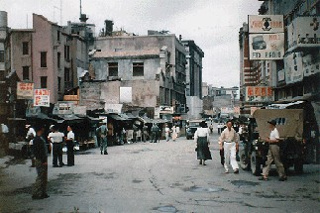

Today

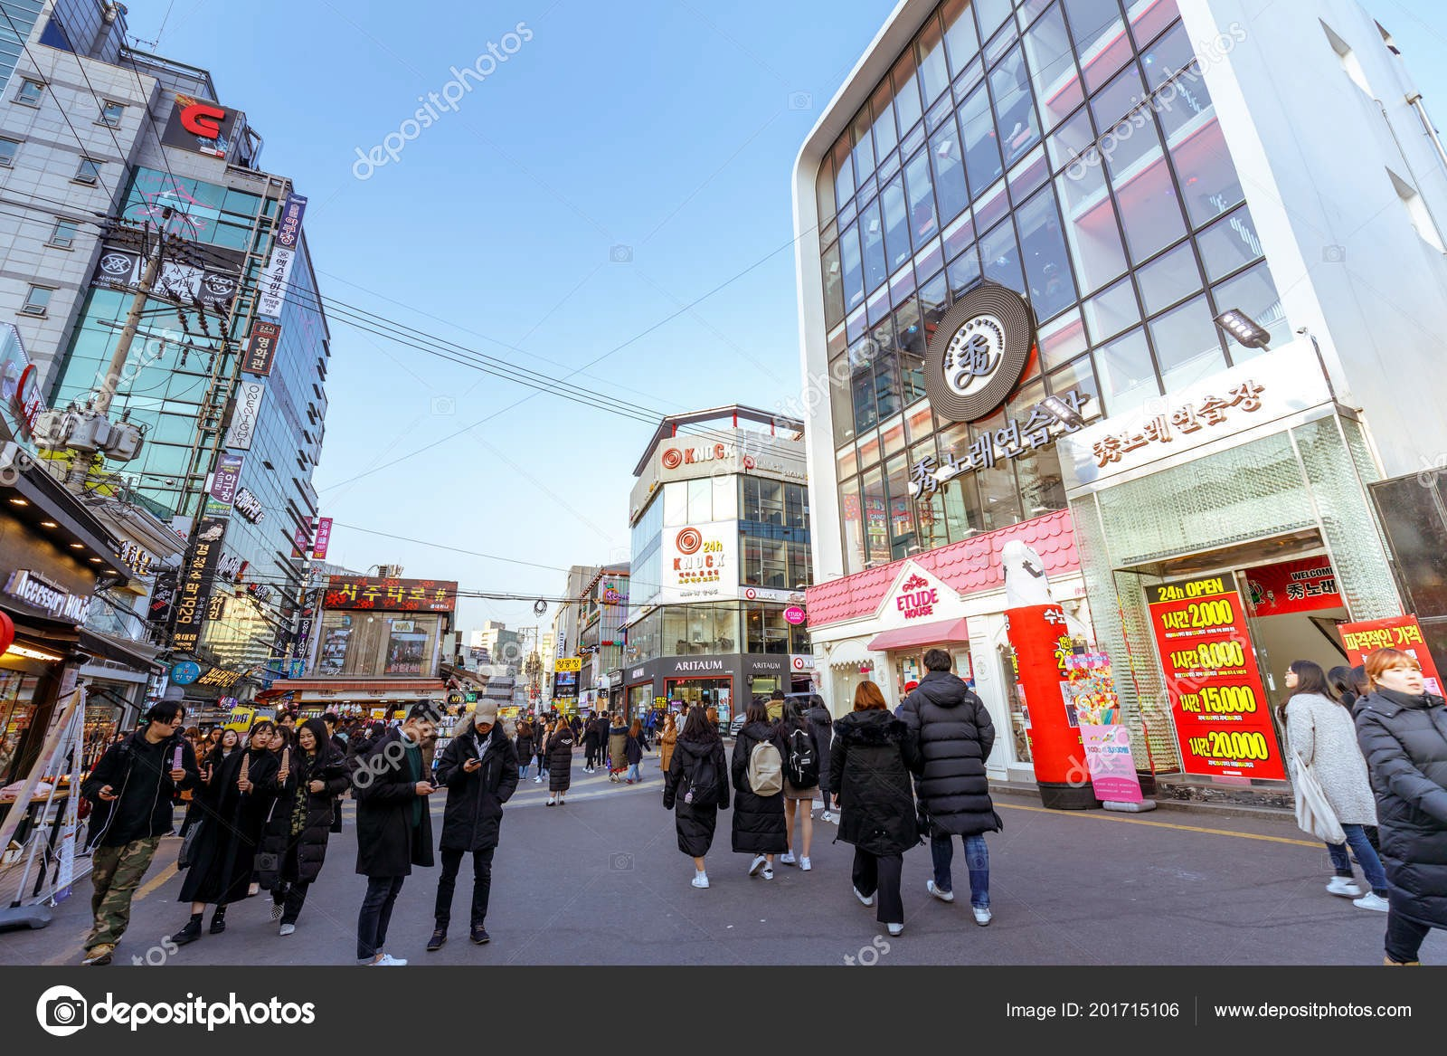

Before the War

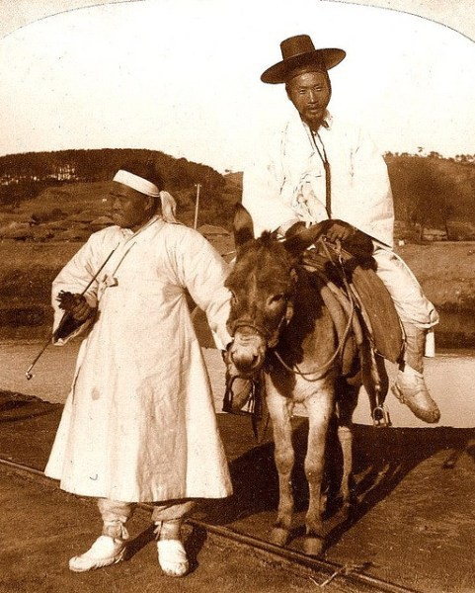

During the War

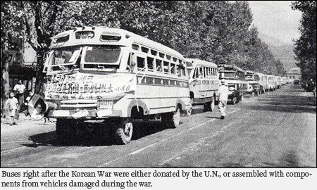

Today

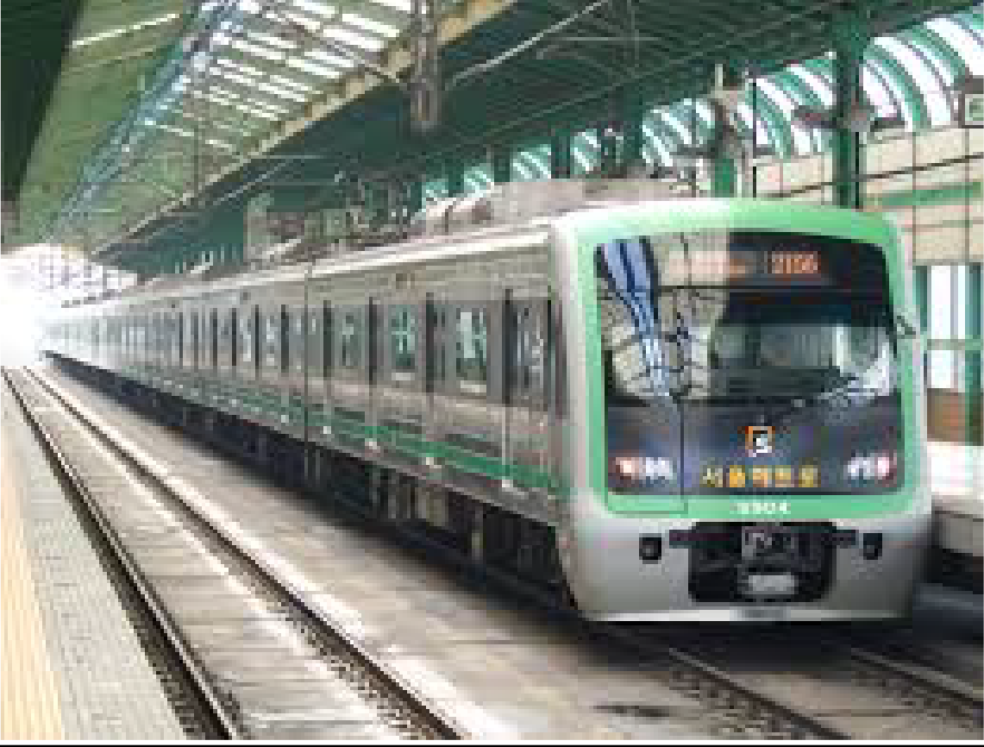

Before the War

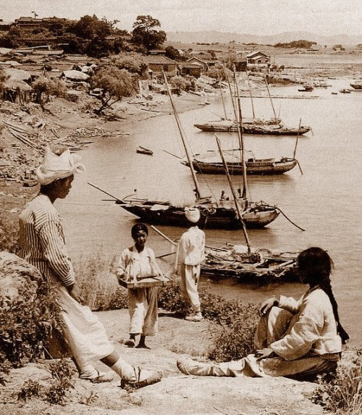

During the War

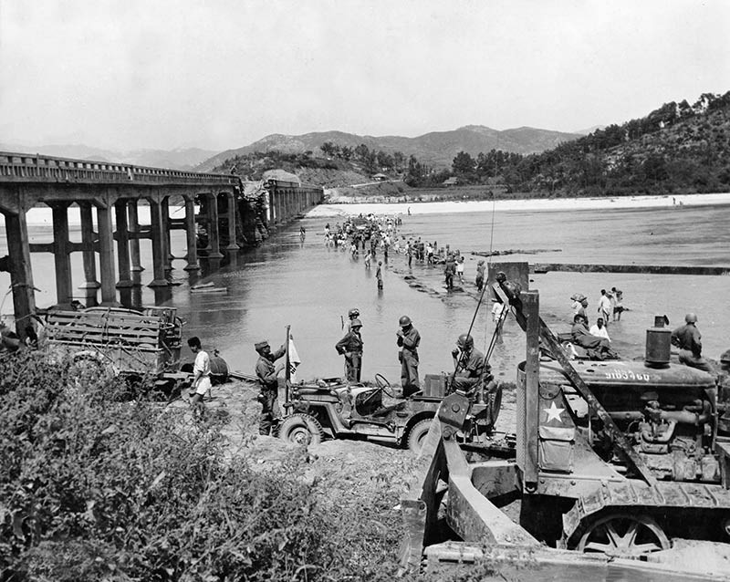

Today

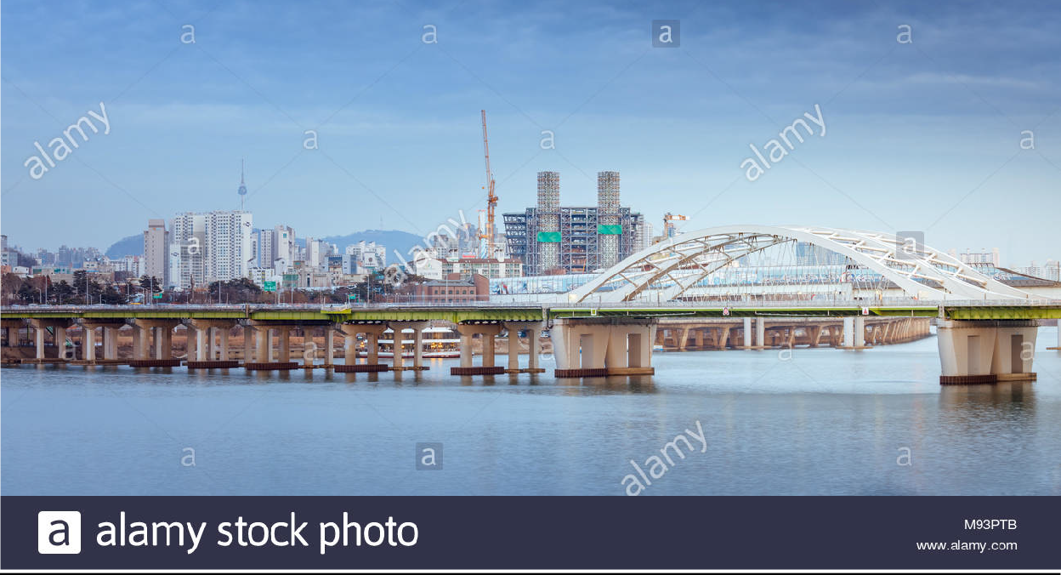

Before the War

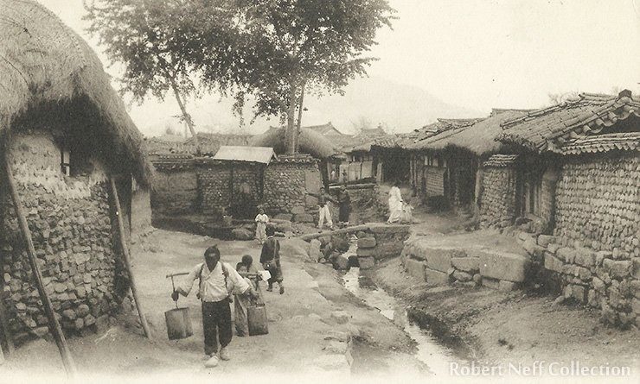

During the War

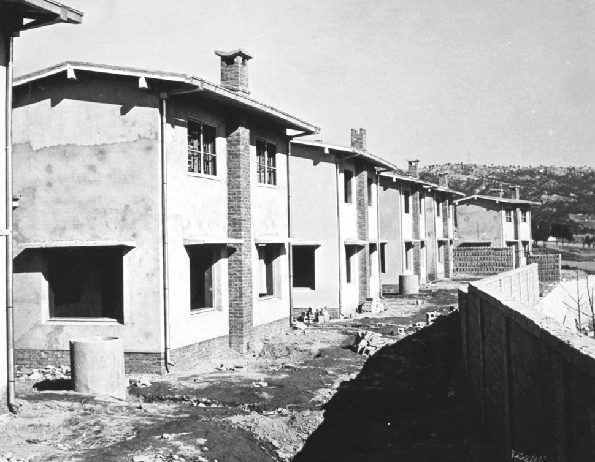

Today

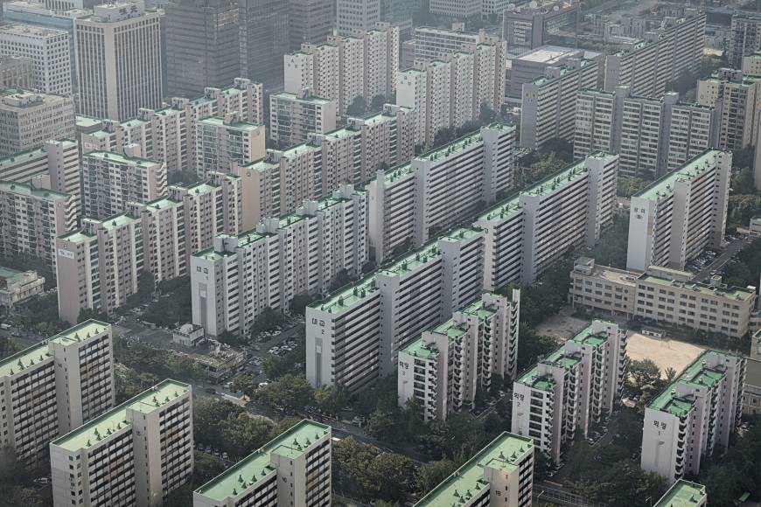

Exit Ticket

Three new facts I learned:
1. | 2. |  | 3.
Two things I enjoyed about the lesson:
1. |  | 2.
One question I have:
1.

Exit Ticket Checklist

Item | Ö or X | Points
3 facts I learned |  | 30
2 things I enjoyed |  | 20
1 Question I have |  | 10
Total | / 50

