Economic Development in the Korean Peninsula:
A Critical Analysis of the Trajectory of Two Economies Divided by War and Unified by History

AUTHOR INFORMATION

Author: Michelle Penyy
State: New York

GENERAL INFORMATION

Lesson Grade Span: Secondary 9-12
Targeted Grade Level/Course: 10-12 AP Macroeconomics or Senior Year Economics course
Estimated Time to Complete Lesson: AP Lessons: 2 days (possibly 3) Non-AP lesson 3-4 days

FOCUSED QUESTION

Compelling Question: How could a nation which was poorer than India in 1950 experience levels of economic growth making it the eleventh largest economy in the world while its genetically identical counterpart, North Korea, has stagnated for decades?

STANDARDS (STATE/C3)

C3 Standards:
D2.Eco.13.9-12. Explain why advancements in technology and investments in capital goods and human capital increase economic growth and standards of living.
D2.Eco.15.9-12. Explain how current globalization trends and policies affect economic growth, labor markets, rights of citizens, the environment, and resource and income distribution in different nations.
D2.Eco.12.9-12. Evaluate the selection of monetary and fiscal policies in a variety of economic conditions.

New York State Standards:
12.E4 THE TOOLS OF ECONOMIC POLICY IN A GLOBAL ECONOMY: Globalization and increased economic interdependence affect the United States economy significantly. The tools that the policy makers have available to address these issues are fiscal policy, monetary policy, and trade policy.

12.E4a Policy makers establish economic goals related to economic indicators, including the Gross National Product (GNP), Gross Domestic Product (GDP), Consumer Price Index (CPI), employment and interest rates, and aggregate supply and demand.

College Board:
Advanced Placement CED Topics 5.6 & 5.7 in Macroeconomics

STUDENT & TARGET OUTCOMES

Students will be able to identify the changes in the South Korean economy which have resulted in it becoming the eleventh largest economy.
Students will be able to categorize the causes of economic growth in South Korea.
Students will be able to juxtapose the standard of living between the two Koreas.
Students will be able to predict the effect of different fiscal policies on a multitude of markets in the AP SRAS model.
Students will be able to synthesize why the North Korean economy failed, while the South Korean economy has thrived.

LESSON OVERVIEW

Inquiry Lesson:
Students will be given the compelling question which will guide the entire inquiry. This lesson is a student driven lesson in which they will build their own understanding through the analysis of rich texts which depict the transformation in the South Korean economy, the causes for the economic growth, and a contrast with current status of the North Korean economy.

Advanced Placement Lessons:
Lesson 5.5 and 5.6 address curricular requirements in the Advanced Placement Macroeconomics curriculum. As opposed to teaching economic growth and the use of fiscal policies in a vacuum, real examples from South Korea’s economic growth are utilized to enhance student understanding of the curricula.

PROCEDURES

Inquiry Lesson:
Each lesson in the inquiry begins with a formative question which students will investigate that day.
Students will work individually on each anticipatory question and then engage in active inquiry through rich texts. The main learning activity for each day can be completed on their own or within groups. At the culmination of each lesson, students will reflect on what they have learned through a series of closing activities. These activities can be modified and be assigned as homework for time purposes.

Advanced Placement Lessons:
Lesson 5.5 starts with a warm up activity which students must answer on their own and then discuss as a group. Following this, the teacher will lead an interactive lecture in which the ingredients of growth are reviewed and then students complete a question for each ingredient. The formative assessment for the lesson is the homework in which students will utilize the information they have learned to apply within the AP standards.
Lesson 5.6 is a student-centered lesson in which they become economic investigators and analyze different governmental policies which took place in South Korea. Students will then participate in a fishbowl seminar as a formative assessment of their understanding of the material.

FORMATIVE ASSESSMENT

Inquiry Lesson:
Each lesson includes formative questions in which students must show their progress and understanding. At the conclusion of each day, there is a short assessment which requires students to summarize the lesson and reflect on their understanding of the material.
A summative assessment is included in the inquiry, which requires students to demonstrate their understanding of the material.

Advanced Placement Lessons:
Lesson 5.5 includes questions in which students must analyze the actions taken by the South Korean government and explain them with the use of graphs (SRAS/AD/LRAS, PPF, Phillips Curve).
The formative assessment for lesson 5.6 is the fishbowl seminar in which students must explain their understanding to argue the merits of different fiscal policies taken in South Korea.

RESOURCE LIST

Kang, Seoghoon. “Globalization and Income Inequality in Korea : An Overview.” OECD Development Centre, 2001, www.oecd.org/dev/2698445.pdf.

Demick, Barbara. Nothing to Envy: Love, Life and Death in North Korea. Fourth Estate, 2012.
Dong-chan, Jhoo. “Koreans Suffer Growing Tax Burden.” Koreatimes, 26 Aug. 2019, www.koreatimes.co.kr/www/biz/2019/08/367_274570.html.
D., Lankov. “Saemaul Undong Sets Model for Developing Countries.” Koreatimes, 16 Apr. 2010, www.koreatimes.co.kr/www/news/biz/2012/03/291_64301.html.
Hankuk University of Foreign Studies. “PUBLICATIONS - Detail : 2012 Modularization of Koreas Development Experience: Land Reform in Korea.” Other Research, 1 May 2013, www.kdi.re.kr/kdi_eng/publications/publication_view.jsp?pub_no=13338.

Harden, Blaine. Escape from Camp 14: One Man's Remarkable Odyssey from North Korea to Freedom in the West. Pan Books, 2015.

Jomo, K.S. “Growth with Equity in East Asia?” UN Department of Economic and Social Affairs (DESA) Working Papers, 2006, doi:10.18356/a3119d0f-en.
Jung, Min-ho. “A Fruit of the Minnesota Project.” Koreatimes, 29 May 2016, www.koreatimes.co.kr/www/culture/2018/08/641_205731.html.
Kim, Kwan. “THE KOREAN MIRACLE (1962-1980) REVISITED: MYTHS AND REALITIES IN STRATEGY AND DEVELOPMENT.” Kellogg Institute at the University of Notre Dame, 1991, kellogg.nd.edu/sites/default/files/old_files/documents/166_0.pdf.
“Nine Charts Which Tell You All You Need to Know about North Korea.” BBC News, BBC, 26 Sept. 2017, www.bbc.com/news/world-asia-41228181.

Rogers, Simon, and Mark McCormick. “South v North Korea: How Do the Two Countries Compare? Visualised.” The Guardian, Guardian News and Media, 8 Apr. 2013, www.theguardian.com/world/datablog/2013/apr/08/south-korea-v-north-korea-compared.
Santacreu, Ana Maria . “How Did South Korea's Economy Develop So Quickly?” St. Louis Fed, Federal Reserve Bank of St. Louis, 19 Mar. 2018, www.stlouisfed.org/on-the-economy/2018/march/how-south-korea-economy-develop-quickly.

MODIFICATIONS & EXTENSIONS

MODIFICATIONS
More scaffolding questions to help differentiate the lesson would be helpful. In addition, a vocabulary box could be included within each lesson to facilitate the understanding of the texts.

EXTENSIONS
Teachers may opt to create a project to civically engage students into taking informed action to help North Korean human rights groups.
In addition, a possible essay can be included as a summative assessment following the inquiry created for non-AP classes. For the AP lessons, a Free Response Question can be created in order to further the economic analysis.

An Inquiry: The Economies of North and South Korea- an in-depth look.
Compelling Question: Why is North Korea so different from South Korea?

Day 1: How did Korea become the eleventh largest economy?

Anticipatory Set: Examine the two sets of photos and answer the questions that follow:
Seoul Immediately after the Korean War:
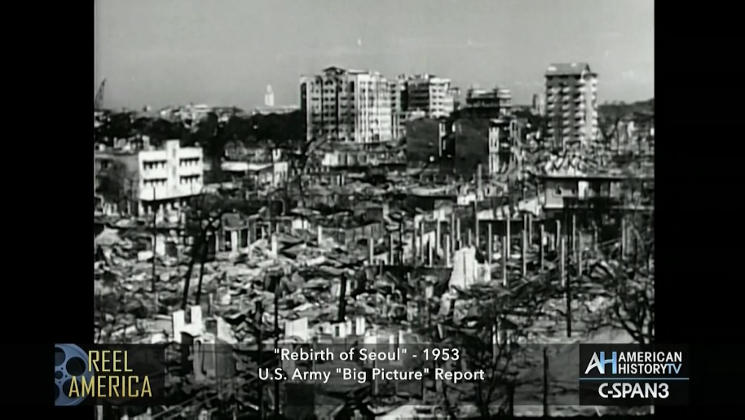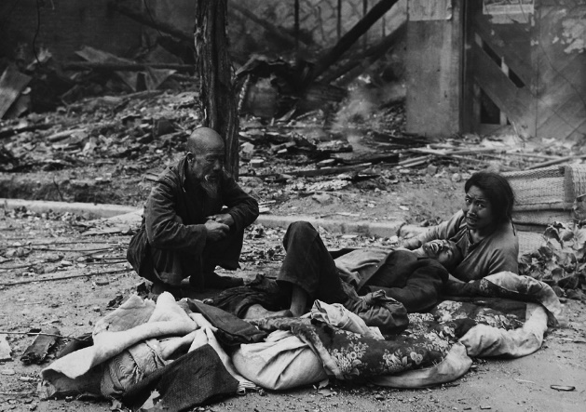
https://www.c-span.org/video/?440629-1/rebirth-seoul Koreans huddle in the street amid rubble and debris after fighting in Seoul, September 1950. (AP Photo/Max Desfor) #

Seoul Today
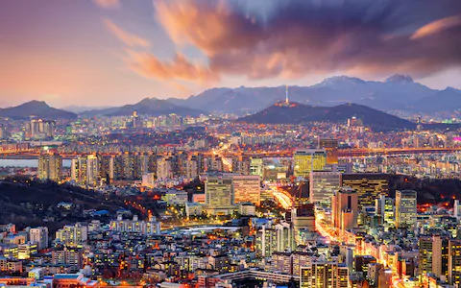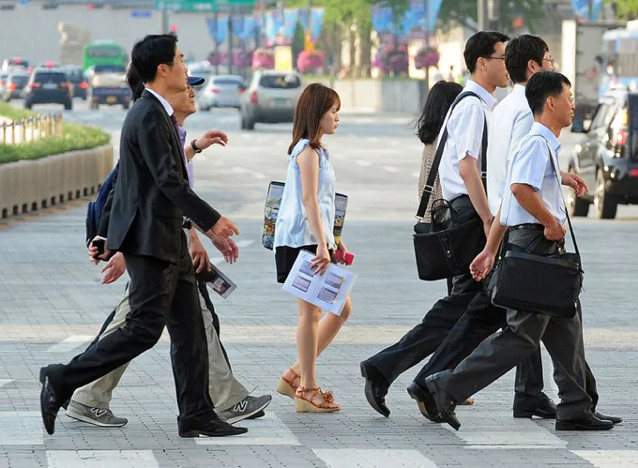
https://www.telegraph.co.uk/travel/galleries/The-worlds-best-city-skylines/skyline-seoul/ https://www.washingtonpost.com/news/worldviews/wp/2018/06/28/south-koreas-president-wants-people-to-work-less-and-have-more-children/
Describe the differences in images:
_________________________________________________________________ _________________________________________________________________ _________________________________________________________________
Using your knowledge of the factors that cause economic growth, predict how these changes occurred in one generation.
________________________________________________________________ ________________________________________________________________ ________________________________________________________________ ________________________________________________________________

Anticipatory Set Two (multimedia)

https://www.c-span.org/video/?440629-1/rebirth-seoul
Watch the video and answer the questions that follow:

1. Describe the conditions in Seoul after the war:
_________________________________________________________________________________
_________________________________________________________________________________ _________________________________________________________________________________ _________________________________________________________________________________ _________________________________________________________________________________
2. Describe the role the U.S. military played in Seoul’s rebirth immediately after the war
_________________________________________________________________________________ _________________________________________________________________________________ _________________________________________________________________________________ _________________________________________________________________________________ _________________________________________________________________________________ _________________________________________________________________________________

3. Now, visit the following website : http://www.pagef30.com/2009/04/seoul-in-1951-during-korean-war-vs.html which compares Seoul then and now and predict how the nation has developed so quickly.
_____________________________________________________________ _____________________________________________________________ _____________________________________________________________ _____________________________________________________________ _____________________________________________________________

Activity 1: Painting a picture: What do the economic indicators tell us about what life is like in South Korea?
Directions: Annotate each document and determine what each reveals about the economy and standard of living in South Korea.

Document 1
South Korea up to well into the 1960s truly represented a backward, desolate economy based on subsistence agriculture with all the difficulties facing a typical developing country today. The area is about the size of the state of Indiana, and unlike the northern part of the peninsula, South Korea (referred to hereafter as Korea) is poor in natural resources. Only about 30% of the land area is cultivable and the arable land per farm household ranks among the lowest in the world (currently less than a hectare). Korean society was traditional, feudalistic, agrarian, and isolated from the West until the late nineteenth century. Japanese colonial rule during the period 1910 to 1945 brought both exploitation and modernization, influencing the country’s future course of development. The small infrastructural base built during Japanese rule was mostly destroyed during the Korean War of 1950-53. The country’s per capita income in the early 1960s was lower than those of Haiti, Ethiopia, and Yemen and about 40% below India’s. With such a low-level income, domestic savings were negligible. The population growth of nearly 3% a year in an already densely populated country meant that the country had to depend on foreign aid for sheer survival. Unemployment, underemployment and poverty were widespread with over 40% of the nation’s population suffering from absolute poverty. If ever there was an economic basket case, Korea of the 1950s was it. Capitalism during the 1950s had done little for South Korea.
(kellog)

Document 2:
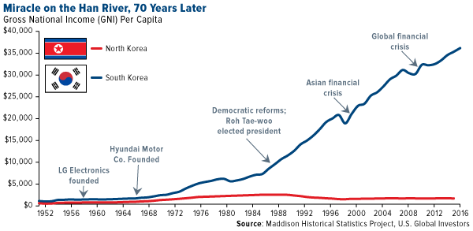
https://www.foreignaffairs.com/articles/south-korea/2013-12-06/six-markets-watch-south-korea
South Korea’s development over the last half century has been nothing short of spectacular. Fifty years ago, the country was poorer than Bolivia and Mozambique; today, it is richer than New Zealand and Spain, with a per capita income of almost $40,000.

Document 3
https://fred.stlouisfed.org/series/MKTGDPKRA646NWDB (interactive)
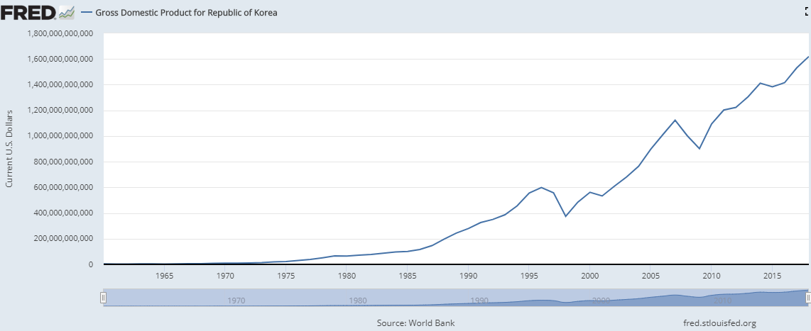

Document 4
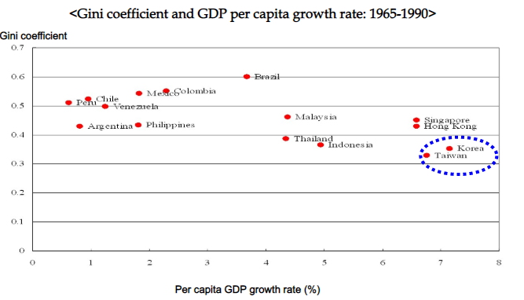

Document 5
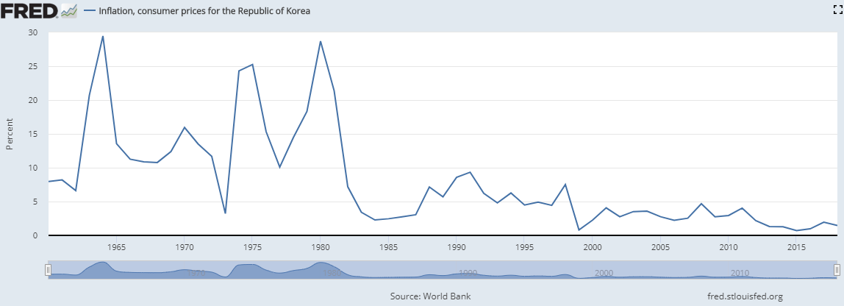
Document 6
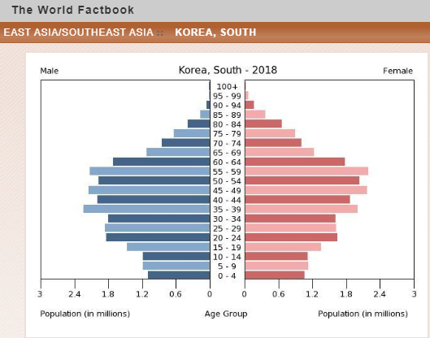

Document 7

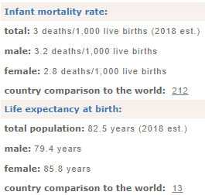

Document 8
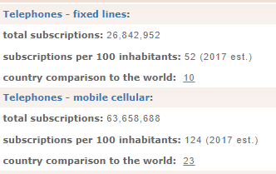
Document 9
Education levels in South Korea:
About 98% of Korean students finish secondary education
University is the traditional route pursued by South Korean students as it is by far the most prestigious form of higher education in South Korea. In 2004, nearly 90 percent of general high school graduates achieved university entrance. In 2017, over 68.9 of South Korean high school graduates advanced to a university

Document 10
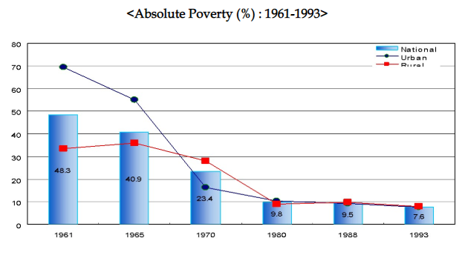

critical analysis
Based on the documents, describe the South Korean economy and standard of living.

Day 2: How did South Korea develop so quickly?

Anticipatory set:
Yesterday we explored the economy of South Korea and the way it has changed since the war ended. Write down your predictions as to how it was able to do this.
_________________________________________________________________________ _________________________________________________________________________ _________________________________________________________________________ _________________________________________________________________________

Directions: Analyze the following documents and answer the questions about each document.

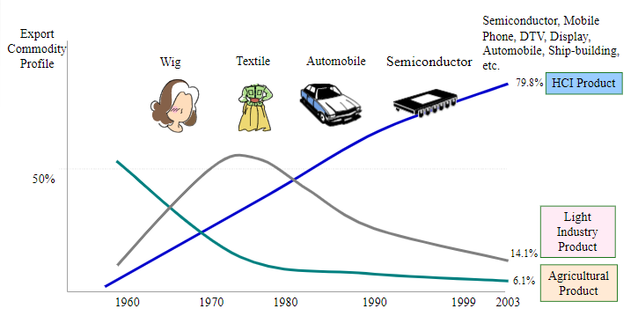

What information can you gather from the document?

How did this contribute to the economic development of the country?

The Land Reform Movement
Korea’s land reform was promoted as part of the U.S.’s anticommunism strategy for the occupied countries after World War II. In order to improve agricultural production and farm household economy under the circumstances where tenant-farming households accounted for 86% of the total farm households and tenant farming land ran to 64% of the total farmland at that time of liberation in 1945, it was certainly required to convert landlord oriented land ownership into independent farmer-oriented land ownership.
After Korea’s liberation, the U.S. Military Government had a significant effect on the Korean economy. In particular, the U.S. Military Government took the lead in Korea’s 1st land reform, implementing land reform aiming at Japan’s devolving properties. The 1st land reform was implemented at the instigation of the U.S. Military Government, whereas the 2nd land reform was carried out according to democratic procedures at the instigation of farmers. As a result, it is deemed that the land reform was successfully implemented. The results of land reform were not limited to the agricultural sector, since land reform had a decisive effect on Korea’s industrialization by promoting human capital development.
Q: How did land reform contribute to income equality in the country?

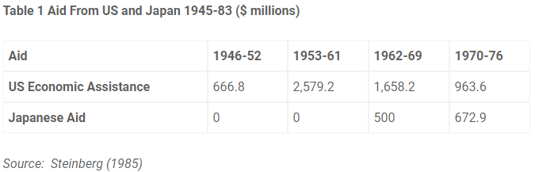
Why was foreign aid an important ingredient of South Korea’s economic growth?

General Park believed in capitalism. But, contrary to the modern day neoliberal economic orthodoxy, he also believed in state intervention and guidance. He had a series of five and six year plans. One was the New Village Movement.
Initially targeted toward underdeveloped rural areas, Saemaul Undong soon inspired various aspects of civic and cultural life throughout the nation. The cooperation of communities across the nation rallied around the movement and it became the driving force behind Korea's modernization and rapid economic development. The major idea was to modernize villages.

The Saemaul Undong is a village-based rural development program to escape from poverty. The Saemaul Undong spirit is based on diligence, self-help and cooperation amongst farmers who composed 60% of the population of Korea at that time.
His slogans of , “we can live well” and “we can do it”, instilled confidence in the farmers, which broke the cycle of self-defeating attitude of the farmers who had previously thought that poverty was their fate.
Saemaul Undong created 5 paradigm changes for the farmers. First, the focus of Korean farmers shifted from quantity to quality. Secondly, instead of focusing on size of farms, farmers started considering environmentally safe agriculture. Third, Korean farming shifted from high input production to low input, sustainable production by reducing labor intensive practices and increasing mechanization. Fourth, instead of producing what the farmers wanted, famers started to produce what the consumers wanted. Lastly, Korean farmers evolved business practices which allowed them to get an income from byproducts like tourism, camping and training rather than only agricultural products.
The main policy strategies were based on incentive-oriented government support and the Saemaul leaders of both genders. Incentive-oriented support strategy was implemented by providing some cement and iron rods to villagers, free of cost. Villagers who used the materials in a productive, efficient way were rewarded with additional free materials to implement more projects.
Saemaul Undong was also a big step for women’s movement in Korea. There were a large number of women among the many legendary leaders of Saemaul Undong. After the start of this movement women gained a new voice. They asked their husbands to stop drinking and gambling during the non-farming season, in winter.

Q: How did the New Village movement change Korean life?

Much of the foreign aid was utilized for capital investment. For instance, much of the reparations from Japan were used to build POSCO, a steel mill. POSCO was launched on April 1, 1968 with a mission for national industrialization.
As the first integrated steel mill in Korea, Posco has grown to produce 41 million tons of crude steel a year, and has grown to become a global business with production and sales in 53 countries in the world.
POSCO has continued to contribute to the development of mankind through endless innovation and developments in technology, and has become the most competitive steel maker in the world.

Q: How did developing a steel industry help South Korea develop?

The Minnesota Project
To help Korea improve its medical infrastructure, the University of Minnesota sent experts in different medical fields to Seoul National University (SNU) from 1955 to 1961 as part of the Minnesota Project. Sponsored by the U.S. government, the project aimed to help the nation stand on its own feet by improving its medical, engineering and agricultural infrastructures. Some of the Korean scholars of the Minnesota Project eventually settled in the U.S., while others returned to Korea to improve the nation's medical infrastructure and train other medical professionals.

Q: Why was the Minnesota Project an important tool for development?

Education, Education, Education!
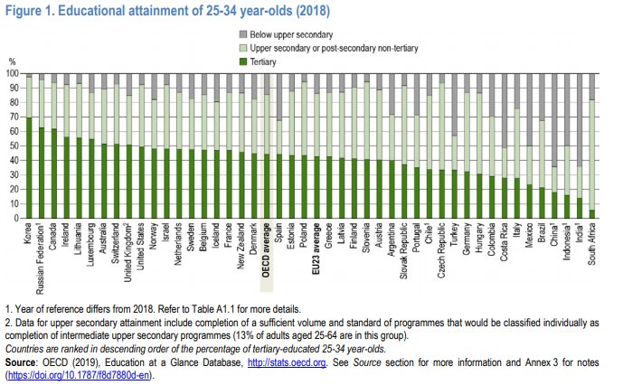
During the Korean War, compulsory primary education was included in the Korean Constitution. Along with their strong belief in the family and cultural traditions, Koreans value education and are willing to make significant personal sacrifices to ensure that their children are afforded the best available learning opportunities. No nation has a higher degree of enthusiasm for education than Korea, and nowhere are children more pressured to study.

Q: How does the education of the people of South Korea contribute to its economic development?

Quick Write:
Assessment: Should this be a model for other developing nations? Why or Why not? EXPLAIN

Day 3: Has North Korea developed or regressed?

Anticipatory Set:

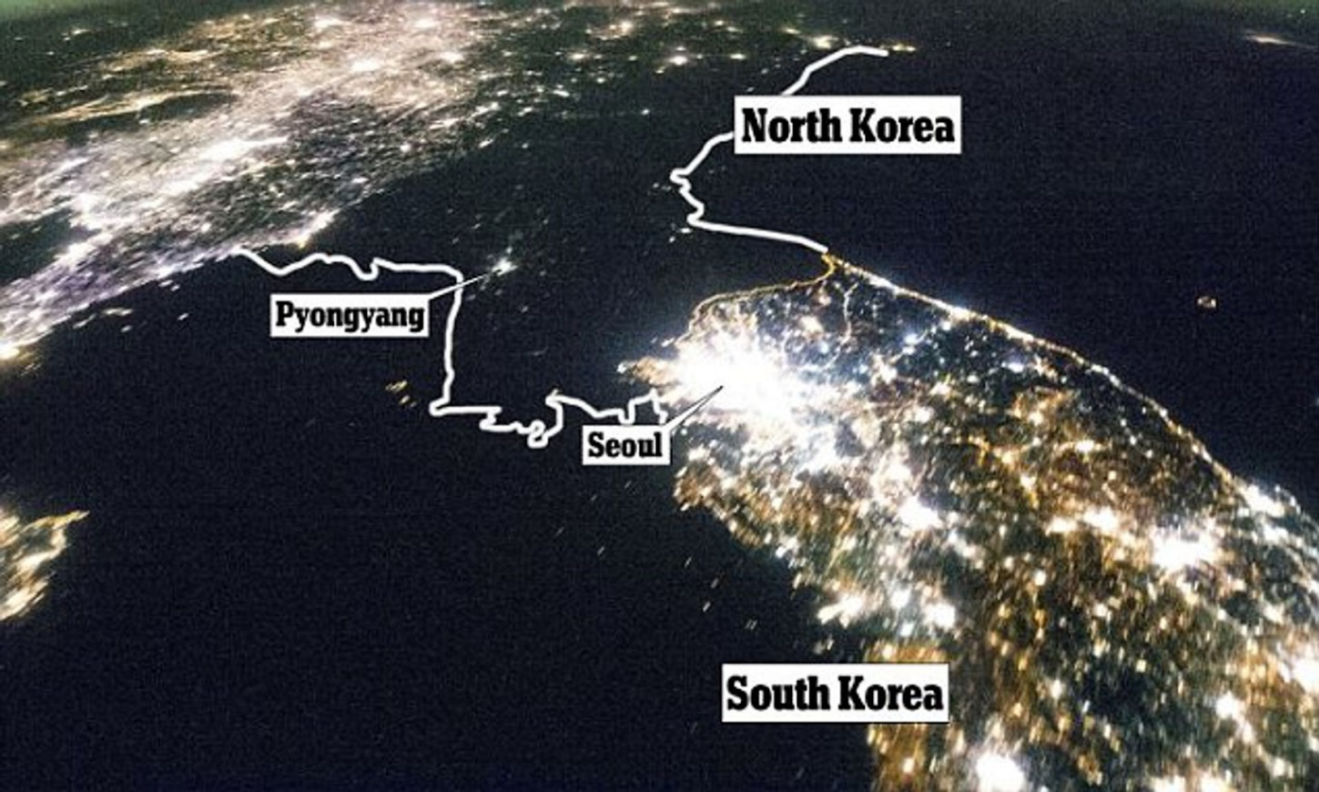

“When outsiders stare into the void that is today’s North Korea, they think of remote villages of Africa or Southeast Asia where the civilizing hand of electricity has not yet reached. But North Korea is not an undeveloped country; it is a country that has fallen out of the developed world. You can see the evidence of what once was and what has been lost dangling overhead alongside any major North Korean road — the skeletal wires of the rusted electrical grid that once covered the entire country.”
Looking at the satellite photo and the text, what conclusions can be made about the infrastructure of North Korea
______________________________________________________________________________________________ ______________________________________________________________________________________________ ______________________________________________________________________________________________
What questions do you have about North Korea?
______________________________________________________________________________________________ ______________________________________________________________________________________________ ______________________________________________________________________________________________

Today’s Inquiry: What is Going on in North Korea?
Today you will examine documents and artifacts to inform you about the economy and living standard in North Korea.
Directions: Next to each document, write down a deduction that can be made from the information provided!

Document What conclusions can you infer from the Document
Every year North Korea needs to produce more than five million tons of rice and cereal grain to feed its twenty-three million people. Nearly every year it falls short, usually by about a million tons. With long winters and high mountains, the country lacks arable land, denies incentives to farmers, and cannot afford fuel or modern farm equipment.
It squeaked by without a food catastrophe thanks to subsidies from Moscow. When the Soviet Union collapsed, the subsidies ended, and North Korea’s centrally planned economy stopped functioning. There was no free fuel for its aging factories, no guaranteed market for its often-shoddy goods, and no access to cheap, Soviet-made chemical fertilizer on which state farms had become dependent.
The masses were told to make toibee, a fertilizer in which ash is mixed with human excrement. In recent winters, frozen human waste has been chipped out of public toilets in cities and towns across the country. Factories, public enterprises, and neighborhoods have been ordered to produce two tons of toibee. (Escape from Camp 14)

Document What conclusions can you infer from the Document
The “eating problem,” as it’s often called in North Korea, is not confined to labor camps. It has stunted the bodies of millions across the country. Teenage boys fleeing the North in the past decade are on average five inches shorter and weigh twenty-five pounds less than boys growing up in South Korea. Mental retardation caused by early childhood malnutrition disqualifies about a quarter of potential military conscripts in North Korea, according to the National intelligence Council, a search institution that is part of the U.S. intelligence community. Its report said hunger-caused intellectual disabilities among the young were likely to cripple economic growth even if the country opened to the outside world or united with the South. Since the 1990s, North Korea has been unable to grow, buy or deliver enough food to feed its population. Famine in the mid-1990s killed perhaps a million North Koreans. (Escape from Camp 14)

Document What conclusions can you infer from the Document
Rule of Law
Almost all property belongs to the state. Government control extends even to chattel property. No functioning judiciary exists, and the rule of law is weak. Corruption and bribery are rampant throughout the government, and state institutions are opaque. The ruling Workers’ Party, the Korean People’s Army, and members of the cabinet run all companies earning foreign exchange.
Source: Heritage Foundation

Document What conclusions can you infer from the Document
North Korea’s economic freedom score is 5.9, making it the least free of the 180 economies measured in the 2019 Index. Its overall score has increased by 0.1 point, with few indicators of economic freedom showing any change at all. North Korea is ranked last among the 43 countries in the Asia–Pacific region, and its overall score is the lowest in the Index.

Beset by chronic structural problems as one of the world’s most centrally commanded and least open economies, North Korea’s despotic military regime has tolerated modest development of markets and limited private entrepreneurship in order to boost government revenue. While certain industries are permitted to sell some of their output in the marketplace and seek private investment from the “new rich,” or donju, a middle class enriched from quasi-private enterprises, the country lacks even the most basic policy infrastructure of a free-market economy.
Source: Heritage Foundation

Document What conclusions can you infer from the Document
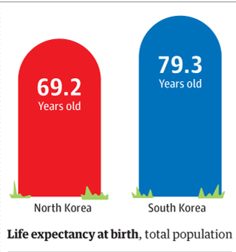

Document What conclusions can you infer from the Document
Government Size
The government commands almost every part of the economy and directs all significant economic activity. The military runs its own extensive underground economy, taking the bulk of scarce resources. No effective fiscal policy is in place. The state sets production levels for most products, and state-owned industries account for nearly all GDP. The impoverished population is heavily dependent on food rations and government housing subsidies.
Source: Heritage Foundation

Document What conclusions can you infer from the Document
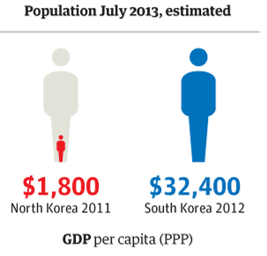 | Updated: South Korea is $39,500 Per Capita GDP

Document What conclusions can you infer from the Document
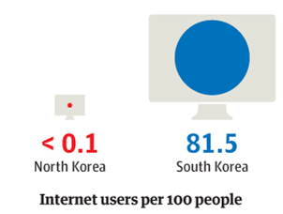

Document What conclusions can you infer from the Document
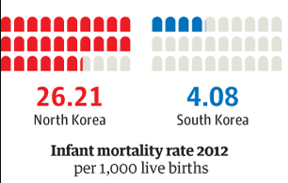
Document What conclusions can you infer from the Document
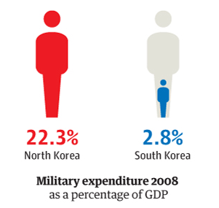

Document What conclusions can you infer from the Document
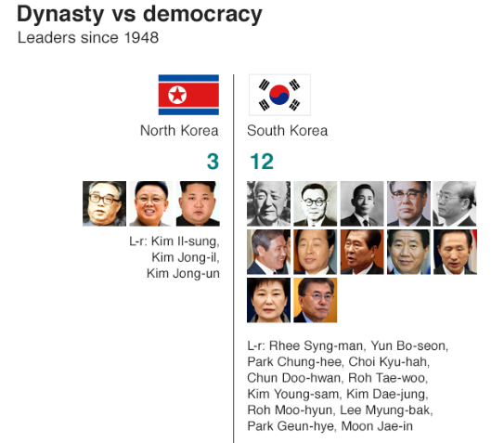source: BBC

Document What conclusions can you infer from the Document
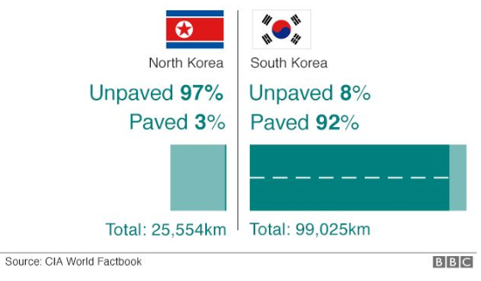

Document What conclusions can you infer from the Document
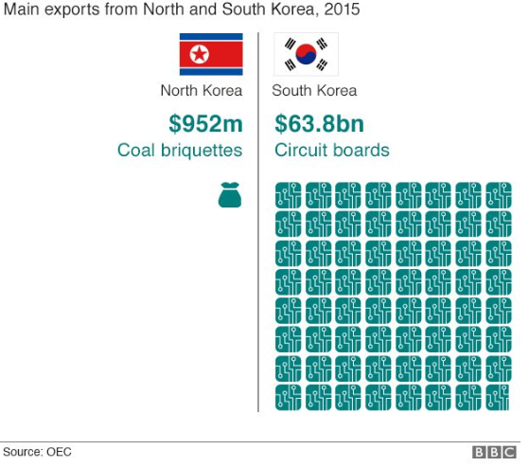

Document What conclusions can you infer from the Document
About the famine and financial crisis…
The North Korean government offered a variety of explanations, from the patently absurd to the barely plausible. People were told that their government was stockpiling food to feed the starving South Korean masses on the blessed day of reunification. They were told that the United States had instituted a blockade against North Korea that was keeping food out…. Enduring hunger became part of one’s patriotic duty. Billboards went up in Pyongyang touting the new slogan, “Let’s Eat Two Meals a Day.” North Korean television ran a documentary about a man whose stomach burst, it was claimed, from eating too much rice.
Nothing to Envy Page 69

Document What conclusions can you infer from the Document
Like every other communist country, North Korea had black markets. Although it was technically illegal to buy and sell most commodities privately, the rules changed frequently and were often ignored. In fact, proper Communists didn’t shop, period. Kim Il-sung hand created about as anti-consumerist a culture as could exist in the twentieth century. Elsewhere in Asia, markets teeming with human activity and merchandise abounded. Not in North Korea. The most famous department stores in the country were Pyongyang’s two department stores- Department Store No. 1 and Department Store No. 2, they were called- and their merchandise was about as exciting as their names. Visitors to Pyongyang in the 1990s reported that the stores sometimes put plastic fruit and vegetables on display for foreign window shoppers.
Nothing to Envy pg. 61-62

Document What conclusions can you infer from the Document
The North Korean regime didn’t publish economic statistics, at least none that could be trusted, and took great pains to deceive visitors and themselves. Supervisors routinely fabricated statistics on agricultural production and industrial output because they were fearful of telling their own bosses the truth. Lies were built upon lies, all the way to the top.
For all its arrogant rhetoric about juche and self-sufficiency, North Korea was utterly dependent on the kindness of its neighbors. The country got subsidized oil, rice, fertilizer, pharmaceuticals, industrial equipment, trucks and cars. X-ray machines and incubators came from Czechoslovakia; architects came from East Germany. Kim Il-sung skillfully played the Soviet Union and China against each other, using their rivalry to extract as much aid as possible.
Nothing to Envy pg. 65

Document What conclusions can you infer from the Document
Trusted and talented members of the elite are periodically allowed outside the country… and are involved in criminal enterprises that funnel hard currency to Pyongyang.
They have been linked to counterfeiting $100 bills, cyberterrorism, trafficking drugs, ranging from heroin to Viagra, and marketing high-quality brand name cigarettes. In violation of UN resolutions, North Koreans have also sold rockets and nuclear weapons to countries including Iran and Syria.
One defector, Kim Kwan Jin, was managing a state-run global insurance fraud. It collected hundreds of millions of dollars from some of the world’s largest insurance companies on falsified claims for industrial accidents and natural disasters inside North Korea. Most of the money was funneled to the Dear Leader.
Escape from Camp 14

Homework Assessment:
Based on today’s lesson, write a journal entry from the perspective of someone living in North Korea.

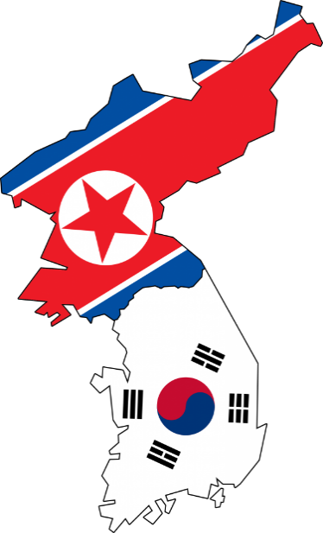
Summative Assessment
Economic Development: A tale of two Korea’s
Directions: Complete the Venn Diagram detailing the
economies of the two nations

AP Macroeconomics Date ____________________________
Unit 5 Economic Growth – Lesson 5 CED: Topic 5.6
Aim: What are the factors that result in economic growth?
Warm up: What is Real GDP? _________________________________________________________________ ___________________________________________________________________________
If Real GDP per capita measures the Real GDP per person, predict what the formula for this measure is:

Comparing Historic Growth in the U.S. and the Koreas
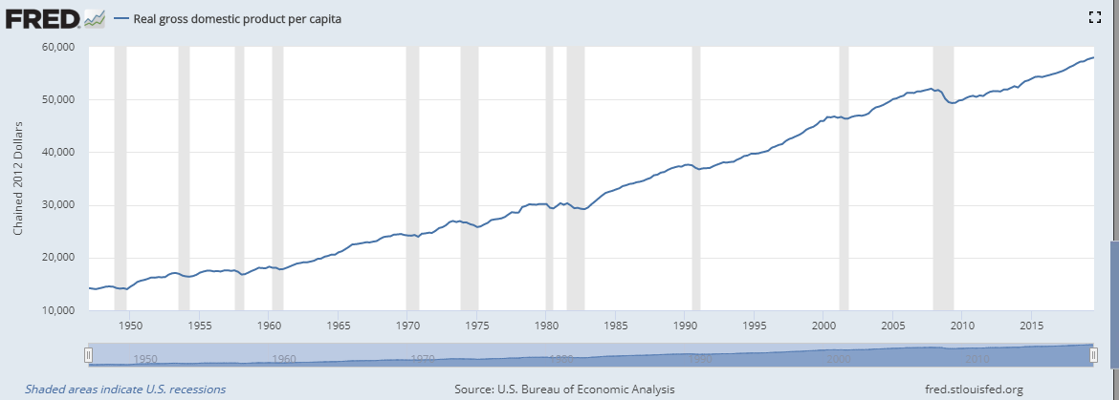
- Historical Growth in the US Vs. Korea
How has GDP per capita in the US changed since the 1950s?
___________________ ___________________ ___________________
What has been the percentage change in growth? ___________ ___________________

Compare and Contrast the rates of growth between the two Koreas _____________________ _____________________ _____________________ _____________________ _____________________ _____________________
What has been the rate of change for Per Capita GDP in each nation?

Based on these two graphs, what information can we gather about standard of living based on Real GDP per capita? ______________________________________________________________________________________
_____________________________________________________________________________________________ _____________________________________________________________________________________________
_____________________________________________________________________________________________

How is Economic Growth Depicted Graphically
Graphically  Represented three ways | PPF | LRAS | Phillips Curve
 | 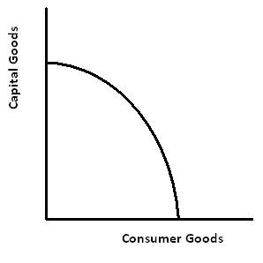 | 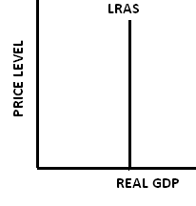

II. Incentives for Growth – variables that will shift the LRAS curve to the right PPF outward
Growth accounting focuses on three sources of long-run economic growth: supply of labor, supply of capital, and the level of technology.
Increases in any one of these elements will increase real GDP.
- The growth in the supply of labor is primarily the population growth rate (also can ____ retirement age or ______ immigration)
- Increases in capital or in technology increase labor productivity and thus increase real GDP.
- Productivity can increase because of an improvement in human capital: ____________________

III. Levers of Economic Growth in the Macro Model – ingredients that increase/ stimulate the economy (LRAS increases)
A. increasing savings – When the supply of Loanable Funds increases- interests rates decrease, investment increases and capital stock increases.
_________________________________________________________________________________________ _________________________________________________________________________________________
Example: From 1945 to 1976, Korea was the recipient of nearly US$13 billion of economic and military assistance, nearly all of it in grants, allocated under the willful hand of the US. Korea also benefited from Japanese economic cooperation funds, or colonial reparations, after relations between the two countries were normalized. Much of this aid was used for consumption within Korea, and beginning in the 1960s, it was used as the funds to build a steel mill which would eventually become a top ten producer of steel in the world.
Explain how the above example demonstrates an increase in capital stock _____________________________ __________________________________________________________________________________________ __________________________________________________________________________________________

B. Increasing government support for basic research will stimulate research and development. One way in which the government can stimulate growth is by giving research grants. Increasing research and development. ______________________________________________________________________________
Example: To help Korea improve its medical infrastructure, the University of Minnesota sent experts in different medical fields to Seoul National University (SNU) from 1955 to 1961 as part of the Minnesota Project. Sponsored by the U.S. government, the project aimed to help the nation stand on its own feet by improving its medical, engineering and agricultural infrastructures. Some of the Korean scholars of the Minnesota Project eventually settled in the U.S., while others returned to Korea to improve the nation's medical infrastructure and train other medical professionals.
Explain how the Minnesota Project contributed to the economic growth in Korea
_______________________________________________________________________________ _______________________________________________________________________________ _______________________________________________________________________________
C. Getting the most from comparative advantage by encouraging international trade this will stimulate growth throughout the world._______________________________________________________________________
Analyze the graph and make a conclusion about how Korea has changed its production. _________________________ _________________________ _________________________ _________________________ _________________________

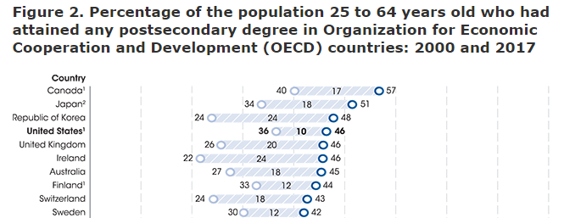
D. Improving the quality and capabilities of the labor force so workers can be more productive with a given level of capital and technology. Improving the quality of education is the primary tool used here. The United States has focuses on improving the quality of public education and using education IRAs provide incentives for people to obtain more education.
What conclusions can be drawn regarding the educational achievements in the Republic of Korea? ____________________ __________________________ __________________________ __________________________ __________________________

Macroeconomics Unit 5 lesson 5 homework Name ______________________________
Complete the following questions:
South Korea GDP per capita for 2018 was $31,363
South Korea GDP per capita for 2017 was $29,743
South Korea GDP per capita for 2016 was $27,608

1. Calculate the rate of change in per capita GDP between the following years: (You will need a calculator)
- 2016 and 2017
- 2017 and 2018
- 2017 and 2018

2. The following are rounded figures. Please complete the calculations below:
Year | Real GDP in South Korea  (in billions) | Population in South Korea | Real GDP in the US | Population in the US
1960 | $6 B | 20 million | $3200 B | 190 million
1970 | $20B | 25 million | $5000 B | 213 million
1980 | $90 B | 32 million | $6800 B | 240 million
1990 | $350 B | 43 million | $9500 B | 260 million
2000 | $850 B | 47 million | 13,000 B | 290 million
2010 | $1,500 | 50 million | 15,000 B | 308 million

- Calculate per capita GDP in 1960 of the US and Korea

- Calculate per capita GDP in 2010 of the US and Korea

- Calculate the rate of economic growth in Korea and US between 1960 and 2010

3. Based on the information from the lesson and the homework answer the following. Using the SRAS/AD/LRAS model, show the difference in growth rates between the US and Korea.
Make sure you complete the following:
a. Show the starting point of the Korean economy and label it PL1 YK1 and the full employment level of Korea in 1950 YFLK1.
b. Show where you believe Korea is now and label the equilibrium PL2 YK2 and the full employment level YFLK2

How Did South Korea’s Economy Develop So Quickly?
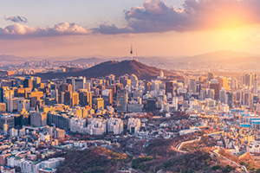
Thinkstock/Reabirdna
By Ana Maria Santacreu, Economist, and Heting Zhu, Senior Research Associate
South Korea has experienced one of the largest economic transformations of the past 60 years. It started as an agriculture-based economy in the 1960s,¹ and it became the 11th largest economy in the world in terms of gross domestic product (GDP) in 2016.² How did the industrialization miracle take place?

Factors in South Korea’s Economic Success
Many studies attribute South Korea’s structural transformation to policy reforms aimed at opening the country to foreign markets. Indeed, the export-oriented policies of South Korea are one of the most important factors of its success: South Korea is now one of the top 10 exporters in the world, and its exports as a percentage of GDP increased from 25.9 percent in 1995 to 56.3 percent in 2012.³
Two additional factors have contributed to the increase in international trade and industrialization in South Korea:
- An improvement in the business environment
- Policies incentivizing investment in innovation

Environment and Innovation
First, a strong business environment fosters growth in the domestic market and attracts foreign investors. According to the World Bank, South Korea is ranked No. 4 in terms of the overall Ease of Doing Business (DB) index in 2018, while the U.S. is ranked No. 6, as seen in the table below.⁴
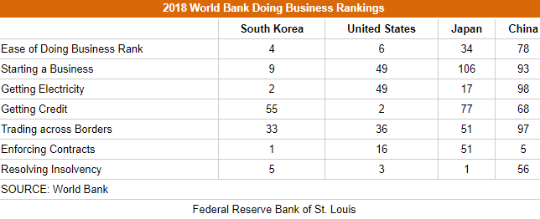
Among the list of criteria, South Korea dominates in the ease to start a business and enforcing contracts. All of them play a significant role in encouraging investment, production, communication and, eventually, economic growth.
Second, South Korea has devoted extra attention to technology development and innovation to promote growth. Innovation and technology are the key factors that have underpinned South Korean export competitiveness and fueled the country's remarkable economic rise over the past decades.⁵
In fact, South Korea is now spending the largest share of its GDP on research and development (R&D), even larger than the U.S. and Japan, two of the global leaders in innovation based on R&D intensity. Between 1996 and 2015, South Korea’s R&D intensity grew 88.5 percent (from 2.24 percent in 1996 to 4.23 percent in 2015), while the U.S.’s only grew 14.4 percent (from 2.44 percent in 1996 to 2.79 percent in 2015).

Challenges for South Korea
Even though South Korea has been successful at promoting exports, its business environment and innovation, challenges still remain, including many from China.
Chinese competition is one challenge. Policymakers in China have also been emphasizing the importance of high-skill manufacturing and exports. This could have a negative impact on South Korea as China has traditionally been a large importer of South Korean goods. China is also catching up fast in innovation. Its R&D intensity has been approaching the levels of the U.S. and Japan.⁶
Furthermore, given South Korea’s relatively limited geographical size, natural resources and population size, an aging population aggravates the threat that South Korea’s economy might fall behind its fellow developed countries.⁷
To maintain sustainable economic growth, South Korea needs to continue its support in innovation and a favorable business environment.
Read the article above and answer the questions that follow:
TASK: Select two factors that contributed to the growth of the Korean economy. Explain how they affected growth and depict the changes using two graphs from your studies (Investment demand curve, SRAS/AD, Phillips curve, Production Possibilities Frontier.

GRAPH Explanation of change

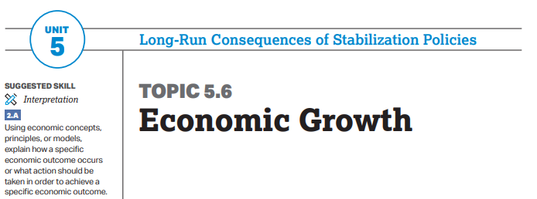
The economy fluctuates between periods of expansion and contraction in the short run, but economic growth can occur in the long run.
Learning objectives
a. Define measures and determinants of economic growth.
b. Explain (using graphs and data as appropriate) the determinants of economic growth.
c. Calculate (using graphs and data as appropriate) per capita GDP and economic growth.

Essential Knowledge
Economic growth can be measured as the growth rate in real GDP per capita over time.
MEA-2.B.2 Aggregate employment and aggregate output are directly related because firms need to employ more workers in order to produce more output, holding other factors constant. This is captured by the aggregate production function.
MEA-2.B.3 Output per employed worker is a measure of average labor productivity.
MEA-2.B.4 Productivity is determined by the level of technology and physical and human capital per worker.
MEA-2.B.5 The aggregate production function shows that output per capita is positively related to both physical and human capital per capita.

AP Macroeconomics Date ____________________________
Unit 5 Economic Growth – Lesson 6 CED: Topic 5.7
Aim: How can the government help or hinder economic growth and policies?
Warm up: Reviewing Fiscal and Monetary Policy: How can the government and central bank of a nation promote economic growth? Explain

When does a central bank or government hinder economic growth? Explain

Economic Investigators
Your task: Examine the following set of documents and determine how each would affect economic growth. There are multiple perspectives for each event as different markets can be affected in multifaceted ways. For example: government spending might mean more taxes…

South Korea is one of the top-performing OECD countries in reading literacy, mathematics and sciences with the average student scoring 519, compared with the OECD average of 493, placing it ninth in the world.

In 2016, the country spent 5.4% of its GDP on all levels of education – roughly 0.4 percentage points above the OECD average

Potentially Positive Effects | Potentially Negative Effects

The Land Reform Movement
Korea’s land reform was promoted as part of the U.S.’s anticommunism strategy for the occupied countries after World War II. In order to improve agricultural production and farm household economy under the circumstances where tenant-farming households accounted for 86% of the total farm households and tenant farming land ran to 64% of the total farmland at that time of liberation in 1945, it was certainly required to convert landlord oriented land ownership into independent farmer-oriented land ownership.
After Korea’s liberation, the U.S. Military Government had a significant effect on the Korean economy. In particular, the U.S. Military Government took the lead in Korea’s 1st land reform, implementing land reform aiming at Japan’s devolving properties.

Potentially Positive Effects | Potentially Negative Effects

Receiving Foreign Aid

Potentially Positive Effects | Potentially Negative Effects

Saemaul Undong or “SU movement,” as it is often referred to), was a community-driven development program pursued during the 1970s in the Republic of Korea. The New Village Remodeling Movement was based on the “Saemaul spirit,” the three components of which were diligence, self-help, and cooperation.
Villages were given cement to build infrastructure. They were also given electricity if they complied with land rules and helped with the operation and costs of the electrical grid.

Potentially Positive Effects | Potentially Negative Effects

Military Spending
Potentially Positive Effects
Potentially Negative Effects

Government-owned enterprises grew rapidly in the Republic of Korea. They were essentially created to serve as industrial infrastructure and to supply inputs to downstream industries. A good example of the success of public enterprises is the Pohang Steel Mill (POSCO), which was constructed in 1973 under Japanese aid. POSCO quickly emerged as a global producer. It has been technologically modern and extremely cost-effective. Its main objective has been to provide low-cost, high-quality products to downstream industries

Potentially Positive Effects | Potentially Negative Effects

Korean taxpayers are shouldering a growing burden as the Moon Jae-in administration is collecting more taxes and quasi-taxes to support its welfare policies. According to data released by the National Assembly Budget Office, Monday, the nation's tax-to-GDP ratio came to 26.8 percent last year, up 1.4 percentage points from the previous year. The tax-to-GDP ratio is determined by dividing the country's entire tax revenue, including social security and healthcare premiums, by its GDP. The figure has risen for five years in a row since 2014, but this was the biggest year-on-year jump in 10 years

Potentially Positive Effects | Potentially Negative Effects

Local banks are facing tough times, suffering from falling profitability and worsening financial soundness following a couple of rate cuts by the central bank amid the deepening global downturn.
The Bank of Korea (BOK) cut its key rate by 0.25 percentage points Oct.16 to a record-low 1.25 percent, the second such move this year, after lowering the rate from 1.75 percent to 1.5 percent in July.
http://www.koreatimes.co.kr/www/biz/2019/10/602_277518.html

Potentially Positive Effects | Potentially Negative Effects

FISHBOWL Discussion!
Formative Assessment: Once you have completed the documents, we will conduct a fishbowl discussion!
Procedure:
Students inside the fishbowl will discuss the economic policies described. Everyone must participate at least once.
Students on the outside must take notes on the most important points made.
Any student that does not participate in the discussion must write a report summarizing the entire fishbowl and answer the following question: Which policies are most likely to spur economic growth?

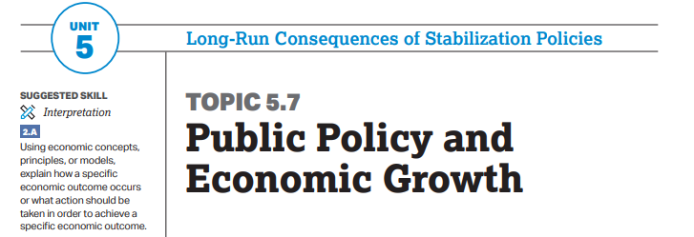

ENDURING UNDERSTANDING Authorities and organizations institute policies that affect economic growth.
Learning Objective:
a. Explain (using graphs as appropriate) public policies aimed at influencing long-run economic growth
Essential Knowledge:
a. Explain (using graphs as appropriate) public policies aimed at influencing long-run economic growth.
Public policies that impact productivity and labor force participation affect real GDP per capita and economic growth. POL-4.A.
2 Government policies that invest in infrastructure and technology affect growth. POL-4.A
3 Supply-side fiscal policies affect aggregate demand, aggregate supply, and potential output in the short run and long run by influencing incentives that affect household and business economic behavior.

