POPULATION MODULE OVERVIEW
SKILL FOCUS: Spatial Relationships, Data Analysis, Scale Analysis | CONTENT: ENDURING UNDERSTANDING SPS-2
Spatial Relationships: Describe spatial patterns, networks and explain a likely outcome in a geographic scenario using geographic concepts, processes, models, or theories  Data Analysis: Explain patterns and trends in maps and in quantitative and geospatial data to draw conclusions.  Scale Analysis: Identify the scale of analysis presented by maps, quantitative and geospatial data, images, and landscapes | Changes in population have long-and short-term effects on a place’s economy, culture, and politics.  Topic 2.9 - Aging Populations  Topic 2.7 - Population Policies

DAY  1 | How does scale affect our analysis of geographic trends?  CLASS ACTIVITY: Identify and analyze demographic trends and scales of analysis  Students will identify and analyze demographic statistics at different scales of analysis and work collaboratively to predict challenges presented by those trends.  AP SKILL ALIGNMENT  Skill Category 2.A Describe spatial patterns, networks, and relationships.  Skill Category 3.C Explain patterns and trends in maps and in quantitative and geospatial data to  draw conclusions  Skill Category 5.A Identify the scales of analysis presented by maps, quantitative and geospatial data,  images, and landscapes

DAY 2 | What challenges are presented by an aging population?
CLASS ACTIVITY: Analyzing Population Policies in South Korea
Students will identify and analyze antinatalist and pronatalist population policies in South Korea and apply their knowledge to explain why a society may want to promote or discourage population growth.
AP SKILL ALIGNMENT
Skill Category 2.C Explain a likely outcome in a geographic scenario using geographic concepts, processes, models, or theories.
Skill Category 3.E. Explain what maps or data imply or illustrate about geographic principles,
processes, and outcomes.

DAY  3 | CLASS ACTIVITY: Concept Mapping and AP-Aligned Assessment  Students will connect vocabulary and concepts via a concept-mapping activity and then demonstrate understanding as they answer five Multiple Choice Questions (MCQs) and one Free Response Question (FRQ) with two stimuli.  AP-ALIGNED ASSESSMENT:  Free-Response Question (FRQ) and Multiple Choice Questions (MCQs)

POPULATION MODULE SOURCES

DAY 1 | STIMULUS TYPE DESCRIPTION  - Population Pyramid East Asia Population, 2020  - Population Pyramid Projected East Asia Population, 2050  - Data Chart East Asia Demographic Indicators  - Population Pyramid Population of South Korea, 2020  - Population Pyramid Projected Population of South Korea, 2050  - Data Chart South Korea Demographic Indicators  - Map Average Projected Annual Rate of World Population Change (%)  - Population Pyramid World Population, 2020  - Population Pyramid Projected World Population, 2050  - Data Chart World Demographic Indicators  - Graph Fertility Rates, South Korea, Selected Provinces, 2017  - Map Ratio of Elderly Population in South Korea by Province, 2010  - Population Pyramid Seoul, 2010  - Population Pyramid Jeollanam-do, 2010

DAY 2 | STIMULUS TYPE DESCRIPTION .  - Population Pyramids South Korea, 1965, 1975, 1995, 2015  - Poster Antinatalist South Korean Government Poster  - Poster Antinatalist South Korean Government Poster  - Text Excerpt South Korea's Child Care Policy  - Graph South Korea’s TFR, 1960-2018  - Text Excerpt Field Note About Changing Family Sizes in Korea  - Text Excerpt Korea Endorses Loop for Birth Control  - Text Excerpt Government Support for Housing For Families With 3+ Children  - Poster Antinatalist South Korean Government Poster  - Poster Antinatalist South Korean Government Poster  - Graph Percentage of South Korean Women Using Contraception (Ages 15-49)  - Text Excerpt South Korea’s Saero-Maji Pronatalist Plan

DAY  3 | STIMULUS TYPE DESCRIPTION .  - Population Pyramid Population of South Korea, 2020  - Text Excerpt “U.S. Homes Problematic for Aging Population”  - Graph Total Fertility Rate of South Korea Since 1984  - Map Average Projected Annual Rate of World Population Change (%)  - Population Pyramid Projected East Asia Population, 2050
D A Y 1
Based on a 60-minute class

How does the scale affect our analysis of geographic trends?

AP curriculum Framework reference
Enduring Understanding SPO-2
Changes in population have long-and short-term effects on the economy, culture, and politics of places.
Topic 2.9 - Aging Populations

Human Geography Skills:
Spatial Relationships: Analyze geographic patterns, relationships, and outcomes in applied contexts.
Skill Category 2.A Describe spatial patterns, networks, and relationships
Scale Analysis: Analyze geographic theories, approaches, concepts, processes, and models across geographic scales to explain spatial relationships.
Skill Category 5.A. Identify the scale of analysis presented by maps, quantitative and geospatial data, images and landscapes.

OVERVIEW

Students will explore population pyramids and maps showing aging populations at different scales to identify trends in the demographic data, as well as determine which scale of analysis is best for understanding the population dilemmas created by those trends. Students will also predict possible economic, social, and political consequences for a country that is aging.

Materials needed For Day 1:
- Butcher paper or its equivalent (chart paper, extra-large sticky notes)
- Markers or colored pencils
- Day 1 Handouts
  - Scale of Analysis Homework (p. 8)
  - Day 1 Student Handout (1 pers student) (pp. 9-10)
  - Vocabulary Sorting Cards (2 sets per group) These need to be cut out in advance (pp. 11-15)
  - Dataset #1 (1 set per group) (p . 17 )
  - Dataset #2 (1 set per group) (p . 18-19)
  - Dataset #3 (1 set per group) (p . 20-21)
  - Dataset #4 (1 set per group) (p . 22)

SEQUENCE OF INSTRUCTION
HOMEWORK OVERVIEW
HOMEWORK Option 1: Aging Populations
- Reading: “The Ageing Population” (https://tinyurl.com/economicsHW)
- Using a copy of “The Ageing Population” students use the CAMS reading strategy to process the information that they read:
Step 1: “C” Circle unfamiliar words and Phrases
Step 2: “A”- Add synonyms for the circled words and phrases
Step 3: “M” Using Metacognitive markers students annotate the text and use metacognition (awareness and understanding of one’s own thought process). Students keep note of their thoughts by using symbols *, ?, !, to mark their ideas, questions, comments, and underline key ideas
Step 4: “S” Stop and Jot in the margin. Summarize what you read. Make notes next to the metacognitive markers.
Homework Option 2: Scale of Analysis:
- Homework Option 2 is designed for students who have not been introduced to the concept of scale, or who might find a brief review of the concept helpful as an introduction.
- Using the Scale of Analysis Homework handout, students will work through several tasks to understand scale.
Teacher Notes
It is important that students understand and can apply the vocabulary needed for day one of this activity. If you feel that your students need more vocabulary practice before they start the day one activities, have them create a Frayer box for each of the terms using the structure below. This could be an optional extension activity to the Homework. Key vocabulary includes the following terms:
- Fertility Rates | - Mortality Rates | - Migration Rates
- Dependency Ratio | - Aging Population | - Life Expectancy
- Immigration Policies | - Pronatalist Policies | - Antinatalist Policies
- Replacement level

Teacher Notes
When using the “CAMS” Strategy it is important that you demonstrate using this strategy by reading at least two paragraphs as a class to model the strategy.

CLASS ACTIVITY 1 of 4: Warm-Up / Introduction
WARM UP/INTRODUCTION (10 MINUTES): Vocabulary Sort

ACTIVITY 1: To check that students understand key demographic vocabulary, students will interact with key vocabulary in a sorting activity.

Activity procedure:
- Distribute Day 1 Student Handout (pp. 9-10) to all students.
- Group students in groups of four and assign numbers one through four to each group member.
- Distribute vocabulary sorting cards, giving two sets to each group.
- Communicate that the students assigned numbers 1 and 3 will be partners and students assigned numbers 2 and 4 will be partners.
- Students use the metacognition cards: “I know this definition”, “I think I know this definition”, and “I don’t know this definition” and separate the cards into three stacks.
- Groups use the vocabulary term cards and sort them under the metacognition card that is most appropriate.
- Students then match the definition to the appropriate term card.
- After students believe they have all definitions correct, use the vocabulary key to determine if any terms are incorrect. If any terms are incorrectly paired, inform students how many incorrect matches they have and ask them to resort. Follow the previous step until the students are correct or warm-up time is complete.
- Debrief activity with students focusing on which terms they found confusing and which terms that they found easy to understand and why.
- Require students to write down any terms they struggled to understand on their “Day 1 Student Handout.”

Teacher Notes
The vocabulary activity provides a quick formative check of understanding of key vocabulary, but If students have already mastered the key demographic vocabulary in the warm-up, teachers can begin with Activity 2.

Teaching Tip
Students often do not struggle to understand the definitions of these particular terms, but often struggle with the implications of these measures. Remind them to focus on understanding the effects as well as the definition.
Teaching Tip
This activity is the culmination of demographic study and would best follow after students have studied AP Human Geography Population Topics 2.1-2.6 and 2.8

CLASS ACTIVITY 2 of 4: Demographic Trends and Scale of Analysis
CLASS ACTIVITY (30 MINUTES): Identifying Trends at Different Scales of Analysis

ACTIVITY 2: Students will interact with demographic information in the form of population pyramids, maps, and charts to determine trends at different scales. Group members will analyze similar data at different scales and share using a sentence stem protocol which encourages elaboration and also helps students who may struggle with speaking in front of others to present information. Groups will then determine at which scale the South Korea population concerns can best be understood.

Activity Procedure:
- If starting with Activity 2, group students into groups of three or four and assign numbers 1-4 to each student. Otherwise, keep groups and numbering from Activity 1; give each student the Data Set Handout that corresponds to their number: Data Set 1, 2, 3, or 4.
- On the Day 1 Student Handout, students individually answer the following questions located on page 9:
  - What is the scale of analysis shown in this data? What are two pieces of evidence to support your answer?
  - What trend(s) do you see in the data? What are at least two pieces of evidence to support your answer?
- Each student will share information using the following sentence stems to encourage depth of conversation
  - The scale of analysis for my data is . . . because of . . . and . . .
    - If students need additional scaffolding provide students with terms such large scale, small scale, global level, regional level, state level, sub-state level.
  - One trend that can be found in the data is . . . because of . . . and . . .
    - If students need additional scaffolding provide students with the following questions:
      - What information is being shown in the data sets?
      - What, in general do, all the data sets have in common?
- Teachers can monitor these group conversations and correct any misconceptions.
- Debrief:
  - As a whole class, explain at which scale of analysis each handout was focused:
    - Handout 1: East Asia - Regional Level
    - Handout 2: Republic of Korea - Country or National Level
    - Handout 3: Global Population - Global Level
    - Handout 4: Political Divisions in South Korea - Local or Sub-state Level
  - Have some of the students share the trends they noted and explain what in the data led them to their conclusions.
  - Focus students on the aging population in East Asia and particularly what is occurring in South Korea.
  - Have each group select which scale they think would be most helpful for understanding the aging of the Republic of Korea’s population and explain their reasoning.
    - Explain to students that the elder dependency ratio would be high for a country like South Korea..
    - Choose one group and have them identify the scale they think would be most helpful to share with the class.
    - After hearing that group’s choice, ask the other groups if they agree or disagree with the conclusion presented. Encourage the other groups to present evidence and an argument why they either agree or disagree with the first group.
      - Try to identify one group that agreed with the findings and one that disagreed with the findings.

Teaching Tip
Scale can be discussed with students as analogous to looking at a picture. The smaller the area of a picture we focus on, the more detail we see. Thus, when looking at a global scale we do not see local variations, which may be important in making geographical decisions. As the scale of analysis narrows, more detailed information comes into focus which can be studied.

Teacher Notes
Students may struggle to understand Dependency Ratio and related implications. Dependency Ratio is the ratio of those too young (14 and under) or too old (65 and up) to support themselves versus those who are in their productive economic years. When there is a high youth dependency, countries must devote significant resources to education and youth services. When there is a high elder dependency, countries must devote significant resources to social security, health care, and other elder services. This places stress on the working age population and economy.

CLASS ACTIVITY 3 of 4: Predicting Challenges for an Aging Population
CLASS ACTIVITY (20 minutes): Identifying Challenges

ACTIVITY 3: Students will brainstorm economic, social, and political consequences for a country with an aging population or high elder dependency ratio. Each group will create their own list of consequences and then analyze other groups' ideas to develop a master list of consequences.

Activity Procedure:
- Students remain in the same groups.
- On a poster or butcher paper, students take five minutes to brainstorm the most important economic, social, and political consequences of an aging population. Students write these down on their Day 1 Student Handout.
- Groups rotate to look at other group predictions and add any new examples on their Day 1 Student Handout:
- Debrief with students:
  - “What were the most common consequences identified?” Students will be able to easily identify these as they will have the greatest number of tally marks.
  - “What was one consequence, from another group, that you thought was insightful? Explain the reason why.”
- Possible consequences:
Political | Economic | Social
- Shifting demographics cause voters to have different priorities (social safety net vs. schools, etc.) | - Shrinking workforce  - Shrinking consumer base  - Shrinking economy | - How to provide for aging population (social programs)  - Closing schools  - Closing colleges (lack of access outside of large cities)

CLASS ACTIVITY 4 of 4: Check for Understanding -- Exit Ticket
Exit Ticket ( 5 MINUTES): Aging Population Analysis

ACTIVITY 4: Students will demonstrate what they have learned on day 1 through a Quick Write.

Activity Procedure:
- Have students write a paragraph that describes the causes of an aging population, using at least one economic, social, and/or political consequence of aging populations. Have students include in their paragraph a discussion of what scale of information would be most helpful in understanding the causes and consequences of aging for any state and why that scale would be most useful.

Homework: Scale of Analysis

Name: __________________________________________________________ Period: ______________
Answer the following questions using the map on the left:
What would happen if you were to click the + button?
Would this view be considered small or large scale?
Why?
What would happen to the map if you were to click the - button?
Would this view be considered small or large scale?
Why?

Zooming in and zooming out describes map scale, but in addition to map scale the scale of analysis can also be analyzed. Scale of analysis relates to the level of the data (also sometimes called data aggregation). Scale of analysis can relate not only to maps, but also to charts, pyramids, etc. In other words I can take a world map and break the data down to the world regional level or, using the same map, I could break the data down to the country level. Changing the scale of analysis can lead to different conclusions regarding the patterns presented.

Directions: Using the spectrum (similar to a timeline), identify the varying levels of scale of analysis from smallest to largest scale. After placing the regions, write a brief justification for your placement under each level of data.

- East Asia: Region | - South Korea: National or State Level
- Global Population: Global Level | - Political Divisions in South Korea: Sub-state or Local Level
Small Scale
Large Scale

Day 1 Student Handout

Name: ______________________________________________ Period: ________________

Vocabulary Warm-Up

Which terms am I still struggling to understand? | How will I better remember this term?

Demographic Trends and Scale of Analysis
For your assigned data set answer the following questions:

- What is the scale of analysis shown in this data? What is evidence to support your answer?

- What trend(s) do you see in the data? What is evidence to support your answer?

Use the following sentence stems as you present to your group
  - The scale of analysis for my data is . . . because of . . . and . . .
  - One trend that can be found in the data is . . . because of . . . and . . .

Day 1 Student Handout - Continued

Which scale of analysis does your group think would most accurately allow you to understand population aging in the Republic of Korea? Why? (Be prepared to share your answer with the class.)

Predicting Challenges for an Aging Population

What challenges did your group identify to be the most important for a country with an aging population?
 | Political | Economic | Social
Consequences My Group Identified
Consequences Other Groups Identified

IN CLASS ACTIVITY MATERIALS
Metacognition cards

I know this definition

I think I know this definition

I don’t know this definition

Term Cards

Fertility Rates | Mortality Rates
Migration Rates | Dependency Ratio
Aging Population | Life Expectancy
Immigration Policies | Pronatalist Policies
Antinatalist Policies | Replacement Level

Definition Cards

Number of immigrants/1000 - the number of emigrants/1000 | The number of deaths/1000
The ratio of the number of people who are either too young (0-14) or old (65+) to support themselves to those who can support themselves | Due to declining birth rates and increase in life expectancy, the ratio of people over 60 to the total population is increasing
The average number of years a person is predicted to live | Policies designed to encourage or discourage immigration
Policies designed to increase birth rates; sometimes referred to as expansive policies | Policies designed to decrease birth rates; sometimes referred to as restrictive policies
The level of fertility needed to maintain the current population (TFR of 2.1). With a TFR lower than 2.1 the total population will shrink; with a TFR above 2.1 the total population will grow. | The average number of children that a woman will have in her lifetime

Vocabulary Answers

Term | Definition
Fertility Rates | The average number of children that a woman will have in her lifetime
Mortality Rates | The number of deaths/1000
Migration Rates | Number of immigrants/1000 - the number of emigrants/1000
Dependency Ratio | The ratio of the number of people who are either too young (0-14) or old (65+) to support themselves to those who can support themselves
Aging Population | Due to declining birth rates and increase in life expectancy, the ratio of people over 60 to the total population is increasing
Life Expectancy | The average number of years a person is predicted to live
Immigration Policies | Policies designed to encourage or discourage immigration
Pronatalist Policies | Policies designed to increase birth rates; sometimes referred to as expansive policies
Antinatalist Policies | Policies designed to decrease birth rates; sometimes referred to as restrictive policies
Replacement Level | The level of fertility needed to maintain the current population (TFR of 2.1). With a TFR lower than 2.1 the total population will shrink; with a TFR above 2.1 the total population will grow.

Dataset #1

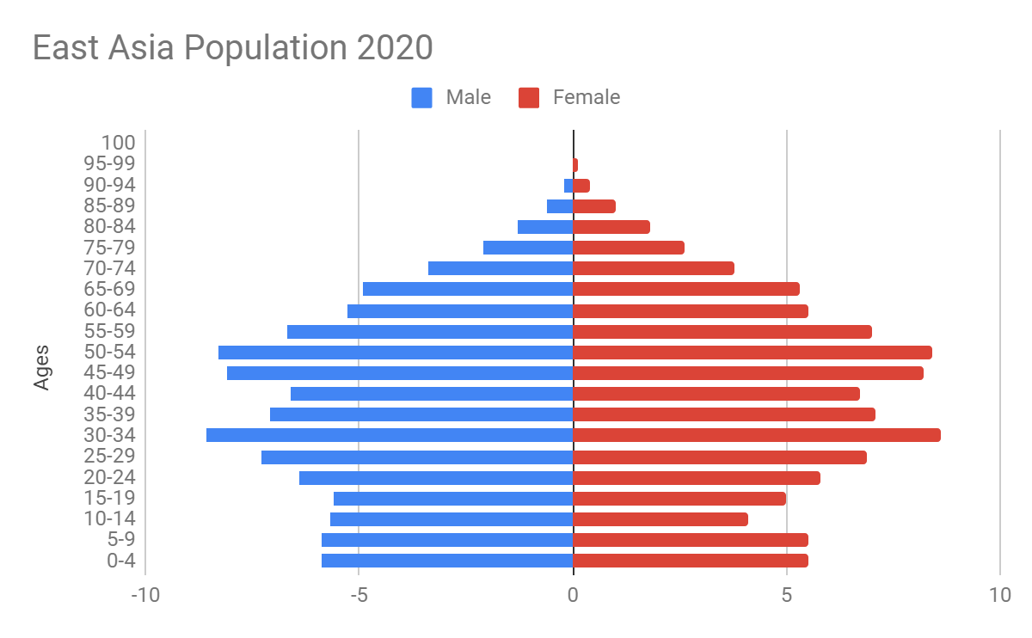
United States Census Bureau - International Data Base. (n.d.). Retrieved March 28, 2019, from https://www.census.gov/data-tools/demo/idb/region.php?N=%20Results%20&T=10&A=both&RT=0&Y=2020&R=121&C=
Mid-year Population by Five Year Age Groups and Sex - East Asia
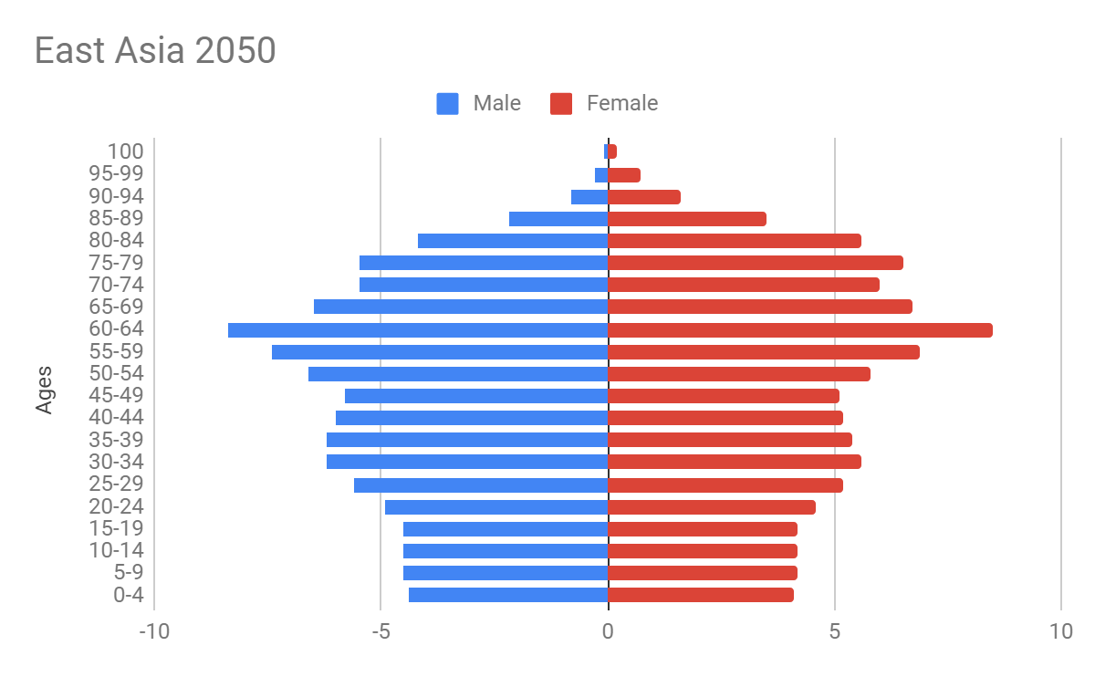
United States Census Bureau - International Data Base. (n.d.). Retrieved March 28, 2019, from https://www.census.gov/data-tools/demo/idb/region.php?N=%20Results%20&T=10&A=both&RT=0&Y=2050&R=121&C=
Mid-year Population by Five Year Age Groups and Sex - East Asia
East Asia Demographic Indicators
 | 2005 | 2015 | 2025 | 2050
Population Growth Rates | .5 | .5 | .1 | -.06
Fertility Rate | 1.5 | 1.6 | 1.6 | 1.6
Life Expectancy | 74 | 75 | 77 | 81
United States Census Bureau - International Data Base. (n.d.). Retrieved March 28, 2019, from
https://www.census.gov/data-tools/demo/idb/region.php?N=%20Results%20&T=13&A=both&RT=0&Y=2050&R=121&C=

Dataset #2

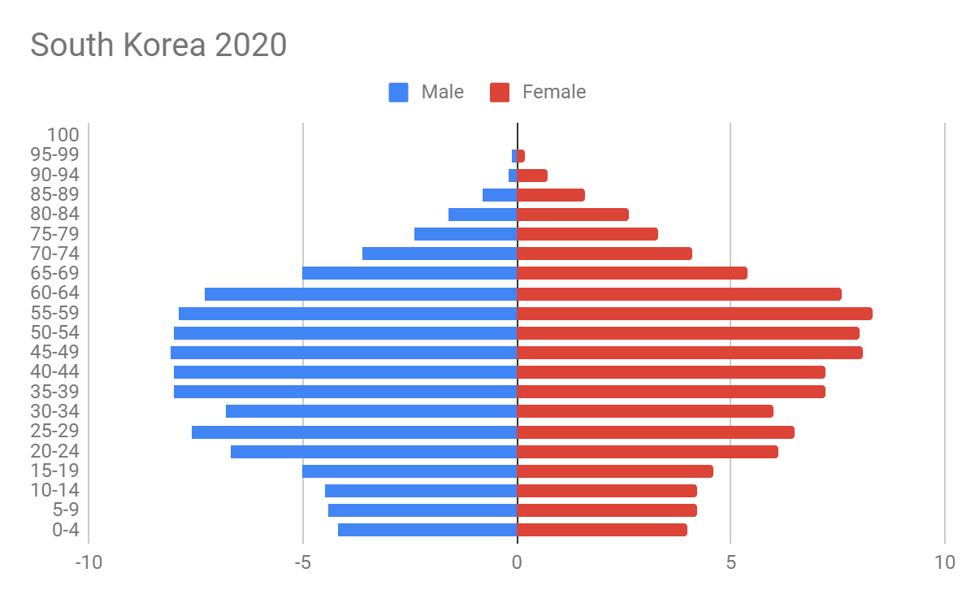
United States Census Bureau - International Data Base. (n.d.). Retrieved March 28, 2019, from https://www.census.gov/data-tools/demo/idb/region.php?N=%20Results%20&T=10&A=separate&RT=0&Y=2020&R=121&C=KS
Mid-year Population by Five Year Age Groups and Sex - South Korea

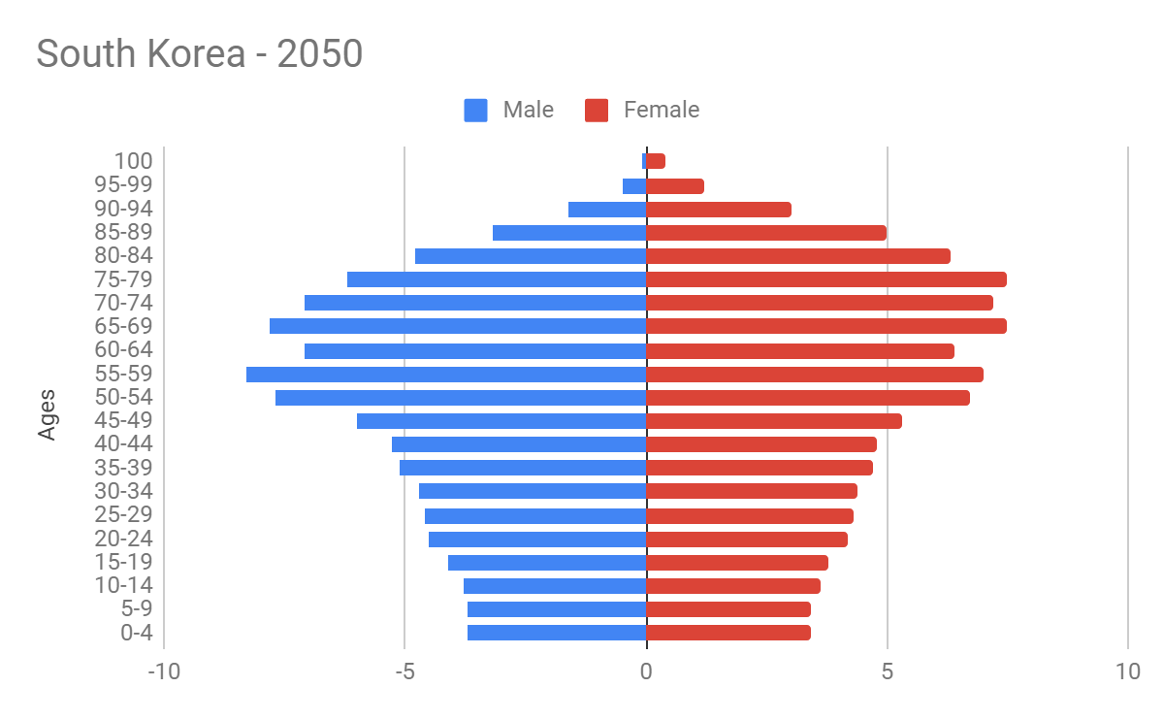

United States Census Bureau - International Data Base. (n.d.). Retrieved March 28, 2019, from https://www.census.gov/data-tools/demo/idb/region.php?N=%20Results%20&T=10&A=separate&RT=0&Y=2050&R=121&C=KS
Mid-year Population by Five Year Age Groups and Sex - South Korea
South Korea Demographic Indicators
 | 2005 | 2015 | 2025 | 2050
Population Growth Rates | .2 | .6 | .2 | -.9
Fertility Rate | 1.1 | 1.2 | 1.3 | 1.6
Life Expectancy | 78 | 82 | 83 | 84
United States Census Bureau - International Data Base. (n.d.). Retrieved March 28, 2019, from
https://www.census.gov/data-tools/demo/idb/region.php?N=%20Results%20&T=13&A=both&RT=0&Y=2050&R=121&C=

Dataset #3
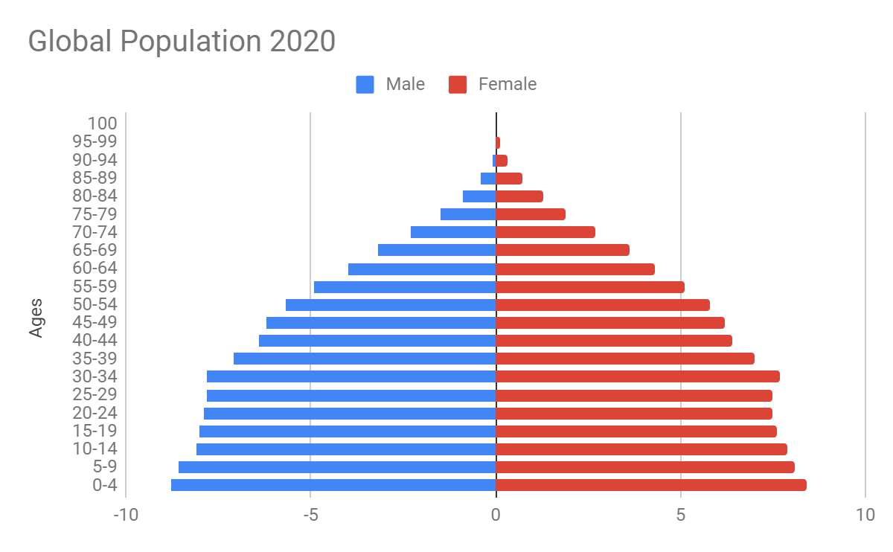
United States Census Bureau - International Data Base. (n.d.). Retrieved March 28, 2019, from https://www.census.gov/data-tools/demo/idb/region.php?N= Results &T=10&A=both&RT=0&Y=2020&R=1&C=
Mid-year Population by Five Year Age Groups and Sex - World
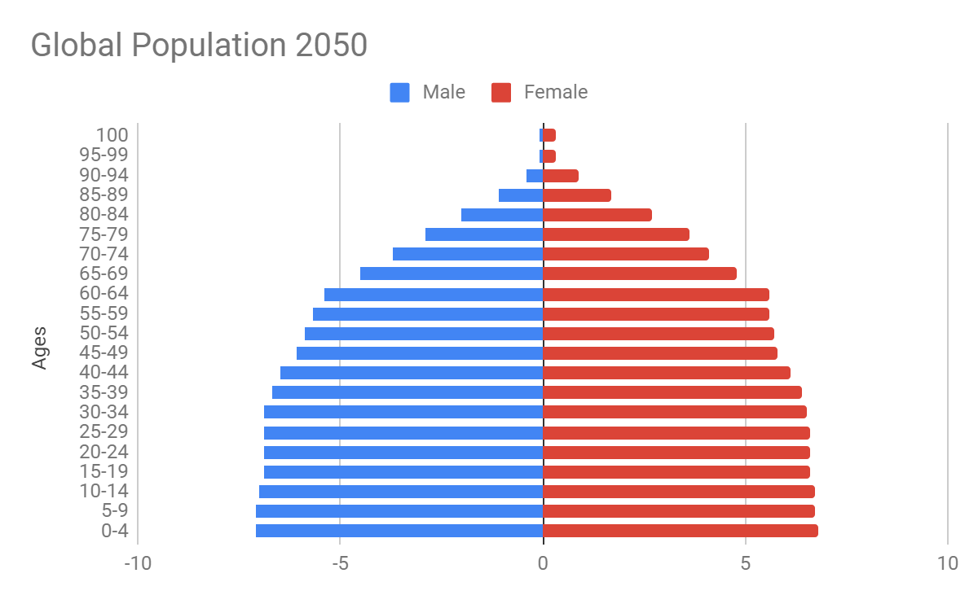
United States Census Bureau - International Data Base. (n.d.). Retrieved March 28, 2019, from https://www.census.gov/data-tools/demo/idb/region.php?N=%20Results%20&T=10&A=both&RT=0&Y=2050&R=1&C=
Mid-year Population by Five Year Age Groups and Sex - World

Global Demographic Indicators
 | 2005 | 2015 | 2025 | 2050
Population Growth Rates | 1.1 | 1.1 | .9 | .5
Fertility Rate | 2.5 | 2.4 | 2.3 | 2.2
Life Expectancy | 66 | 69 | 71 | 77
United States Census Bureau - International Data Base. (n.d.). Retrieved March 28, 2019, from https://www.census.gov/data-tools/demo/idb/region.php?N=%20Results%20&T=13&A=both&RT=0&Y=2050&R=1&C=

Dataset #4

