INDUSTRIALIZATION AND ECONOMIC DEVELOPMENT MODULE OVERVIEW
SKILL FOCUS: SPATIAL RELATIONSHIPS, DATA ANALYSIS, SOURCE ANALYSIS | CONTENT: ENDURING UNDERSTANDING SPS-7
Spatial Relationships: Describe spatial patterns, networks and explain a likely outcome in a geographic scenario using geographic concepts, processes, models, or theories  Data Analysis: Explain patterns and trends in maps and in quantitative and geospatial data to draw conclusions.  Source Analysis: Analyze and interpret qualitative geographic information represented in maps, images (e.g., satellite, photographs, cartoons), and landscapes | Industrialization, past and present, has facilitated improvements in standards of living, but it has also contributed to geographically uneven development.  Topic 7.1 The Industrial Revolution  Topic 7.2 Economic Sectors and Patterns  Topic 7.3 Measures of Development

DAY 1 | What are economic sectors and the factors that affect their development?  CLASS ACTIVITY: Understanding and Identifying Economic Sectors  Students will work collaboratively to identify and learn the five different economic sectors. Students will then use their new understanding of the economic sectors and examine maps and data sets to predict the locations of different economic sectors within South Korea.  AP SKILL ALIGNMENT  Skill Category 2.B Explain spatial relationships in a specified context or region of the world, using  geographic concepts, processes, models, or theories.  Skill Category 2.C Explain a likely outcome in a geographic scenario using geographic concepts,  processes, models, or theories.  Skill Category 4.D Compare patterns and trends in sources to draw conclusions.

DAY 2 | What are the key measures of development in a country?
CLASS ACTIVITY: Understanding and Identifying Measures of Development
Students will work collaboratively to define and learn a variety of measures of development. Students will then analyze data sets to identify changes in several measures of development in South Korea over the past 70 years and speculate as to the reasons for those changes.
AP SKILL ALIGNMENT
Skill Category 3.F Explain possible limitations of the data provided.
Skill Category 4.D Compare patterns and trends in sources to draw conclusions.
Skill Category 4.E Explain how maps, images, and landscapes illustrate or relate to geographic
principles, processes, and outcomes.

DAY 3 | CLASS ACTIVITY: Concept Mapping and AP-Aligned Assessment  Students will connect vocabulary and concepts via a concept-mapping activity and then demonstrate understanding as they answer one Free Response Question (FRQ) with two stimuli and Multiple Choice Questions (5 MCQs total).  AP-ALIGNED ASSESSMENT: Free-Response Question (FRQ) and Multiple Choice Questions (MCQs)

INDUSTRIALIZATION AND ECONOMIC DEVELOPMENT SOURCES
DAY 1 | STIMULUS TYPE DESCRIPTION STIMULUS TYPE DESCRIPTION  - Map The Global Spread of 11. Image New York Stock Exchange  Industrialization  - Image Tractor on a Farm 12. Map Outline Map of South Korea  - Image Textile Manufacturing Equipment 13. Map Population of South Korea (Dot Map)  - Image Barbershop 14. Map Road and Highway Systems of South  Korea  - Image Researcher / Scientist 15. Map Food and Beverage Services of South  Korea (Dot Map)  - Image Business Leaders 16. Map Percentage of People per Subunit  Engaged in Market Gardening in South  Korea (Choropleth map)  - Image Open Mine Site 17. Map Percentage of people Engaged in  Manufacturing in South Korea  (Choropleth map).  - Image Manufacturing Plant 18. Map Distribution of Colleges and  Universities in South Korea  - Image New York Storefronts 19. Map Distribution and Number of Hospitals  - Image University Research Facility in South Korea

DAY 2 | STIMULUS TYPE DESCRIPTION .  - Data Chart Data Charts of GDP for South Korea from 1960 - 2018  - Article South Korea's GDP Surges 31,000-fold since 1953  - Data Chart South Korea’s GDP Growth (Annual Percentage) and  Annual Change from 1960 - 2018  - Data Chart South Korea’s Oil Consumption 1969 - 2018  - Article South Korea Relies on Imports to Meet about 98% of its  Fossil Fuel Consumption  - Data Chart South Korean Usage of Renewable Energies from 1990 –  2015  - Data Chart Trends in South Korea’s HDI Component Indices 1980 - 2014  - Data Chart South Korea’s HDI Trends  - Map South Korean Regions by Human Development Index in 2017

DAY 3 | STIMULUS TYPE DESCRIPTION  - Data Chart South Korea’s Greenhouse Gas Emissions Rising Quickly  - Image Researcher / Scientist  - Image Worker in Rice Field  - Image Auto Factory
D A Y 1
Based on a 60-minute class

Lesson Question: What are economic sectors and the factors that affect their development?

AP curriculum Framework reference
Enduring Understanding SPS-7
Industrialization, past and present, has facilitated improvements in standards of living, but it has also contributed to geographically uneven development.
Topic 7.1 - The Industrial Revolution
Topic 7.2 - Economic Sectors and Pattern

Human Geography Skills:
Spatial Relationships: Describe spatial patterns, networks and explain a likely outcome in a geographic scenario using geographic concepts, processes, models, or theories.
Skill Category 2.B Explain spatial relationships in a specified context or region of the world, using geographic concepts,
processes, models, or theories.
Skill Category 2.C Explain a likely outcome in a geographic scenario using geographic concepts, processes, models, or
theories.
Source Analysis: Analyze and interpret qualitative geographic information represented in maps, images (e.g., satellite, photographs, cartoons), and landscapes.
Skill Category 4.D Compare patterns and trends in sources to draw conclusions.

OVERVIEW
Students will learn to identify the different economic sectors and relate them to the economic development of the Korean peninsula through structured source analysis of selected images, short readings, data charts, and maps of population and resource locations in South Korea. This activity is designed to help students learn the essential knowledge of the five economic sectors and to apply this knowledge as they analyze geospatial data through various sources. Students will use their understanding of the sectors to speculate where different economic sectors would be located in modern-day South Korea. Students will need a prior knowledge of the beginnings of the Industrial Revolution and the spread of industrialization to areas outside of the West to access the opening stages of the activity. Students should finish the activity with a greater understanding of the five economic sectors, how they relate to South Korea’s economic development, and how resource locations in Korea play an integral role in the locations of South Korea’s different economic sector zones.

Materials needed For Day 1:
- Day 1 Handouts
  - Day 1 Preparation Homework Activity - these will need to be distributed to students to complete as homework prior to the Day 1 Lesson Plan (1 per student)
  - Day 1 Student Handout (1 per student)
  - Economic Sectors Definition Cards - these will need to be cut out in advance (1 per team)
  - Economic Sector Cards - these will need to be cut out in advance (1 per team)
  - Economic Sectors Image Cards - these will need to be cut out in advance (1 per team)
  - Economic Sectors Location Cards - these will need to be cut out in advance (1 per team)
  - Economic Sector Location Map Resources (1 per team)
  - South Korea Economic Sector Map (1 per student)

SEQUENCE OF INSTRUCTION
HOMEWORK OVERVIEW
HOMEWORK - CLASS PREPARATION - (30 MINUTES):
To ensure students have a basic knowledge and understanding of the Industrial Revolution and to provide background knowledge, students will watch the John Green Crash Course on the Industrial Revolution. The video is a brief and entertaining overview of how the Industrial Revolution occurred and how industrialization impacted the world.
- Prior to watching the video, students will write down three facts that they know about the Industrial Revolution in the left column on the Day 1 Preparation Homework Activity sheet.
- Students will watch the Crash Course video which can be found here (https://www.youtube.com/watch?v=zhL5DCizj5c). Students will then add at least five new things they learned in the right column.
- Students will examine the map showing the global spread of industrialization found on the back of the Day 1 Preparation Homework Activity sheet. Students will answer two questions related to areas of the world that industrialized after the West.
Teacher Notes
While the John Green video provides a great overview of industrialization, he speaks quickly and it is often hard for students to catch all of the important concepts he discusses. It is beneficial to slow down the playback on the video and turn on the closed captioning feature when watching the video. Encouraging students to pause the video as they are working through the handout can also be helpful.
An alternative to homework, is to have students watch the John Green Crash Course video in class.

CLASS ACTIVITY: OPTIONAL Homework Debrief

Optional Homework Debrief (5 MINUTES): Industrialization and its Impact on Population Processes

ACTIVITY: Teachers may want to debrief the homework activity to ensure students have a solid understanding of industrialization and the impact it had on population processes. This activity will help teachers gauge the level of understanding and will allow students to demonstrate what they learned from the homework activity on industrialization.

Activity Procedure:
- In teams of three to four, each team will share with the class one of the “new things” they noted from watching the Crash Course video as noted on the Day 1 Preparation Homework Activity sheet (2 minutes).
  - Communicate that the teacher will select a team member to share their findings, so all team members need to be prepared to share the team’s conclusions.
  - To encourage students to work through this quickly, set a timer for two minutes to complete their group discussion.
  - For students who may struggle with language or confidence speaking in front of peers, you can provide the following sentence stems to help with structure:
    - One thing that I thought was interesting about the Industrial Revolution was...
    - One thing that I learned about the Industrial Revolution was...
- Call on randomly selected students to share their responses.
Teacher Notes
While sharing, some groups will realize that they have similar ideas; however, students should be challenged to articulate their ideas by expanding on the original example.

CLASS ACTIVITY 1 of 4: Warm Up / Introduction

WARM UP/INTRODUCTION (15 MINUTES): SCATTERGORIES ACTIVITY

ACTIVITY 1: Students will identify different jobs in today’s world and attempt to place them into larger categories by playing a Scattergories style game. This activity is designed to get students to begin thinking about the economic roles that people play and how these might fit into the economic sectors.

Activity Procedure:
- In teams of three to four, students will brainstorm as many different jobs as possible using the Brainstorming Space on their Day 1 Student Handout (two minutes). Explain to students that their team will earn points only for jobs that are unique - meaning that their team is the first one to identify this job.
- Rotate from team to team asking each to identify one of the jobs that they have listed. Write the profession on the board or a large piece of paper.
- Teams may want to be strategic in which jobs they share first, as more common jobs are likely to be on multiple teams’ lists, and therefore be more likely to earn points earlier in the game. Remind the teams that once a profession has been used it can no longer be used and will not count in earning points. Once all of the jobs have been identified, declare the team with the most points (unique jobs listed) the winner.
- Teams place the posted jobs into four categories to force students to find commonalities. Have the students put similar jobs together and then create a title or description that would fit all of those jobs.
- Students can organize their jobs using the Job Category boxes (Day 1 Student Handout). The teacher should help guide student teams as needed. After the teams have categorized the jobs, have them share their categories and the jobs they placed into each category. Encourage the teams to debate the merits of each category and come to a consensus on the four “best” categories.
Teacher Notes
Students may struggle in creating categories for sorting the jobs by thinking too narrowly. If necessary, provide guidance as you walk around observing the teams by suggesting groupings that fit a wide variety of jobs but fall under the same type of work. An example could be factory jobs or restaurant jobs. This will help students understand the basic ideas of the economic sectors we will be discussing in the next activity.
Teaching Tip
Creating a competition among teams will often incentivize students to be more engaged in the activity. Consider offering up a “reward” to the team that earns the most points by identifying the largest number of unique jobs. Also, using the word “team” instead of group will often foster a sense of camaraderie and encourage participation from all members of the team. Adding a timed element also helps students produce without overthinking.

CLASS ACTIVITY PART 2 of 4: Identifying and Explaining the Five Economic Sectors

CLASS ACTIVITY (15 MINUTES): ECONOMIC SECTOR DEFINITIONS
ACTIVITY 2: Building off the categories students created in Activity 1, students will now begin to create an understanding of the five economic sectors and their definitions.
Activity Procedure:
- Students will remain in teams and be provided with a set of Economic sector names, images, definitions, and locations (Economic Sector Definition Cards, Economic Sector Cards, Economic Sector Image Cards, and Economic Sector Location Cards). Provide each team with an envelope containing the cards.
- Students match the name, image, definition, and location for each of the economic sectors using the provided cards (5-10 minutes). The teacher should walk around the room and help struggling teams.
- Teacher can debrief correct answers with the class. Students will write a quick definition, description of the image, and information about the location on their Day 1 Student Handout (page 2).
- Students go back to the jobs list they created in Activity 1. Working individually, students assign each job an Economic Sector category using the following numbers (3 minutes):
  - Primary Sector = 1
  - Secondary Sector = 2
  - Tertiary Sector = 3
  - Quaternary and Quinary Sector = 4/5
- Students compare their answers with their team members to see if they agree on which jobs correspond to which economic sectors. Call on students from various groups to share their responses (2 minutes).
Teacher Notes

Although several textbooks and resources will separate out Quaternary and Quinary Sectors and provide definitions for each of these terms, those definitions vary widely from source to source and do not have universal agreement. For the purposes of teaching the skills and knowledge necessary for AP Human Geography, students must simply understand that the Tertiary Sector consists of lower-level services where workers do not require a great deal of advanced training or education, while Quaternary and Quinary Sectors consist of higher-level services where workers tend to need significant training and often require specialized education. The idea of Quaternary and Quinary sectors emerged out of the wide variance in what were originally all classified as Tertiary (Service) Sector jobs. For the purposes of this activity, we have purposely combined Quaternary and Quinary in an attempt to make these concepts easier to understand.

Prior to the activity, teachers will need to cut out all of the Economic Sectors Definition Cards, Economic Sectors Cards, Economic Sectors Images Cards, and Economic Sectors Locations Cards, shuffle all of these cards together, and place them in an envelope for each group. This will require each group to sort through all of the terms, images, and definitions when trying to find matches. For the Quaternary and Quinary Sectors, there will be a total of TWO Economic Sector Image Cards and TWO Economic Sector Locations Cards.
Teaching Tip
Requiring students to justify their reasoning for the matches they created will encourage them to think through the choices they have made and create arguments supporting the connection between each definition, image, and location. Since this is a key element required of students on the AP exam, practicing this skill often will lead to greater success.

CLASS ACTIVITY PART 3 of 4: Determining the Locations of Economic Sectors

CLASS ACTIVITY (15 MINUTES): determining the locations economic Activities and Sectors

ACTIVITY 3: Students will use their knowledge of the economic sectors from activity 2 to help them make informed guesses as to the locations of different economic sectors by examining a variety of different maps.

Activity Procedure:
- Students remain in their previous teams of three to four people.
- Working individually, students complete the Identifying Economic Sectors section of the Day 1 Student Handout (page 3). Students should be able to complete this activity quickly as they will have just worked with similar examples in Class Activity Part 2 (1-2 minutes).
- Students share their answers within their teams. Call on teams to share out their answers and correct any mistakes for the entire class (1-2 minutes).
- Provide teams with Economic Sector Location Resources Map #1 and Map #2. Teams review the maps and discuss what information the map shows and how that could help them in deciding where the different economic activities are located.
- Teams work together to decide where they believe the economic activities (Market Gardening, McDonald’s, Hospital, University, KIA Motors Plant) would occur. They should label these individually on the blank map in the Day 1 Student Handout (page 3). Teams should use the Economic Sector Location Map Resources to help them determine these locations (10 minutes).
  - The term Market Gardening refers to the farming of fruits and vegetables.
- Students will explain their reasoning for location choices on their Day 1 Student Handout (page 3).
Teacher Notes
Even though students are working as a team to find the location of the economic activities and to develop a rationale for that location, individual students are still responsible for noting the locations on their map and completing the Reasons for Location on the Map section of their handout.
Since Industrial and Economic Development Patterns and Processes is the last unit covered in the course description, Class Activity Part 3 gives an opportunity to make connections back to previous units. For example, the location of many of these activities will correspond to Central Place Theory. Higher order services such as hospitals and universities will be located in areas with large populations, while McDonald’s are more likely to be found all over the country (despite being more prevalent in the more densely populated areas). In addition, infrastructure such as roads, railways, and ports will impact the location of activities such as the KIA Motors plant. Students can also connect market gardening to location decisions. A useful model is the von Thünen model, which states that agricultural land use is defined by a relationship between the cost of the land and the cost of transporting agricultural products to market. Von Thünen's model predicts that people will organize their systems of land use into four concentric circles, radiating outwards from the city (where the markets are located and agricultural products are actually sold). Each zone has a different character, based on the cost of land and the cost of getting the products to the city.

CLASS ACTIVITY PART 4 of 4: Check for Understanding

CLASS ACTIVITY (15 MINUTES): Comparing the ideal locations of economic sectors with reality

Exit Ticket: Students will compare actual locations of economic sectors in South Korea with the ideal economic sector locations they chose in activity 3. Students will conclude by writing a brief analysis of the factors impacting the location of economic sectors.

Activity Procedure:
- Give each team a copy of the Economic Sector Location Key Maps #1 through #5 showing the actual locations of the economic activities found in Class Activity Part 3.
- Each team will compare the Key Maps to where they located the activities.
- Individually, students choose one of the economic activities (Market Gardening, McDonald’s, Hospital, University, and KIA Motors Plant) and answer the following prompt:
  - Evaluate the accuracy of your locations and note potential reasons for your accuracy or inaccuracy.
  - Prompt students to consider the following as they write:
    - Evaluate the accuracy of your economic activity locations.
    - If you were correct, what factors helped you to identify the correct locations?
    - If you were incorrect, what factors did you not consider and/or what factors led to the incorrect location?
- Collect this paragraph or short answer as an exit ticket as students leave the class.

Day 1 Preparation Homework Activity

Name: ______________________________________________ Period: ________________

Crash Course: The Industrial Revolution
Watch John Green’s Crash Course video on the Industrial Revolution. Before watching the video, write down at least THREE things you know about the Industrial Revolution. After watching the video, add at least FIVE additional things that you learned AND correct any misconceptions you made in your “What I knew before the video!” section.
https://www.youtube.com/watch?v=zhL5DCizj5c

What I knew before the video! | New things that I learned about the Industrial Revolution by watching the Crash Course video!
 | 1.
 | 2.
2. | 3.
 | 4.
3. | 5.
Additional Info: | Additional Info:

Day 1 Preparation Homework Activity - Continued

The Global Spread of Industrialization
Study the map below that shows the global spread of industrialization and answer the questions that follow.

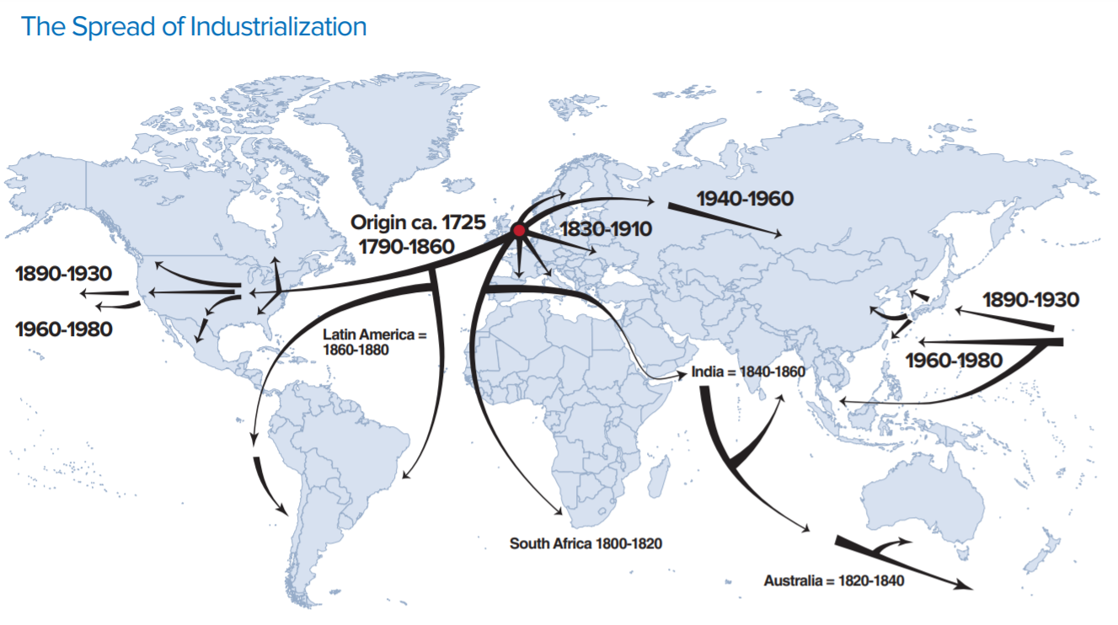
- Based on the map showing the global spread of industrialization, what issues might areas outside of the West (the United States and Europe) face in developing their economies?

- In contrast to the focus of the countries that industrialized first, what economic activities do you think countries that industrialized later would have focused on instead? List several examples below.

Economic Sectors Definition Cards

Extract, process, produce, and package raw materials and basic foods from the earth | Manufacture, process, and construct finished goods by transforming raw materials
Services for the general population and businesses to acquire and use finished goods | Knowledge and skill for complex processing and handling of information and high-level economic and social decision making

Economic Sectors Definition Cards Teacher Answer Key

PRIMARY SECTOR  Extract, process, produce, and package raw materials and basic foods from the earth | SECONDARY SECTOR  Manufacture, process, and construct finished goods by transforming raw materials
TERTIARY SECTOR  Services for the general population and businesses to acquire and use finished goods | QUATERNARY and  QUINARY SECTORS  Knowledge and skill for complex processing and handling of information and high-level economic and social decision making

Economic Sectors Cards

Primary  Sector | Secondary  Sector
Tertiary  Sector | Quaternary  and Quinary Sectors

Economic Sectors Image Cards

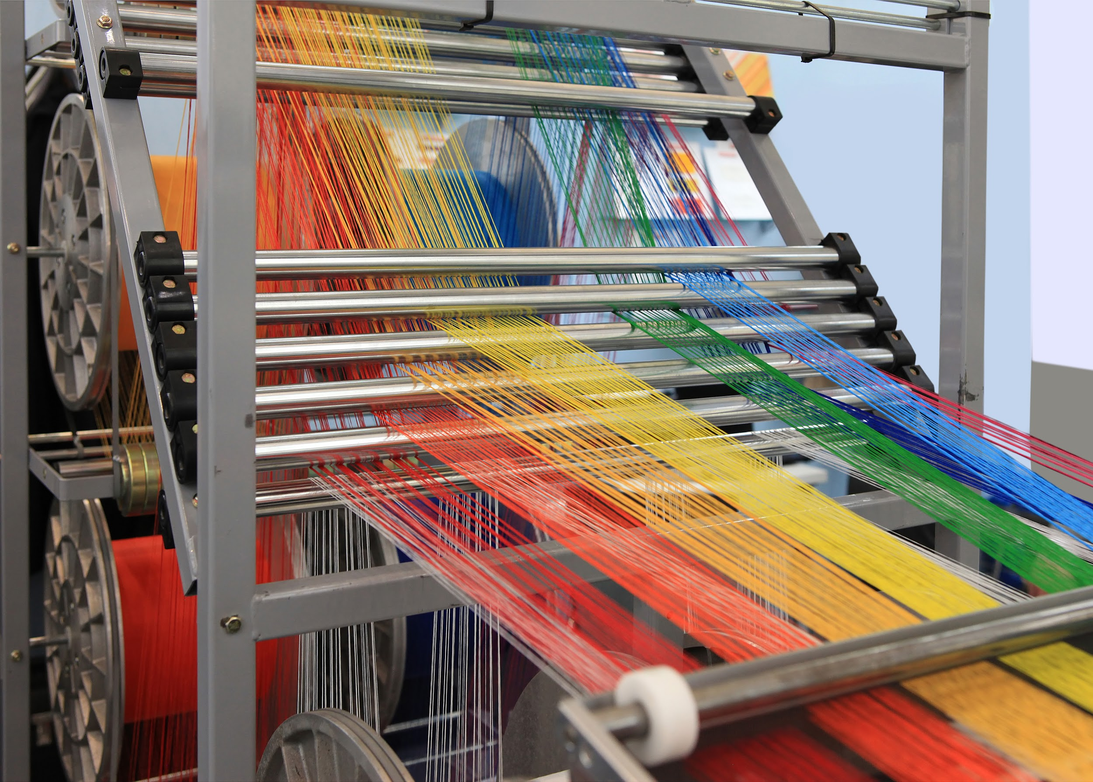

Economic Sector Locations Cards

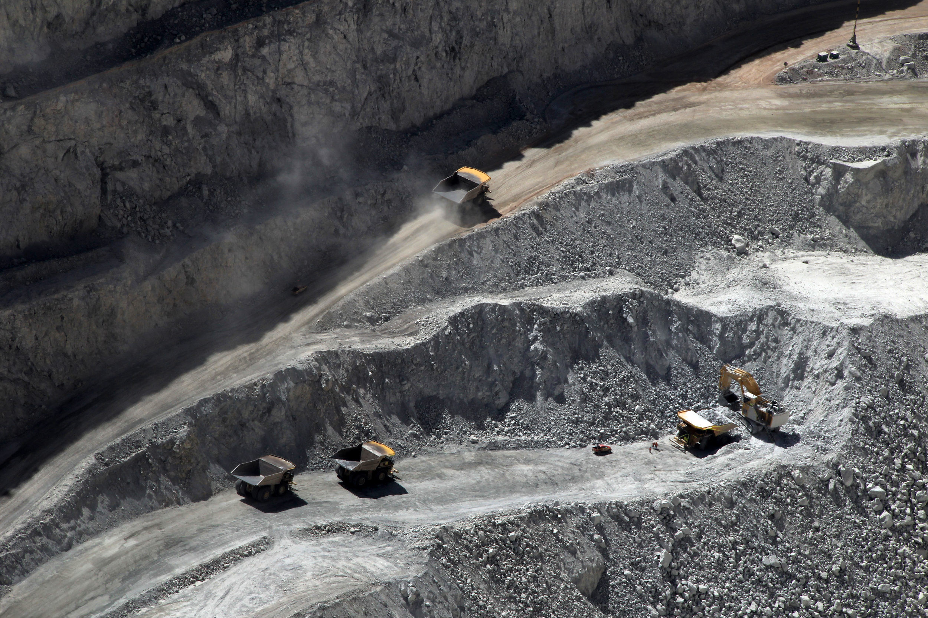
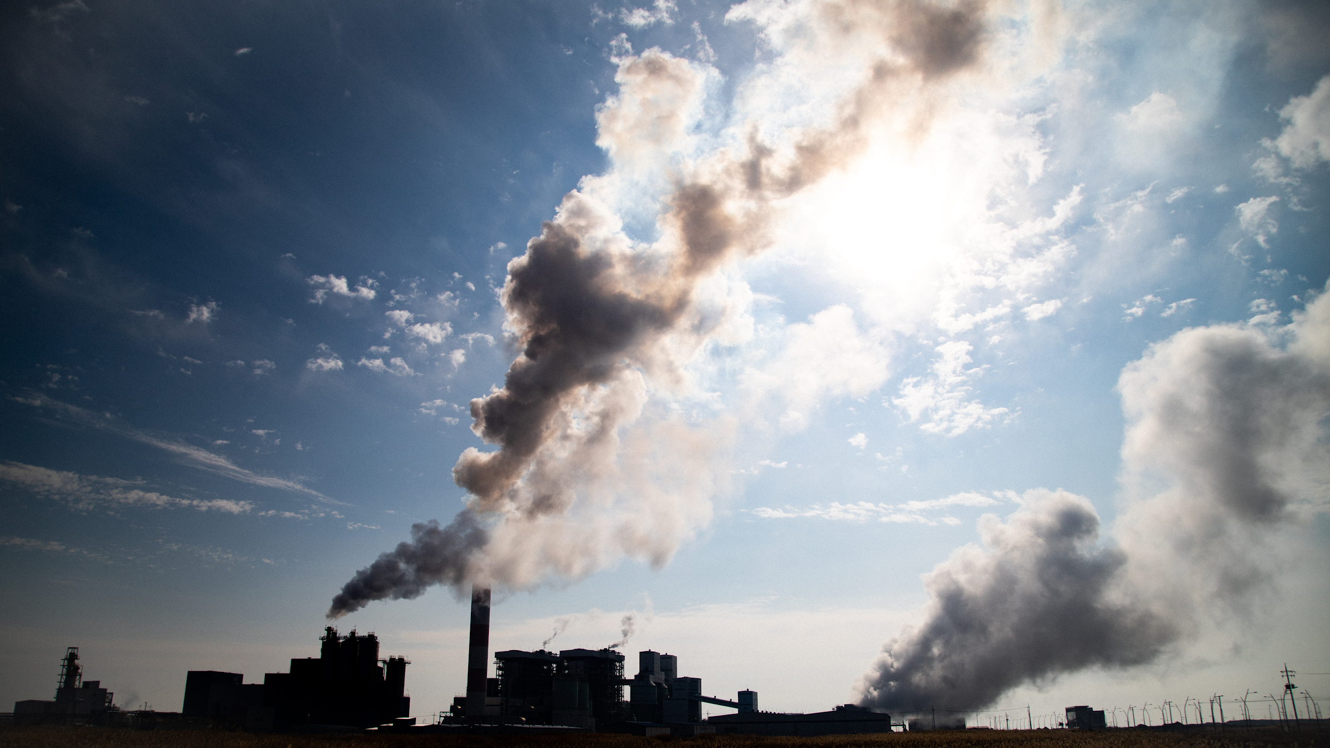

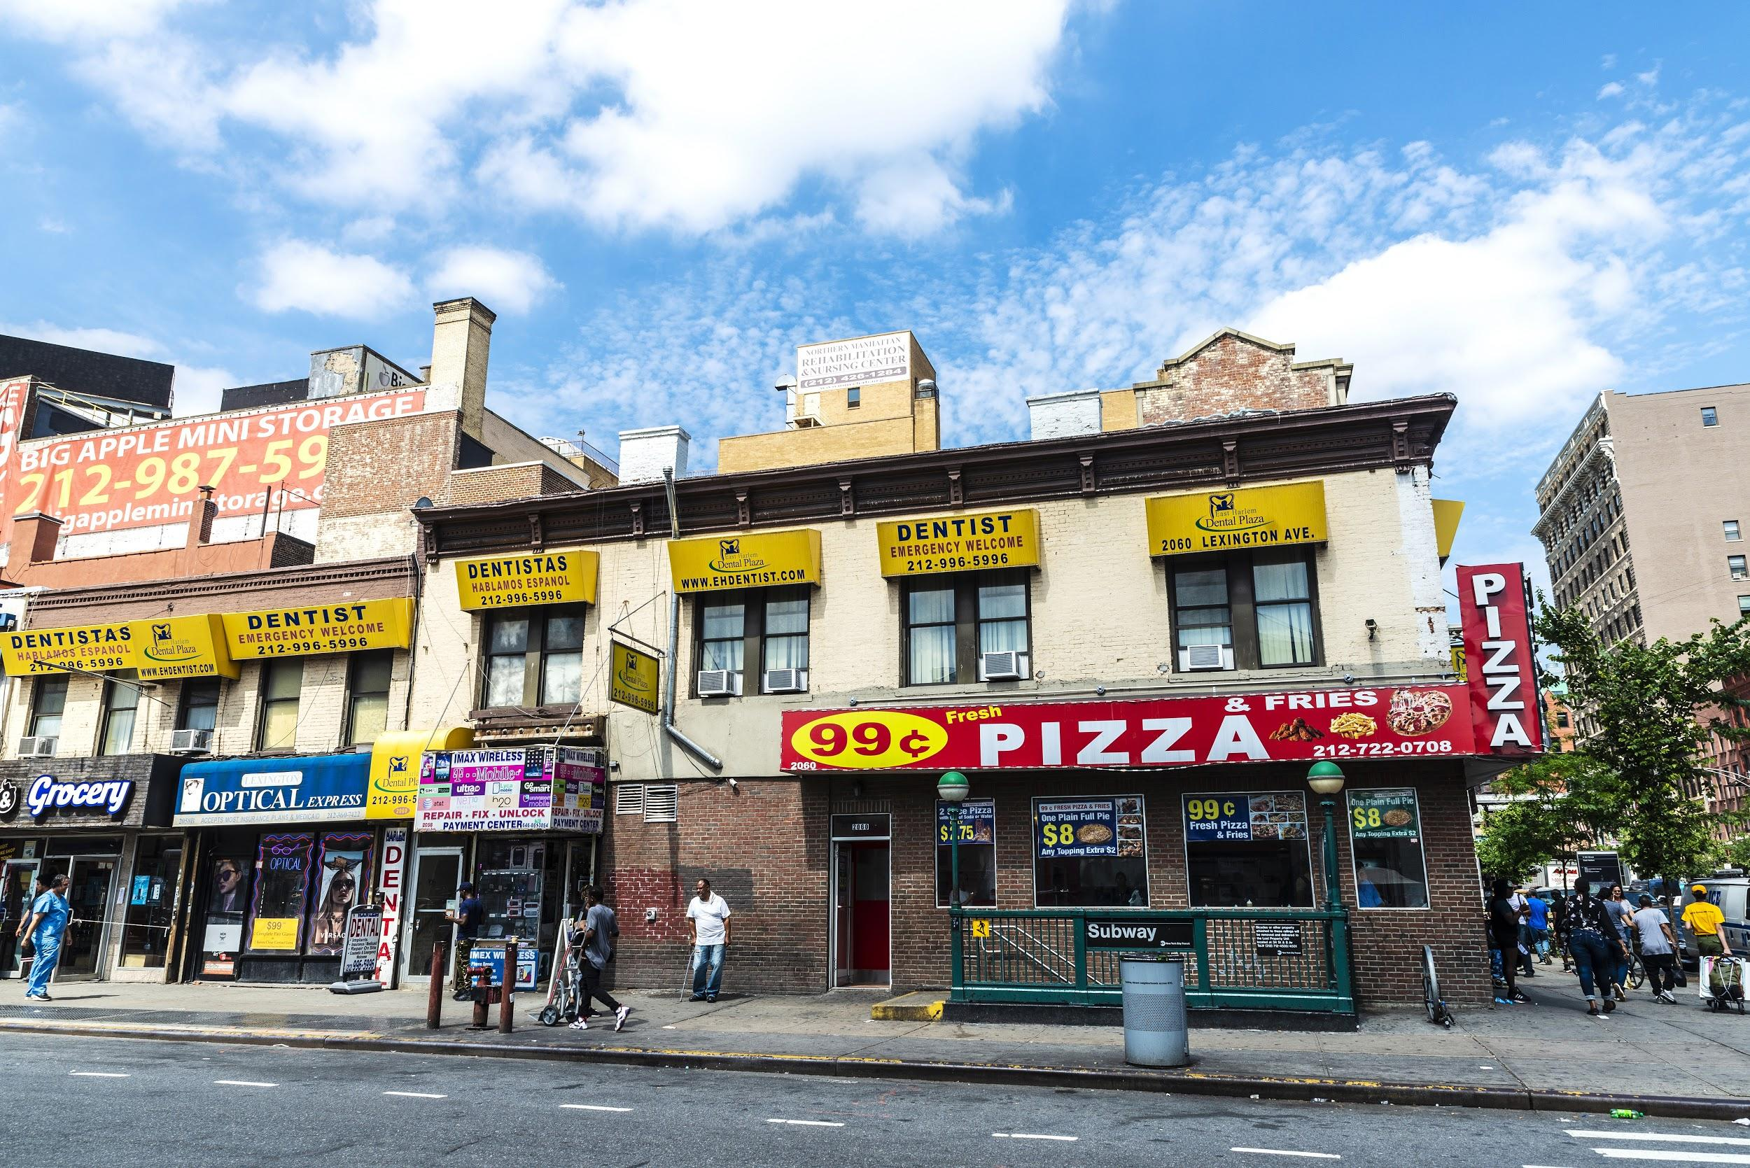

Day 1 Student Handout

Name: ______________________________________________ Period: ________________

Brainstorming Space
How many jobs can our team name? | What jobs did other teams come up with that we did not have on our original list?

Job and Profession Categories
For each of the jobs listed above, place them into FOUR categories. Create a title for each of your categories that explains how the jobs are connected.

Category Name: | Category Name: | Category Name: | Category Name:

Day 1 Student Handout - Continued (page 2)
Economic Sectors Matching
Match the correct definitions, images, and locations for each of the following sectors.
Economic Sector | Definition | Image | Location
Primary Sector
Secondary Sector
Tertiary Sector
Quaternary and Quinary Sectors

Day 1 Student Handout - Continued (page 3)

Identifying Economic Sectors
Identify which of the 4 Economic Sectors best describes each of the following:

- Market Gardening* = _______________________________ Economic Sector
- McDonald’s = _____________________________________ Economic Sector
- Hospital = ________________________________________ Economic Sector
- University = ______________________________________ Economic Sector
- KIA Motors Plant = _________________________________ Economic Sector
*Market Gardening is the farming of fruits and vegetables.

Where Would You Find These Economic Sectors?
Now that you know and understand the four different economic sectors, let’s see where you think you would find each of these sectors on a map. Indicate where you believe you would find each of these economic activities by labeling it with the numbers one through five on the map below:
Market Gardening = 1 McDonald’s = 2 Hospitals = 3 Universities = 4 KIA Motors Plants = 5
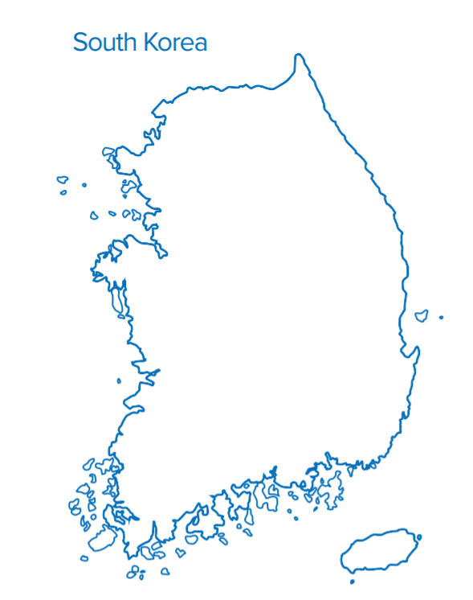
Day 1 Student Handout - Continued (page 4)

Where Would You Find These Economic Sectors?
Explain your reasons for each of the location choices in the boxes below. Your explanations should have specific reasons for your location choice based on what we have learned about the different economic sectors in class today.
Economic Sector | Reasons for Location on the Map
Market Gardening (Farming of Fruits and Vegetables)
McDonald’s
Hospital
University
KIA Motors Plant

Economic Sector Location Resources Map #1

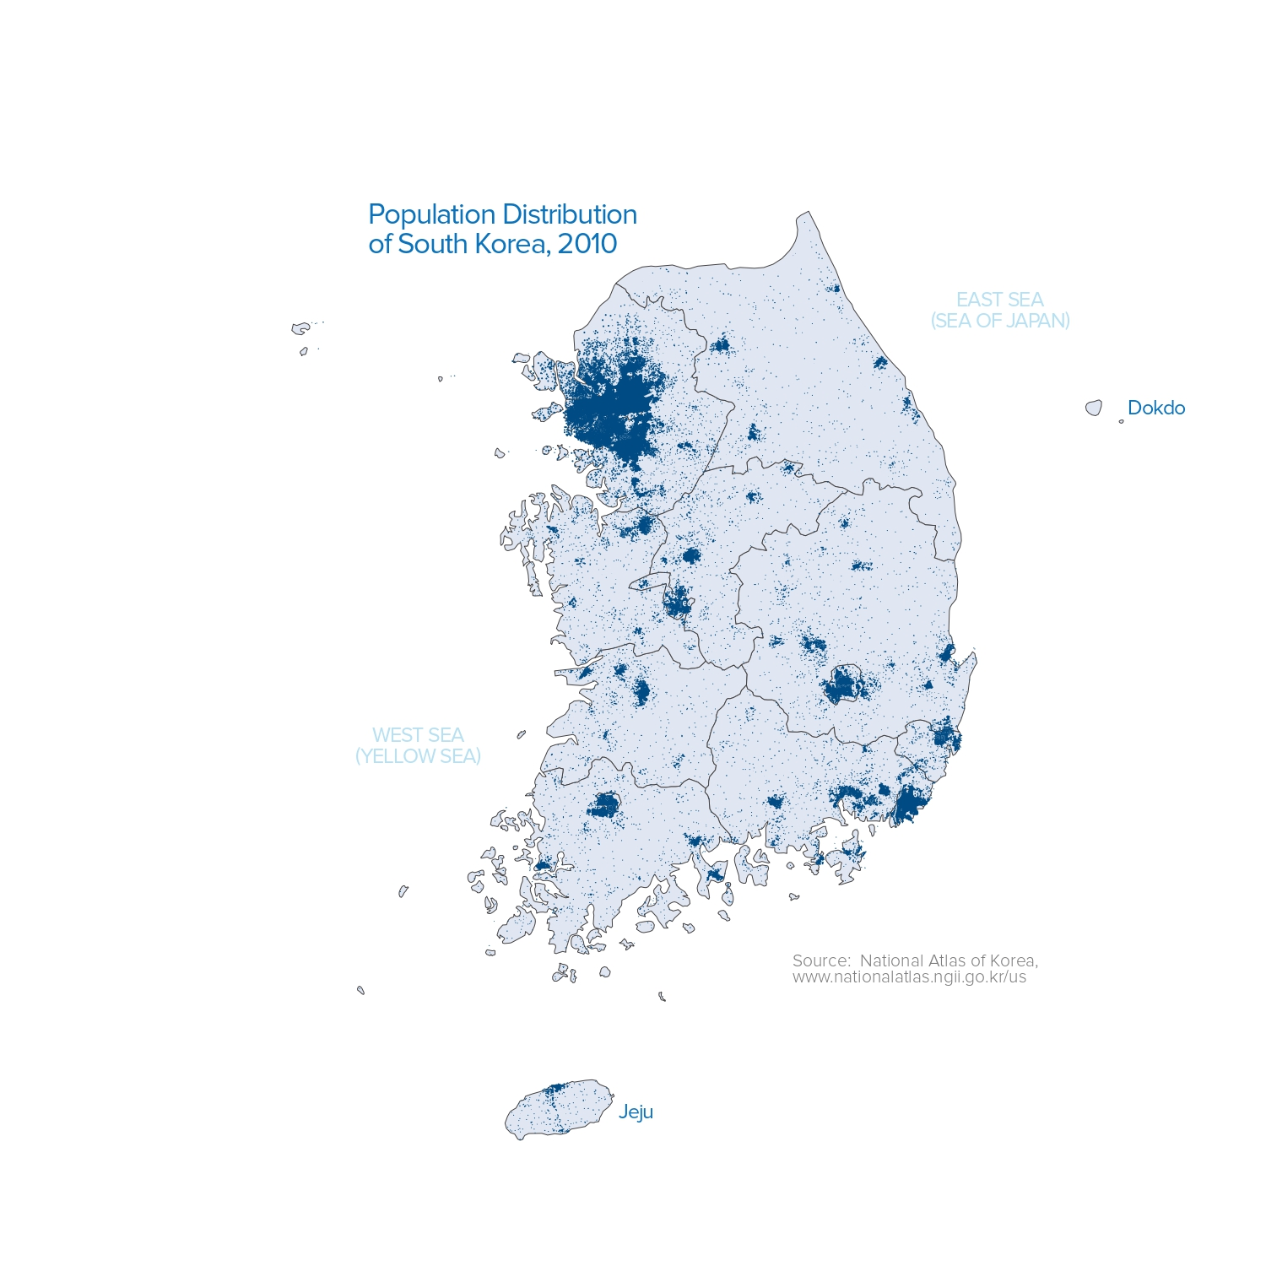
Economic Sector Location Resources Map #2

Economic Sector Location Key Map #1
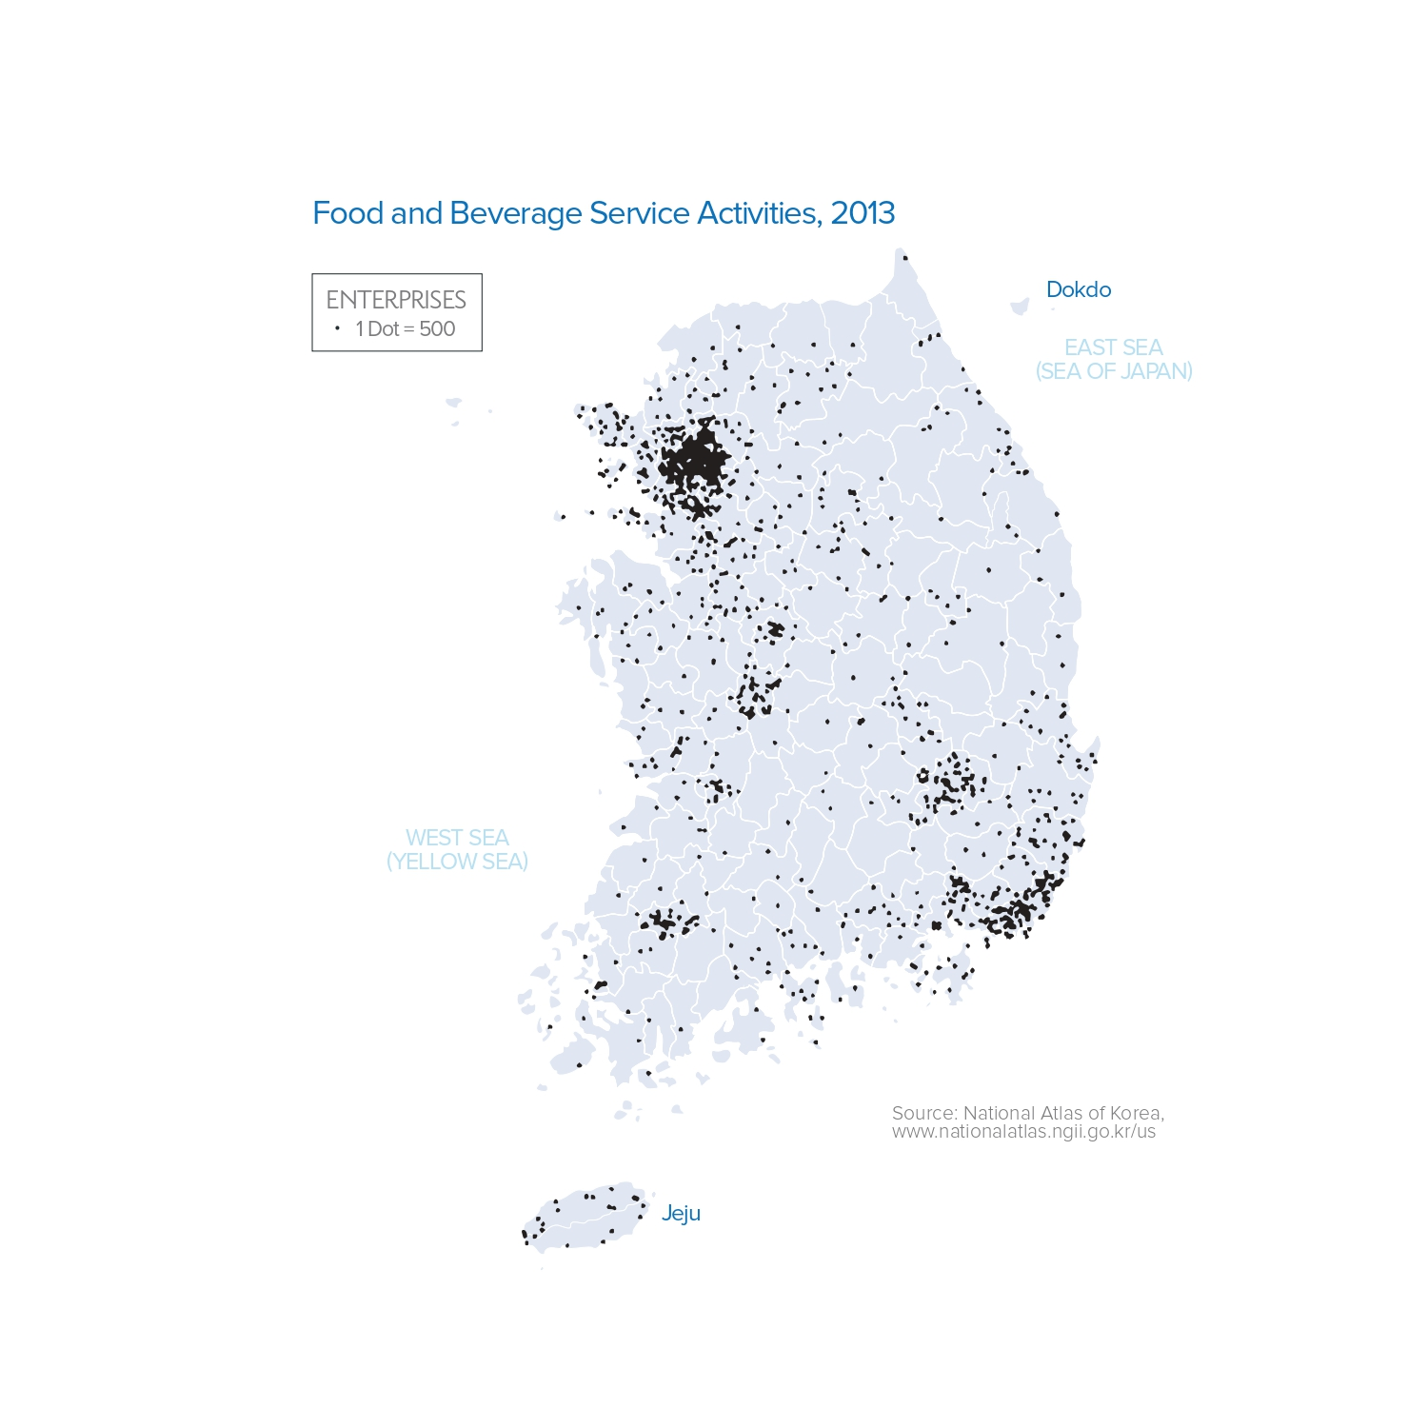

Economic Sector Location Key Map #2

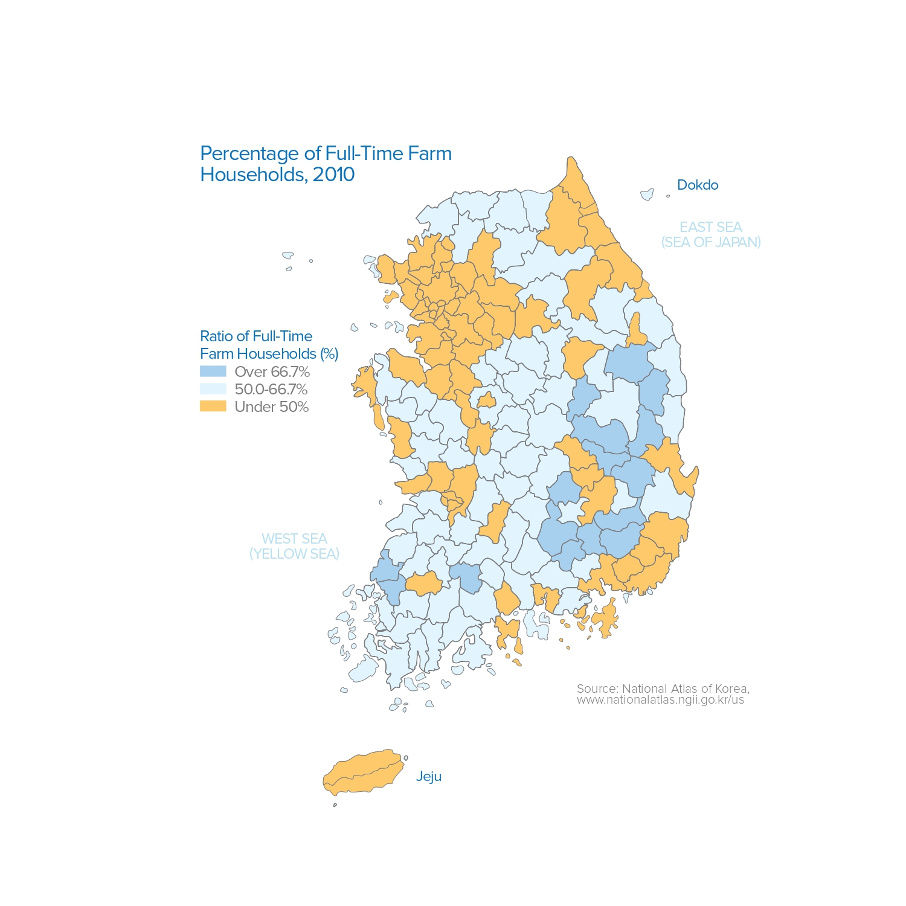

Economic Sector Location Key Map #3

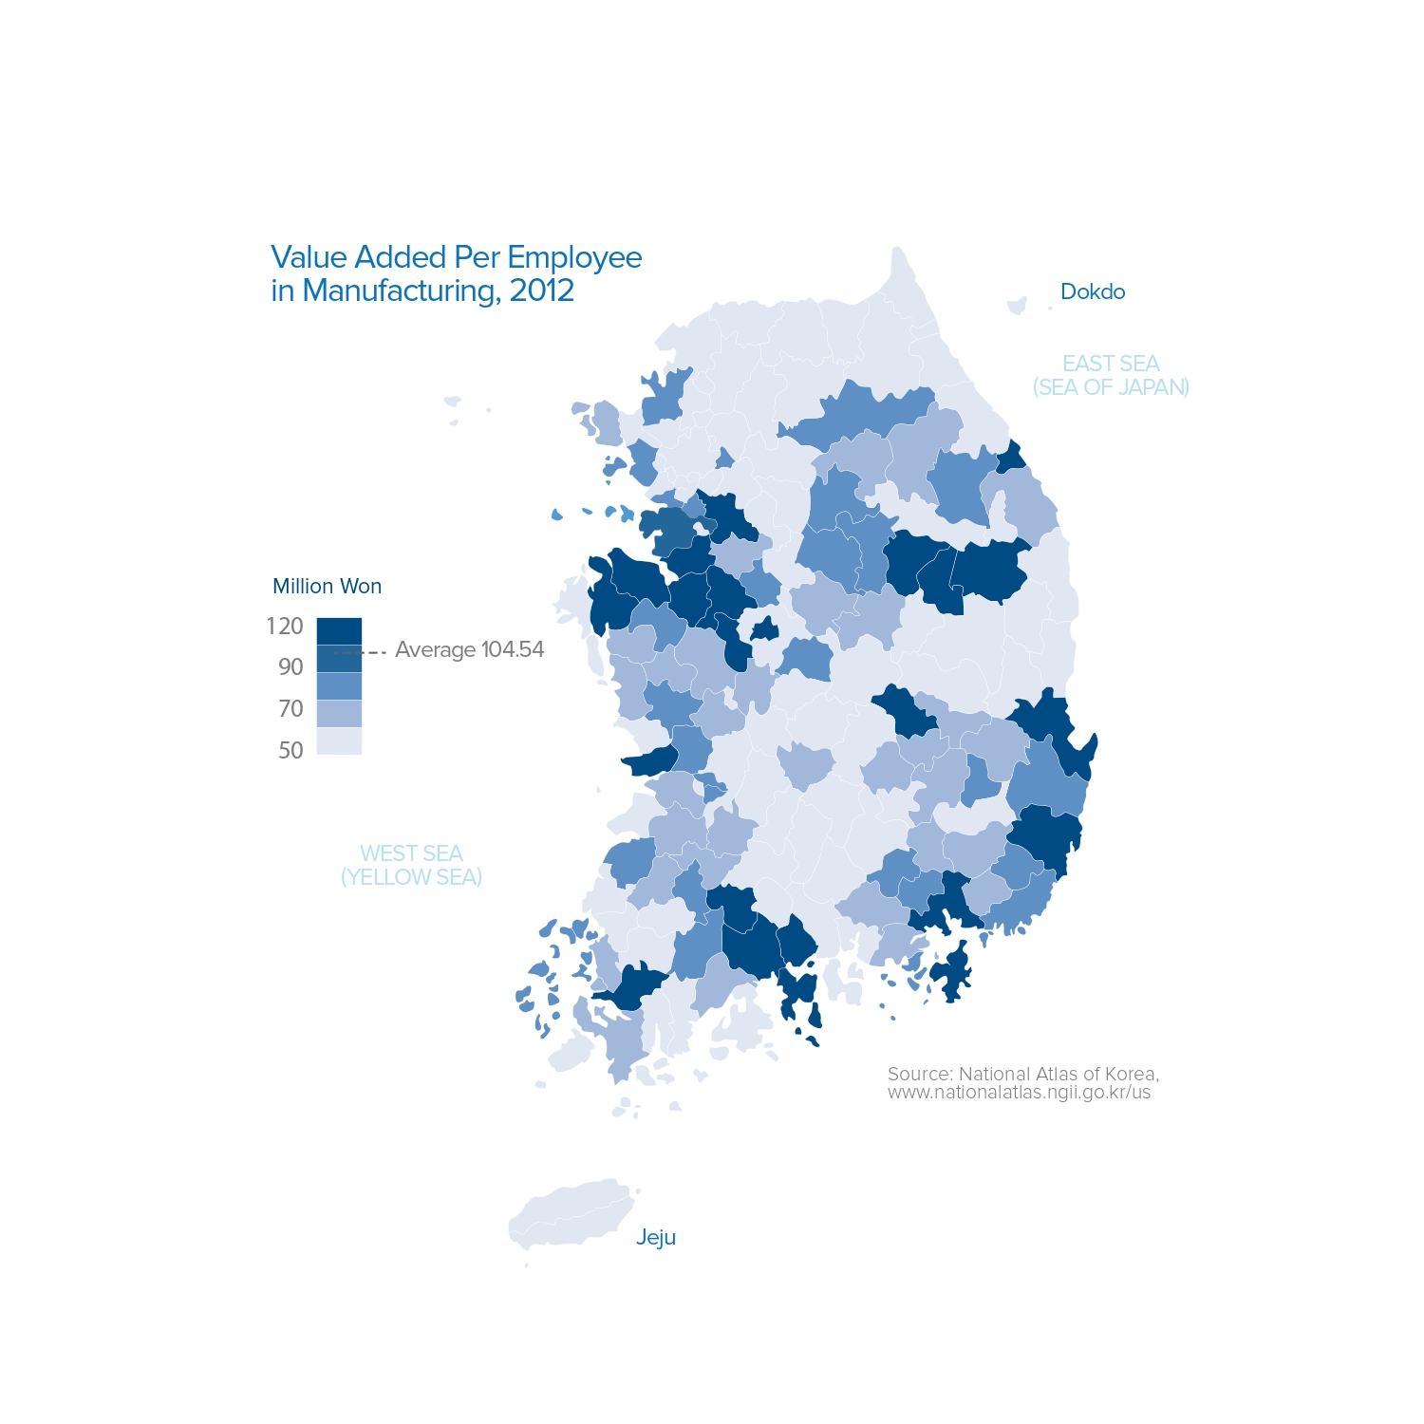

Economic Sector Location Key Map #4

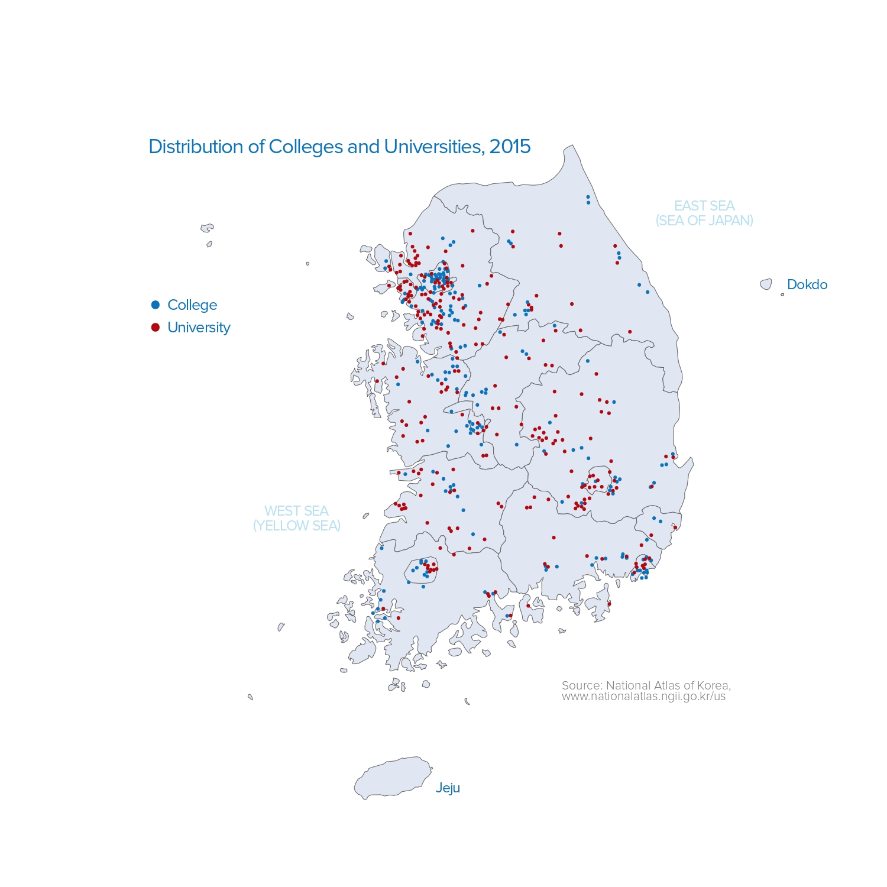

Economic Sector Location Key Map #5
