CULTURE MODULE OVERVIEW
SKILL FOCUS: Source Analysis, and Concepts and Processes | CONTENT: ENDURING UNDERSTANDING SPO-3
Source Analysis: Analyze and interpret qualitative geographic information represented in  maps, images (e.g. satellite, photographs,  cartoons), and landscapes.  Concepts and Processes: Describe geographic concepts, processes, models, and theories. | Cultural practices vary across geographical locations because of physical geography and available resources.  Topic 3.2 Cultural Landscapes  Topic 3.5 Historical Causes of Diffusion  Topic 3.6 Contemporary Causes of Diffusion

DAY 1 | How do cultural landscapes reflect cultural practices?
CLASS ACTIVITY: Reading a Cultural Landscape
Students will work collaboratively to identify and understand the components that make up cultural landscapes. Students will then use their new understanding of cultural landscapes to analyze information in visual sources from South Korea for cultural indicators and to draw conclusions about the patterns they see.
AP SKILL ALIGNMENT
Skill Category 4.A Identify the different types of information presented in visual sources.
Skill Category 4.C Explain patterns and trends in visual sources to draw conclusions.

DAY 2 | How does diffusion impact cultural landscapes?
CLASS ACTIVITY: Cultural Diffusion Investigation
Students will explore how the elements of the cultural landscapes are diffused by brainstorming ways cultural elements diffuse, and by studying cultural diffusion of Korean culture, culminating in an analysis of how cultures change due to diffusion.
AP SKILL ALIGNMENT
Skill Category 4.D Compare patterns and trends in sources to draw conclusions.
Skill Category 4.E Explain how maps, images and landscapes illustrate or relate to geographic
principals, and outcomes.

DAY 3 | CLASS ACTIVITY: Concept Mapping and AP-Aligned Assessment  Students will connect vocabulary and concepts via a concept-mapping activity and then demonstrate understanding as they answer one Free Response Question with two stimuli (FRQ) and Multiple Choice Questions (5 MCQs total).
AP-ALIGNED ASSESSMENT: FRQ

Multiple Choice Questions (MCQs) and Free-Response Question (FRQ)

CULTURE MODULE SOURCES

DAY 1 | TYPE of STIMULUS DESCRIPTION .  - Image Card 1 The Old Seoul City Hall, built in 1925 during the Japanese occupation  - Image Card 2 The New Seoul City Hall, built in 2012  - Image Card 3A Part of a photo of the Old and New Seoul City Halls  - Image Card 3B Part of a photo of the Old and New Seoul City Halls  - Image Card 3C Part of a photo of the Old and New Seoul City Halls  - Image Card 3D Part of a photo of the Old and New Seoul City Halls  - Image Card 3E Full photo containing Images 3A, 3B, 3C, and 3D  - Image Card 4A Daytime View of the Old and New City Halls  - Image Card 4B Nighttime view of the Old and New City Halls  - Image Card 4C Side view of the Old and New City Halls  - Image Card 4D View of the Old and New City Halls from across the street  - Image Card 5A Sequent Occupance Card #1: Hagia Sophia as a Church  - Image Card 5B Sequent Occupance Card #2: Hagia Sophia as a Mosque  - Image Card 6A Cultural Detective Photo Card #1: Street in Myeong-dong  - Image Card 6B Cultural Detective Photo Card #2: Bukchon Hanok Village  - Image Card 6C Cultural Detective Photo Card #3: Christian Church, Seoul  - Image Card 6D Cultural Detective Photo Card #4: Steel works (POSCO, Pohang Iron and  Steel Company) near the river in Pohang Kyeongsangbuk-do

DAY 2 | TYPE of STIMULUS DESCRIPTION  - Image 1 Diagram of the basic layout of Seoul, reflecting Geomancy principles  - Image 2 Photograph of Seoul with mountains in background  - Map City Map of Hanyang (Seoul) in 1822  - Image 3 Locations of major buildings in Seoul, reflecting Geomancy principles  - Image 4 Photo of the “Blue House,” the presidential office and residence  - Image 5 Photo of Koreatown in Manhattan  - Map Cheonggyecheon reclamation project  - Image Koreatown Manhattan  - Map BTS YouTube Views 2018  - Graph Top 10 Countries with Most BTS YouTube Views 2018  - Graph Total Exports Induced by the Korean Wave

DAY 3 | TYPE of STIMULUS DESCRIPTION  - Image Church located in Seoul  - Map Number of Views of K-Pop Videos on YouTube by Country in millions, 2011  - Image Photo of Koreatown in Manhattan
D A Y 2
Based on a 60-minute class

Lesson Question: How does diffusion impact the cultural landscapes?

AP curriculum Framework reference
Enduring Understanding SPO-3
Cultural practices vary across geographical locations because of physical geography and available resources.
Topic 3.2 Cultural Landscapes
Topic 3.5 Historical Causes of Diffusion
Topic 3.6 Contemporary Causes of Diffusion

Human Geography Skills:
Source Analysis: Analyze and interpret qualitative geographic information represented in maps, images (e.g., satellite, photographs, cartoons), and landscapes

Skill Category 4.A Identify the different types of information presented in visual sources.
Skill Category 4.B Describe the spatial patterns presented in visual sources.
Skill Category 4.C Explain patterns and trends in visual sources to draw conclusions.

Concepts and Processes: Describe geographic concepts, processes, models, and theories.

Skill Category 1.A Describe geographic concepts, processes, models, and theories.
Skill Category 1.D Describe a relevant geographic concept, process, model, or theory in a specified context

OVERVIEW
Students will explore how the elements of the Cultural landscapes are diffused by brainstorming ways cultural elements diffuse, and by studying cultural diffusion within Korean culture, culminating in an analysis of how cultures change due to diffusion.

Materials needed For Day 2:
- Homework Assignment on Geomancy
- Answer Key on the Effects of Cultural Diffusion
- Student Handouts
  - Article on Cultural Diffusion and Korean Culture
  - Day 2 Student Handout
  - Handout on the Effects of Cultural Diffusion

SEQUENCE OF INSTRUCTION
HOMEWORK OVERVIEW
HOMEWORK:
The homework assignment is designed to provide an introduction to Geomancy and provides another opportunity to consider cultural landscapes as students analyze evidence in light of Geomancy. This sets the stage for students to further consider cultural diffusion in this lesson.
Teacher Notes
A Supplemental Homework Reading is provided that could add further context and information on Geomancy or may alternatively be used by teachers as background knowledge.

CLASS ACTIVITY: OPTIONAL Homework Debrief

Optional Homework Debrief (5 MINUTES)

ACTIVITY: Teachers may want to debrief the homework activity to check student understanding of geomancy. Discussing how students read the images from Korea in light of geomancy could also connect to their understanding of cultural landscapes.

CLASS ACTIVITY 1 of 4: Exploring Methods of Diffusion
WARM UP ( 15 MINUTES)

ACTIVITY 1: Brainstorm: Students will use their exit Ticket question from Day 1 to develop a list of possible factors that lead to the spread of Culture. This activity will culminate in the class creating a vetted list of factors that spread elements of culture. If you decide to start with Day 2, students will need to start by answering the exit ticket questions first, then follow the rest of the procedure for Activity 1.

Activity procedure:
- Students will be working in groups of three to four for the first two activities.
- Students will use their response to the Exit Ticket from the Day 1 lesson. If students have not completed the Exit Ticket from Day 1, they will need to start by answering the following question: :
  - K-Pop has become a very popular music style, despite the fact that less than 5% of the world speaks Korean. This causes us to wonder, how did K-Pop become so popular? Try to come up with as many reasons as possible for the spread of ideas.
- Students share their answers from the Exit Ticket, with their group members.
  - Walk around to guide the students. Possible answers could include:
    - Modern telecommunication technology makes culture globally accessible
    - Social media, such as YouTube, creates an easily accessible platform for sharing culture
    - Music video channels / platforms
    - Ease of use or access to translations of K-Pop songs
    - Counter to Western or other dominant cultures
    - Spread across teenagers in various locations
Note: students may want to say K-Pop has become popular due to migration, but migration has not been a significant factor.
Teacher Notes
Showing some K-Pop videos on You-Tube can also be a high-interest introduction to Day 2.

CLASS ACTIVITY 2 of 4: Cultural Diffusion and Korean Culture: Close Reading
CLASS ACTIVITY (20 MINUTES):

ACTIVITY 2: Students will read an article on cultural diffusion and Korean culture to determine how and where the cultural elements have diffused as well as the economic and political causes and consequences of this diffusion.
- Working in the same groups from Activity 1, assign each student a number ( one through four).
- Students answer the following questions based on their assigned numbers:
  - Student 1: How has Korean culture diffused?
  - Student 2: What are the political causes AND consequences of the diffusion mentioned in the article?
  - Student 3: What are the economic causes AND consequences of the diffusion mentioned in the article?
  - Student 4: What are examples of countries and regions that have been influenced by the diffusion mentioned in the article?
- Have each student read the Cultural Diffusion and Korean Culture Article.
  - While reading, students should use highlighters or underline evidence that helps to answer their assigned question.
  - Students answering questions 2 and 3 might use the handout titled “Economic and Political Examples” as a support to guide their answers.
- When the entire group has finished reading the article and answered their individual questions, each member shares their question and answer with the group, starting with Student 1.
- Students will then rank the most important factors contributing to the spread of Korean Culture and write their answers on the Day 2 Student Handout (page 3).
  - Students can work as a group, or in pairs, or individually to complete this task.
  - After groups have shared their evidence and completed the “Processing Cultural Diffusion and Korean Culture” Day 2 Student Handout, students will rank the three most important factors that have led to the spread of Korean Culture and include a brief explanation/justification for their ranking.
- Students will answer the following question:
  - What is the MOST SIGNIFICANT factor that led to the diffusion of Korean popular culture? (Make sure to use evidence from all four tasks to support your answer.)
Teaching Tip
One challenge students face on the AP Human Geography Exam is differentiating between economic, political, or social examples. It is important to remind students to think in economic, political, and social categories when they analyze evidence from graphs, maps, pictures, and text. Practicing this skill helps students to think about geographic concepts in greater depth and prepares them to identify and address these on AP Exams.

CLASS ACTIVITY 3 of 4: Acculturation, Assimilation, Syncretism, and Multiculturalism Analysis
CLASS ACTIVITY ( 15 MINUTES):

ACTIVITY 3: Students will identify and explain how cultures change by focusing on the concepts of acculturation, assimilation, syncretism, and multiculturalism.

Activity Procedure:
- Group students in pairs and have them use the handout on “The Effects of Cultural Diffusion” to match examples of assimilation, acculturation, syncretism, and multiculturalism.
- Students will match the example to the proper definition (students may simply write the number), using the examples at the bottom of the Cultural Changes page.
- Share the “Cultural Changes Key” so they can check their answers. Have students explain errors and why the correct answer is a better match.
- Have students examine the photo of KoreaTown in Manhattan and return to the article on “Cultural Diffusion and Korean Culture” and answer the following questions individually:
  - Is KoreaTown an example of acculturation or assimilation? Pick a position and support your answer with evidence.
  - Is the United States more of a multicultural society or a syncretic society? Pick a position and support your answer with evidence.
- Take a class vote for each question after students have had an opportunity to share their responses.
  - You will likely see that responses are mixed which is acceptable. It is more critical that students display a correct understanding of the term and support their position with evidence (a very important FRQ skill).

CLASS ACTIVITY 4 of 4: Check for Understanding

Exit Ticket: Students will demonstrate what they have learned in day 2 through a Quick Write..
- Individually students will complete the following tasks:
  - Identify one example of assimilation, acculturation, multiculturalism, and syncretism in your hometown/region.
  - Next, complete the following sentence stems:
    - If I acculturate I will….
    - Which could contribute to multiculturalism by….
    - Acculturation and multiculturalism could result in syncretism if…
    - On the other hand, if I assimilate instead of acculturate I would…
    - A society might prefer for people to assimilate because…
    - But some advantages of a multicultural society, which assimilation doesn’t provide, are...

Day 2 Homework
Name: __________________________________________________ Period: ______________

Geomancy: The Power of Place in Korea
(adapted from Jongwoo Han, Power, Place, and State-Society Relations in Korea)

On the Korean peninsula, an important cultural phenomenon called Geomancy governs the relations between state and society, politics and economy, values, and even the arrangement and ordering of spaces, especially in the capital city of Seoul. It is also influenced by Neo-Confucianism and thus values the precedence of political over economic institutions. In Korea, it is called Poong Soo Jiri (Poong means wind, Soo means water, and Jiri means land), but the global term is geomancy. Geomancy significantly affects the cultural landscapes and the reading of cultural landscapes in Korea, as well as the political culture, by affecting the location of land uses and important buildings. .

What is Geomancy?  Geomancy is the practice of using certain principles to determine the locations on earth that best reflect divine favor as seen in the heavens. This means that certain locations on earth are more sacred and preferred. A housing location with a river in front and mountains behind that protect it from cold wind in the winter and access to water and transportation in front of a property is highly valued. We can see these values reflected in the cultural landscapes throughout Korea |  | How is Geomancy used?  People in South Korea consult geomancy charts and professional geomancers when deciding on a location for homes, businesses, cemeteries, important political institutions, and many other institutions. See the 10 Principles below to consider how we might see Geomantic and Neoconfucian principles reflected in the Korean cultural landscapes.
Ten PRINCIPLES OF GEOMANCY IN KOREA  1. A location aligned under the North Star/Pole Star is sacred space  2. Axis Mundi is a very important north-south axis aligned to the North Star  3. East-West axis also establishes an important boundary between profane and sacred  4. Vertical and horizontal arrangement of buildings and spaces along the 2 axis  5. Confucian political institutions = along the Axis Mundi  6. Sacred Spaces are located along the Axis Mundi and above the East-West axis  7. Political institutions are greater than Economic institutions;  8. Economic center (commercial and industrial businesses) was in SE quadrant  9. Mountains that curve around the location to the north is ideal for protection  10. Water that flows in front of the location is ideal |  | Diagram of the basic layout of Seoul, reflecting Geomancy principles  Adapted from Jongwoo Han, Power, Place, and State-Society Relations in Korea  The following diagram offers a rough layout of the city of Seoul according to the principles of geomancy.  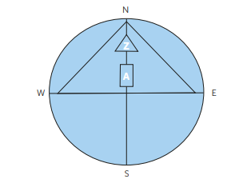  The Axis Mundi runs from North to South.  A=The Six Ministries Street, where numerous important political offices are located, including a prestigious location for the U.S. Embassy because it is located along the Axis Mundi.  Z=the Core Sacred area, where the Palace is located
Directions: Choose 3 of the following and identify the principles of Geomancy for each.

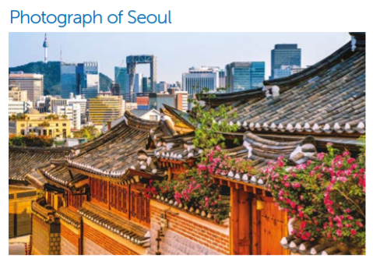 | 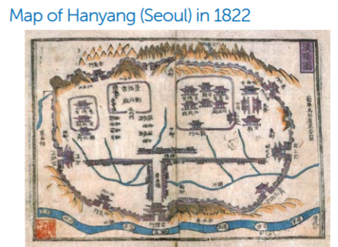
Geomancy Principles (cite evidence from the image): | Geomancy Principles (cite evidence from the map):

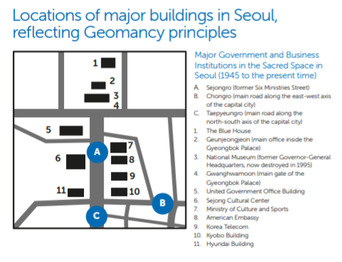 | 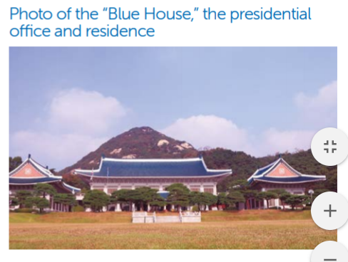
Geomancy Principles (cite evidence from the image):  What is surprising about this? (*see note) | Geomancy Principles (cite evidence from the image):

How is Geomancy Evident Today?

Today, people in Korea still consult geomantic principles when building homes or choosing a place for burial. Larger projects require an official geomancer. The government continues to protect the natural features that make Seoul a prime location. The US Embassy is located in the former Six Ministry Street, which is the most sacred space other than the Palace and the ruling power should sit along the Axis Mundi in the sacred space of the north. The markets and many shops are still located on the east-west alignment that does not block the palace from the North Star. It is clearly still an important part of the Korean culture and everyday life.
The following Introduction to Geomancy could be offered as a Supplemental Homework Reading or as background knowledge for the teacher.

INTRODUCTION TO GEOMANCY
(based on Dr. Jongwoo Han’s Power, Place, and State-Society Relations in Korea

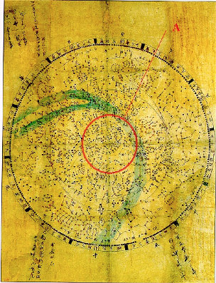
When geographers and historians seek to explain the economic miracle of South Korea, especially as it happened at the same time as the country built a democracy, almost every analysis points to political or economic factors. Neither Confucian doctrine nor indigenous Korean schools of thought, such as geomancy (pungsu jiri sasang in Korean or feng shui in Chinese), have been examined. The significant economic growth, as well as its simultaneous economic and political development, are worthy of careful consideration. Geomancy has been largely overlooked as a source of explanation because it has often been treated as a superstitious belief system of the Orient (4). However, it is essential to understand how Confucianism and geomancy have served as a foundation for the government and economic systems in Korea and how we can still see it today in the Korean cultural landscape (5).
Geomancy has its origins as a discourse between early humans, nature, and the supernatural as they sought to understand where they were, who had created the whole world, what the future held, and how they should live. They looked up to heaven and discovered that only one star, the North Star, did not move or shift, which seemed to be something they could rely on, interpreting it as a sign of God, Truth, or the Way (see Map 1 -- Astronomical Quadrants). They divided the celestial chart into two: the sacred and the profane. And existentially, they had to find something similar on the earth. So they looked for topological connections and divided the landscape into sacred vs profane.
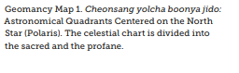
Compared to Western city layouts that emphasize economic functions and professions, ancient Asian cities emphasize religious or mystical characteristics. Geomancy was a specific method for finding the perfect place where heaven’s power is reflected on earth. Groups of the governing elite in the ancient cities of Asia set up their national capitals and sacred places for the government in such ideal places. Buildings were constructed and arranged based on certain principles that determined the ideal location, such as mountains to the north or water located in front of the city (see Map 2). Political buildings were more highly
valued than economic buildings, which clearly aligns to Confucian principles. These political buildings were consequently placed along the most important north-south axis of the city to communicate power and order of the ruling power (37).
Essentially, geomancy explained how “Heaven’s will” was reflected in the natural world through geographical features and combined with humanity’s actions. If they were in harmony with the social, cultural, and political situations, then the society would be successful. This relied on the understanding of cosmology, astronomy, and astrology in order to properly position buildings to access the earth’s energy (105). An additional factor was Confucianism, a political ideology and method for realizing an ideal society on earth through strong state leadership and Confucian meritocracy. People were willing to sacrifice for the sake of the state because of their Confucian and geomantic understanding of their world. Thus, the proper arrangement of buildings and the environment, which was a shared understanding among the people of Korea, communicated a powerful message to anyone in the city--both in the past and today (see Map 3).
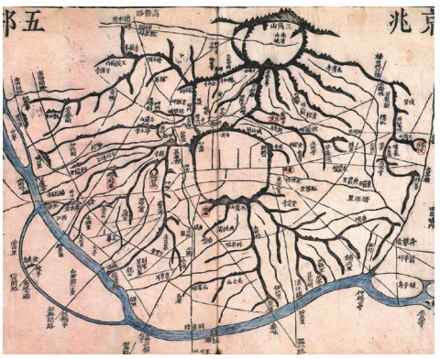 | Geomancy Map 2  The Five Districts of Hanyang (Seoul). This map represents two major geographic features—mountains (presented in black) and rivers (presented in blue).
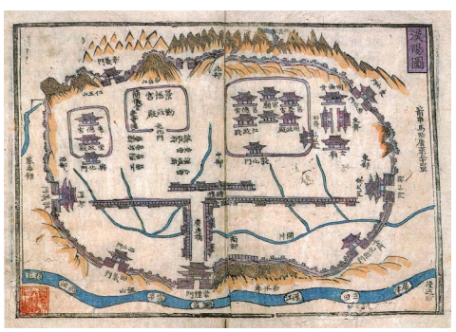 | Geomancy Map 3  The capital city, Hanyang (modern-day Seoul), in 1822, illustrated in this recreation of a woodblock print. The map shows the main Confucian political institutions—such as the king’s palaces, the Confucian National University, the Confucian Ancestral Shrine, and the Six Ministries—all surrounded by mountains and rivers in a harmonious arrangement.

Day 2 Student Handout

Name: __________________________________________________ Period: ______________

Cultural Diffusion and Korean Culture - Notes

Question # | Complete the notes sheet below based on your assigned task.
Question 1 | - How has Korean culture diffused?
Question 2 | - What are political causes AND consequences of the diffusion mentioned in the article?
Question 3 | - What are economic causes AND consequences of the diffusion mentioned in the article?
Question 4 | - What are examples of countries and regions that have been influenced by the diffusion mentioned in the article?

Your Question | Evidence from the Article to answer the question

Processing Cultural Diffusion and Korean Culture
Record notes for each question below as your group members share their answers.
1 - How has Korean culture diffused? | 2 - What are political causes and consequences of the diffusion mentioned in the article?
3 - What are economic causes and consequences of the diffusion mentioned in the article? | 4 - What are examples of countries and regions that have been influenced by the diffusion mentioned in the article?

GROUP ACTIVITY: IDENTIFY THE TOP 3 FACTORS THAT LED TO THE DIFFUSION OF KOREAN POPULAR CULTURE
Rank | Factor | Explanation of why this is important
1.
2.
3.
Answer to the following:
What is the MOST SIGNIFICANT factor that led to the diffusion of Korean popular culture? (Make sure to use evidence from all four tasks to support your answer.)

EFFECTS OF CULTURAL DIFFUSION

Assimilation
The process through which people lose originally differentiating traits, such as dress, speech particularities or mannerisms, when they come into contact with another society or culture (usually a dominant one).

Acculturation
When cultures come into contact and a less dominant culture adopts some of the traits of the more influential or dominant one.

Multiculturalism
The practice of giving equal attention to many different backgrounds in a particular setting.

Syncretism
The combining of cultural traits from two distinct cultures.

Directions: Place the following examples with the appropriate definition/term/geographic concept in the chart above.

1. A group of people adopt the language, religion, and culture of a place to which they have moved. | 2. Official Languages in Bolivia: Spanish, Quechua, Aymara, Guarani. | 3. Sikhs celebrate the Sikh New Year in Toronto, Canada.  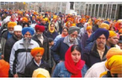 | 4. Haiti has a unique cultural history of African, Indigenous, and European elements that have led to a distinct language, music traditions, and religious observances.
5. Your family has moved to Germany. At school you are learning to speak German and you eat traditional German food in the cafeteria during lunch. When you get home, your conversation about the day takes place in English and you look forward to having some home cooking. | 6. Native American Boarding schools were established between the late 19th and mid-20th centuries with a goal of indoctrinating children in Euro-American culture and preventing children from practicing their own culture. | 7. Tex Mex food  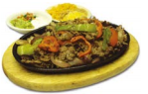 | 8. In the United States, Korean food has gone from being primarily eaten within the Korean-American community to now being a mainstream American food.

Exit Ticket

    - If I acculturate I will….
    - Which could contribute to multiculturalism by….
    - Acculturation and multiculturalism could result in syncretism if…
    - On the other hand, if I assimilate instead of acculturate I would…
    - A society might prefer for people to assimilate because…
    - But some advantages of a multicultural society, which assimilation doesn’t provide, are...

EFFECTS OF CULTURAL DIFFUSION: ANSWER KEY
Assimilation  The process through which people lose originally differentiating traits, such as dress, speech particularities or mannerisms, when they come into contact with another society or culture (usually a dominant one). | A group of people adopt the language, religion, and culture of a place to which they have moved.
 | Native American Boarding schools were established between the late 19th and mid-20th centuries with a goal of indoctrinating children in Euro-American culture and preventing children from practicing their own culture.
Acculturation  When cultures come into contact and a less dominant culture adopts some of the traits of the more influential or dominant one. | In the United States, Korean food has gone from being primarily eaten within the Korean-American community to now being a mainstream American food.
 | Your family has moved to Germany. At school you are learning to speak German and you eat traditional German food in the cafeteria during lunch. When you get home, your conversation about the day takes place in English and you look forward to having some home cooking.
Multiculturalism  The practice of giving equal attention to many different backgrounds in a particular setting. | Official Languages in Bolivia: Spanish, Quechua, Aymara, Guarani.
 | Sikhs celebrate the Sikh New Year in Toronto, Canada.
Syncretism  The combining of cultural traits from two distinct cultures. | Haiti has a unique cultural history of African, Indigenous, and European elements that have led to a distinct language, music traditions, and religious observances.
 | Tex Mex food
Economic and Political Examples

Economic Examples | Jobs  Economic theories  Economic policies/laws  Agriculture  Industry  Labor  Markets  Farming  Ranching  Healthcare spending  Spending money
Political Examples | Government leaders  Nations/states  Laws/acts/policies/taxes  Political parties  Nationalism  Imperialism  Political persecution  Rights  Strategy  Alliances  Treaties  Wars/Revolutions  International organizations

ARTICLE ON CULTURAL DIFFUSION AND KOREAN CULTURE
WORLD HISTORY DIGITAL EDUCATION FOUNDATION

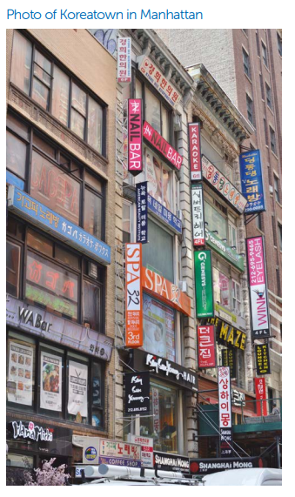
The music and cultural landscape is shifting from traditional media giants in the west to countries such as South Korea. In fact, in 2018, BTS, a K-Pop group, was the second most streamed group behind Imagine Dragons on the music service Spotify. K-Pop, as a musical style, has become so common in countries like the United States, according to a nationwide survey, that two out of three people between the ages of 13 and 49 have heard of the term K-Pop.¹

Music is not the only cultural element that Korea is exporting. As of a market research report conducted by IBISWorld in August of 2019, there were 8,430 Korean restaurants in the United States, generating over $6 billion dollars in revenue.2 Whether through music, entertainment, or food, Korean culture has become influential far beyond the Korean Peninsula.

As we often find with the diffusion of culture, migration helps explain the spread of Korean food and music in countries such as the United States. The first step for this migration was when the United States government passed the Immigration Act of 1965, which removed restrictions on immigration from Asian countries. In addition to these U.S. changes to immigration policy, the Korean government encouraged emigration to reduce population pressure and to gain the benefits of remittances. This has caused the Korean immigrant population in the United States to grow from 11,000 in 1960 to 290,000 by 1980.³

Like many other immigrant groups, Koreans moved to major cities such as New York and Los Angeles, creating Koreatowns or K-towns.⁴ In New York City, the timing could not have been better for those arriving from South Korea. With the city pushing redevelopment of the portion of the city around West 32nd street, rent was relatively cheap compared to other areas of New York City.⁵ Korean immigrants began to cluster businesses in this small location. This area quickly came to be known as K-town.

Today there are over 100 Korean businesses found there, including bakeries, grocery stores, store outlets, hair and nail salons, restaurants, and nightclubs. These businesses not only provide an economic benefit for the city, but they also provide a conduit for the spread of culture.⁶

Due to changes in the economic landscape, Korean culture spread outside of K-Town in New York City. The major reason for the presence of Korean businesses outside K-town is that rent was no longer cheap in K-town, as demonstrated when Sam Won, one of Korea’s oldest restaurants, opened a new restaurant in K-town and was reported to have paid $85,000 a month for rent.7 Other restaurants and businesses have located in new areas of New York, spreading the impact of Korean culture.

Korean culture has spread far beyond the K-Towns in major cities. In fact, it is not uncommon to find kimchi at a local grocery store or gochujang (red chili paste) at Whole Foods Stores.⁸ Today, Korean culture has diffused far beyond the original areas where Koreans first settled and has become one of the most influential and important factors to shape American culture.
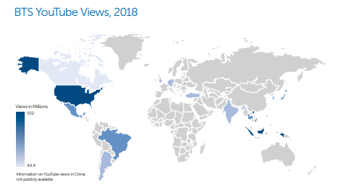
Korean cultural influence can also be seen in Korean-language media targeting the Korean community. Furthermore, many forms of this media, including newspapers, are available in both English and Korean. Much of this media is created in cities with large Korean-American populations such as New York or Los Angeles, and can even be distributed virtually anywhere globally via satellite, cable television, and streaming options over the internet. Even though the target audience for much of this media is Korean-American, widespread access to English as well as digital translation services, have increased access to Korean news and culture outside the Korean community.

Other institutions of culture, such as religion, are also seen in many areas with high concentrations of Korean Americans. Because 73% of Korean-Americans identify as Christian, churches are an important part of the community. Not only do these churches bring people with similar cultural roots and common experiences together; they serve as yet another way Korean culture can be preserved.⁹

Unlike migration, the spread of Korean culture as a part of global popular culture is a much more recent phenomenon. The opportunity to host the 1988 Summer Olympics in Seoul was a turning point for South Korea as the government seized the opportunity to showcase Korean culture on a global scale and capitalized on the powerful economic and cultural force of globalization. The South Korean government set a course that would extend into the 1990s to deliberately grow and spread Korean culture in order to build soft power (cultural and economic influence). The government directed time and resources to develop cultural industries across Korea as new soap operas, Hip-Hop groups, Boy Bands, and movies all started to become internationally popular and more in demand.¹⁰
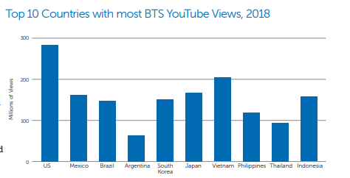
The rise of K-Pop music coincided with the new focus on spreading Korean culture. Many point to a talent show in 1992, when the group Seo Taeji and Boys performed a mix of Korean lyrics, Euro Pop, Hip-Hop, and Rap with members dancing in sync, as the epicenter of this spread. Ironically, this cultural phenomenon didn’t start with accolades.

In fact, the band received the lowest scores of the night.
However, in the following days and weeks, Seo Taeji and the Boys’ song “I Know” sky-rocketed to the top of the charts and stayed there for seventeen weeks.11 The elements that helped form K-Pop were born with early diffusion to other countries in Asia.

K-Pop music, unlike music in Japan and China, embraced international social media platforms such as Facebook, Twitter, and YouTube. The best example of the impact of social media occurred in 2012 with the global phenomenon sparked by the video and song “Gangnam Style.”

The song’s influence was immediate and long-lasting, with over three-billion views, making it the most watched YouTube video of all time.¹² Not only did “Gangnam Style” receive global views; it was unique because it was not a copy of Western pop culture. Through YouTube and technology to download music, people all over the world were listening, dancing, and singing along with the song

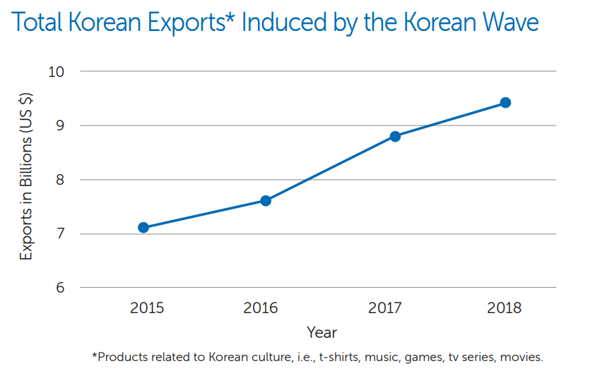
The power of YouTube as a way of spreading Korean culture continued in 2019 when the BTS single “Boy with Luv” hit 74.6 million views on YouTube within the first 24 hours of its release, setting a YouTube record. The release was also the fastest video to hit 100 million views in YouTube history.¹³ Typical popular culture is connected to the most spoken languages in the world, but the spread of K-Pop music is unique because it has remained primarily in the Korean language, spreading the cultural influence of the language globally. Platforms such as YouTube have been major means of spreading Korean culture and language globally.

The global reach of K-Pop can be seen with K-Pop artists such as BTS. In 2018 alone, BTS has topped the charts on the Billboard 200 albums in the United States twice, broken into the UK Official Top 40 Chart, and topped the iTunes Charts in over sixty countries.

BTS tours have sold out in venues around the world, including North America, Europe, and Asia. Further, in 2018 BTS was awarded a Medal of Honor from the South Korean government for spreading Korean culture and language around the world. While spreading Korean culture, groups like BTS have helped generate billions of dollars, bringing in $3.6 billion USD in 2018 alone.¹⁴ Not only do K-Pop groups such as BTS spread Korean culture globally; they have strengthened the economic power of South Korea.

In addition to the power of K-Pop music, South Korean soap operas have also gained a global market. Due to the global and regional popularity of these K-Dramas (as they are called), over 12.2 million people, according to the Korea Tourism Organization (KTO), visited the sites where these soap operas are filmed.¹⁵ Chinese and Japanese tourists travel to South Korea to visit television-themed destinations to see locations where characters have shared a kiss or to have the chance to wear the same clothing as their favorite television stars. This influence can even be seen in the volume of orders from the Korean fried chicken restaurant Kko Kko, where take-out orders in Singapore increased 20% after the restaurant and its chicken were featured in a Korean soap opera.¹⁶ Combined with K-Pop music and other cultural exports of South Korea, the diffusion of culture has become an important part of the economy of South Korea.
The last factor that helps explain the spread and diffusion of Korean culture, particularly in Asia, is the appeal of Korean culture versus “Western” and Japanese influences. For many around the world, popular culture from countries such as the United States is often viewed as cultural imperialism, forcing western language and values on people at the expense of their own local cultures. Additionally, the historical legacy of Japanese imperialism and war atrocities during World War II make Japanese culture less appealing to some.¹⁷ Korean culture appeals to many who fear cultural imperialism from the West and also provides a cultural balance to Japan, reducing barriers to diffusion and allowing for the spread of Korean culture within Asia and globally.

The Korean “Wave,” as this spread of culture from Korea is known, has moved beyond Asia and has found a global audience. The next time that you watch a Korean drama, listen to K-Pop music, or eat Korean food, understand that the phenomenon and its diffusion involved migration, the use of global social media, governmental influences, responses to Western and Japanese popular culture, and the rising popularity of Korean culture.

NOTES

1. Caitlin Kelley, “BTS Became The Second Most-Streamed Group On Spotify In 2018,” Forbes, December 4, 2018

2. “Industry Market Research, Reports, and Statistics,” IBISWorld, http://www.ibisworld.com/united-states/market-research-reports/ korean-restaurants-industry/.

3. Allison O’Connor and Jeanne Batalova, “Korean Immigrants in the United States,” Migrationpolicy.org, April 25, 2019

4. “Koreatown Manhattan 2009.” Wikicommons, http://commons.wikimedia.org/wiki/File:Koreatown_Manhattan_2009.JPG.

5. Sam Kim, “How NYC's Koreatown Got Swallowed Up by Chain Restaurants,” Eater NY, July 31, 2018, http://ny.eater. com/2018/7/31/17633796/k-town-nyc-restaurants-chains-report.

6. Yun Park, “Little Seoul in New York City, Manhattan Koreatown,” March 31, 2016, http://ekdbs0503.wordpress.com/2016/03/31/ little-seoul-in-new-york-city-manhattan-koreatown/.

7. Sam Kim, note 5 above

8. Sam Kim, note 5 above.

9. Joseph Hong, “New York's Korean Christian Congregations Thrive,” NY City Lens, http://nycitylens.com/blog/2017/03/01/ new-yorks-korean-christian-congregations-thrive/.

10. Evan Osnos, “Asia Rides Wave of Korean Pop Culture Invasion,” Chicagotribune.com, August 26, 2018, http://www.chicagotribune. com/news/ct-xpm-2005-12-23-0512230216-story.html.

11. British Broadcasting Corporation (BBC), “Culture - How Did K-Pop Conquer the World?” May 29, 2019, http://www.bbc.com/culture/ story/20190529-how-did-k-pop-conquer-the-world.

12. Ibid.

13. Julia Hollingsworth and Sophie Jeong,“BTS' New Music Video Breaks YouTube Record for Most Views in 24 Hours,” CNN, Cable News Network, April 17, 2019, http://www.cnn.com/2019/04/17/asia/korea-bts-youtube-intl/index.html.

14. Ibid.

15. See Kit Tang, “Food and Fashion: How K-Drama Is Influencing Asia,” CNBC, June 19, 2014, http://www.cnbc.com/2014/06/18/foodand-fashion-how-k-drama-is-influencing-asia.html.

16. Evan Osnos, note 10 above

17. Ibid.

